Condition monitoring for mobile equipment
Higher machine availability with mobile X90 control system
The modular X90 control and I/O system can now be equipped with condition monitoring functions. Problems can be detected in their early stages and corrected before they result in unplanned downtime. Condition-based predictive maintenance can maximize machine availability and save the considerable cost of outages and unplanned service calls.
Predictive maintenance
The X90 module allows operators to continuously monitor the status of mobile equipment. The results help determine exactly which components require maintenance and when. Typical applications include continuous monitoring of rotating machine components such as hydraulic assemblies, belts, gears and motors. The processed sensor data is also available for further use in the application.

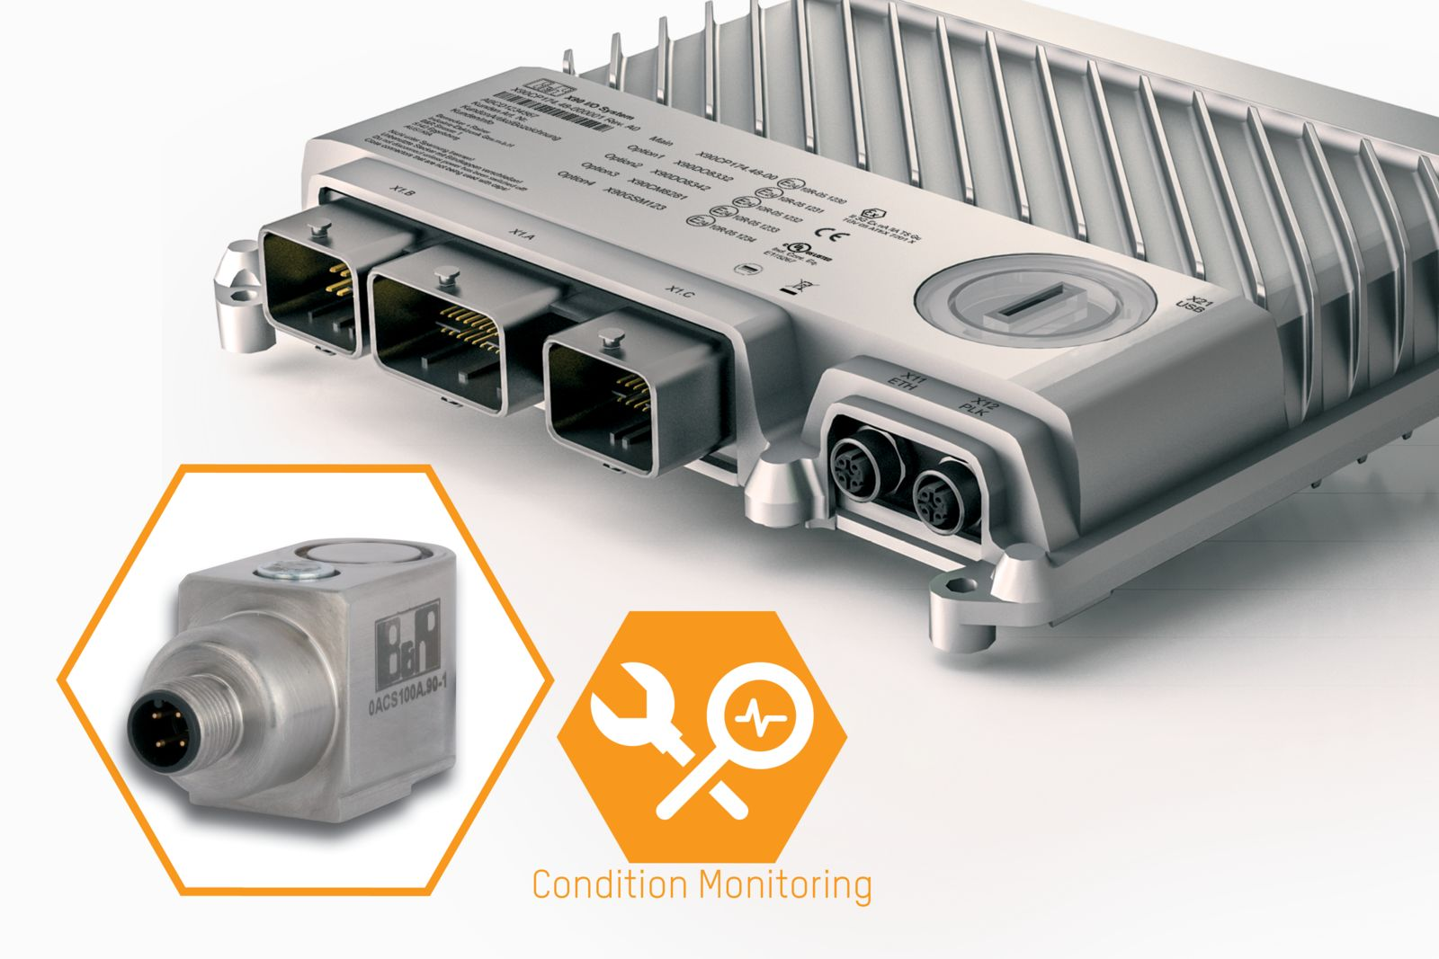
The option board for condition monitoring provides early detection of impending faults on mobile equipment.

About B&R
B&R, a division of ABB Group, is a global leader in industrial automation headquartered in Austria. B&R combines state-of-the-art technology with advanced engineering to provide customers in virtually every industry with complete solutions for machine and factory automation, motion control, HMI and integrated safety technology. With Industrial IoT communication standards including OPC UA, POWERLINK and openSAFETY as well as its Automation Studio software, B&R is constantly redefining the future of automation engineering. The innovative spirit that keeps B&R at the forefront of industrial automation is driven by a commitment to simplifying processes and exceeding customer expectations.
For more information, visit www.br-automation.com.

