Automatic control loop tuning
New software components for easy hydraulics control
B&R is introducing new software components for controlling hydraulics applications. These components provide easier access to advanced closed-loop control functions and assist developers in the design, simulation, virtual commissioning and diagnosis of hydraulic systems. B&R mapp Hydraulics provides numerous new functions, particularly for variable-speed pump drives.
Automatic control loop tuning
With the autotuning function, the system automatically optimizes the control loop parameters for the hydraulic pressure controller. This boosts both quality and system performance. Optimized pressure control parameters also help prevent damage caused by overloading or cavitation. If autotuning is used during operation, the machine software can automatically recalibrate the controller following changes to environmental conditions such as load forces or characteristics.
Automatic calculation of maximum values
Another mapp Hydraulics component automatically calculates the maximum acceleration and deceleration values for a hydraulic drive. The drive moves autonomously within the operational limits defined by the user to identify the maximum values for a given hydraulic axis. This significantly shortens commissioning times for hydraulic axes.

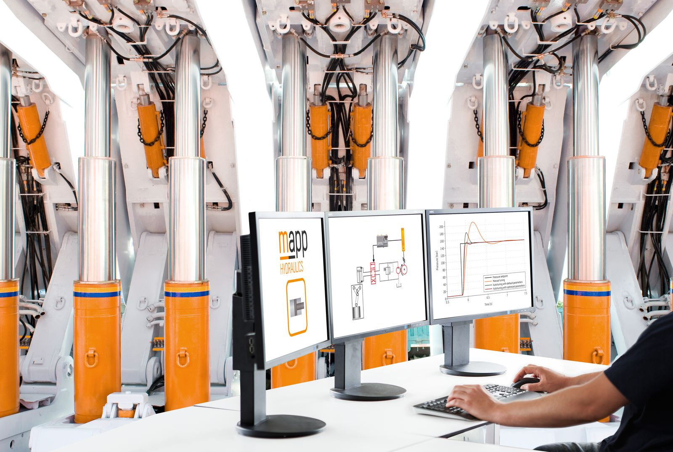
mapp Hydraulics software components provide convenient access to advanced closed-loop hydraulic functions.

About B&R
B&R, a division of ABB Group, is a global leader in industrial automation headquartered in Austria. B&R combines state-of-the-art technology with advanced engineering to provide customers in virtually every industry with complete solutions for machine and factory automation, motion control, HMI and integrated safety technology. With Industrial IoT communication standards including OPC UA, POWERLINK and openSAFETY as well as its Automation Studio software, B&R is constantly redefining the future of automation engineering. The innovative spirit that keeps B&R at the forefront of industrial automation is driven by a commitment to simplifying processes and exceeding customer expectations.
For more information, visit www.br-automation.com.

