Dynamic HMI design made easy
Easy HMI animations with mapp View's Paper widget
mapp View's new Paper widget makes it easier to visualize complex manufacturing processes with dynamic HMI content. The new widget allows users to animate SVG images with runtime data.
Configurable animations from a single SVG image
Simply drag and drop the new widget onto the desired page in your HMI application and configure it there. At runtime, animation of the SVG image can be controlled directly from the application program. Rotations, transitions and movements can all be animated from a single SVG image – saving the time and cost otherwise needed to create sequences of multiple images.
High-resolution zoom
Among the advantages of using SVG images: Since they are based on vector graphics, they retain their high resolution without any loss of quality even when zoomed in.

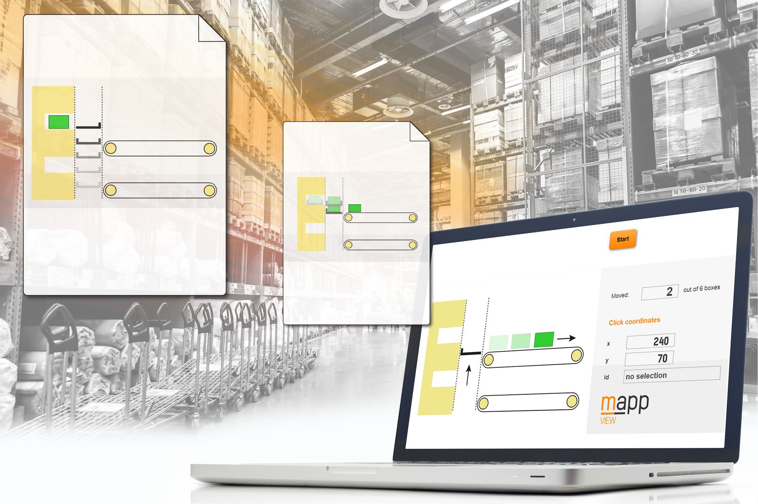
New from mapp View: Paper widget allows users to display SVG images and create animated HMI content using real-time process data.

About B&R
B&R, a division of ABB Group, is a global leader in industrial automation headquartered in Austria. B&R combines state-of-the-art technology with advanced engineering to provide customers in virtually every industry with complete solutions for machine and factory automation, motion control, HMI and integrated safety technology. With Industrial IoT communication standards including OPC UA, POWERLINK and openSAFETY as well as its Automation Studio software, B&R is constantly redefining the future of automation engineering. The innovative spirit that keeps B&R at the forefront of industrial automation is driven by a commitment to simplifying processes and exceeding customer expectations.
For more information, visit www.br-automation.com.

