Advanced automation platform for mobile equipment
B&R presents condition monitoring solution at Agritechnica
At this year's Agritechnica exhibition from November 12-18 in Hanover, B&R will be presenting a condition monitoring solution for mobile automation. Visitors to Hall 15, Booth H13 will also see how advanced automation solutions can be implemented based on a comprehensive hardware portfolio, ready-made software components and a powerful engineering tool.
Forebyggende vedligeholdelse
The X90 controller with integrated condition monitoring allows operators of agricultural machinery to continuously monitor the health of their equipment. The results help determine exactly which components require maintenance and when. Problems can be detected in their early stages and corrected before they result in unplanned downtime. Repairs can instead be timed to coincide with regular scheduled service.
Develop 3 times faster
The ready-made software components of mapp Technology make it easier and faster to perform frequently recurring programming tasks. With the software for new machinery and equipment completed in a third of the time, this brings a dramatic reduction in time to market. Since the components are maintained entirely by B&R, the resulting application software is also of higher quality.

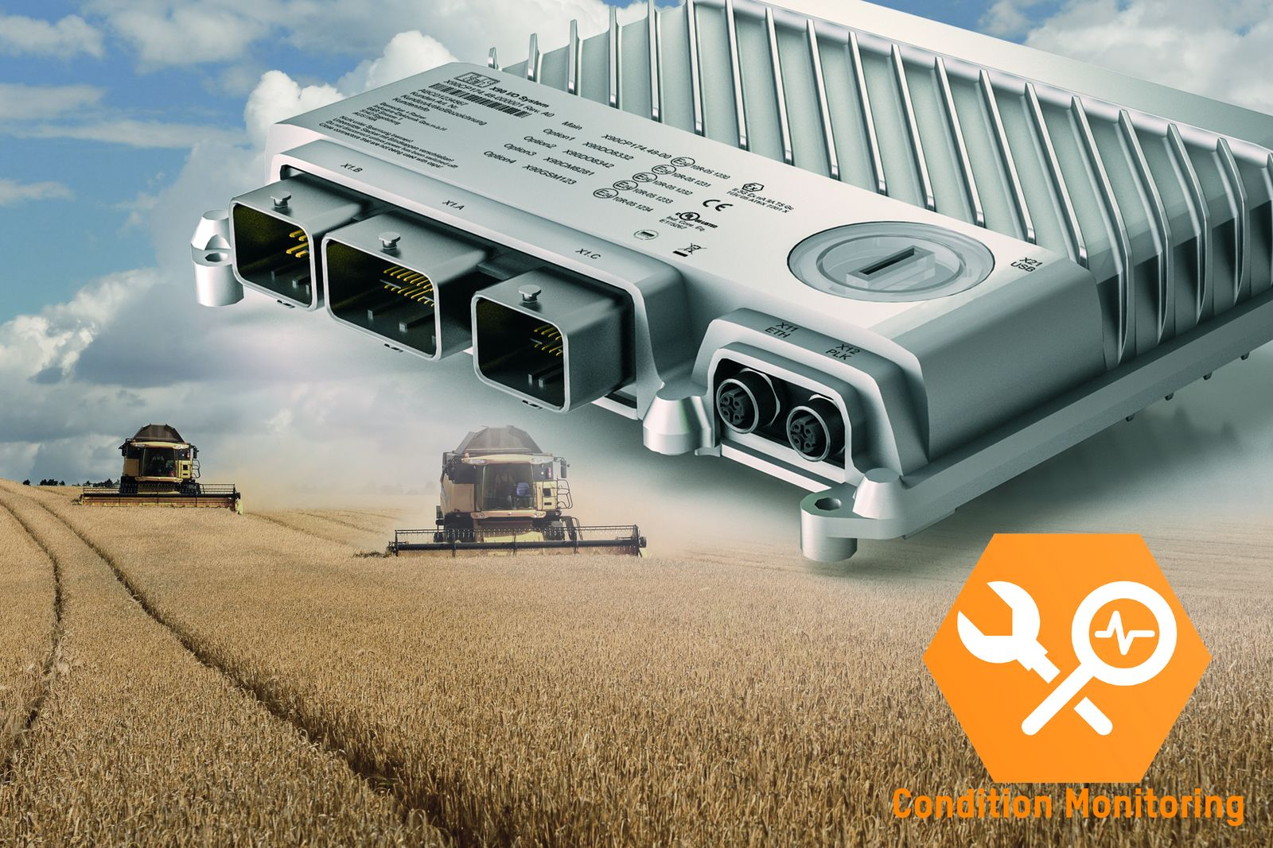
At Agritechnica, B&R presents a condition monitoring solution for mobile applications. The X90 controller with integrated condition monitoring allows operators of agricultural machinery to continuously monitor the health of their equipment.

Om B&R Industrial Automation i Danmark
B&R i Danmark er et datterselskab af B&R Industrial Automation, som er en innovativ automationsvirksomhed med hovedkontor i Østrig og kontorer i hele verden. Den 6. juli 2017 blev B&R en selvstændig forretningsenhed i ABB Group. Som global markedsleder i industriel automatisering kombinerer B&R den nyeste teknologi med avanceret ingeniørarbejde for at forsyne kunder i stort set alle brancher med de mest optimale løsninger inden for automation og proceskontrol. Firmaets styrings- og drevløsninger samt industri PC’er og visualiseringssystemer sætter nye standarder inden for industriel automation. Med Industrial IoT kommunikationsstandarder som OPC UA, POWERLINK og openSAFETY såvel som den effektive software platform Automation Studio, skubber B&R konstant grænserne for hvad der er muligt inden for automatisering. Den nyskabende ånd og en klar forpligtelse af skabe simple processer sikrer B&R til at være på forkant med industriel automatisering og overstige kundernes forventninger.
Ved genoptryk af denne pressemeddelelse, venligst send en kopi til:
B&R Industrial Automation A/S
Marketingafdeling
Rolundvej 17-19
5260 Odense S
office.dk@br-automation.com

