B&R steps up efforts advancing OPC UA
Automation specialist appointed to OPC Foundation's Technical Advisory Council
B&R is now represented in the OPC Foundation's Technical Advisory Council (TAC). This move further strengthens B&R's role in the strategic advancement of the OPC UA standard. Appointment to the TAC is a tribute to B&R's committed involvement throughout numerous OPC Foundation working groups.
Drawing its membership from the likes of Microsoft, SAP, Rockwell
and Siemens, TAC is the highest technical body within the OPC
Foundation. The council is tasked with setting the strategic course for advancing OPC UA in a way that maximizes user benefits. It has the authority to establish technical working groups and approve new OPC UA specifications.
Pub/Sub and TSN
B&R will be represented in the TAC by Dr. Dietmar Bruckner. As Technical Manager of Open Automation Technologies at B&R, Dr. Bruckner is responsible for all development activities surrounding OPC UA TSN. "I'm very much looking forward to working in the TAC," he says. "Together, we will make rapid progress in the development of Pub/Sub and TSN. In combination with application-specific OPC UA companion specifications, we will very soon be able to offer a uniform standard for seamless communication from the sensor to the cloud."

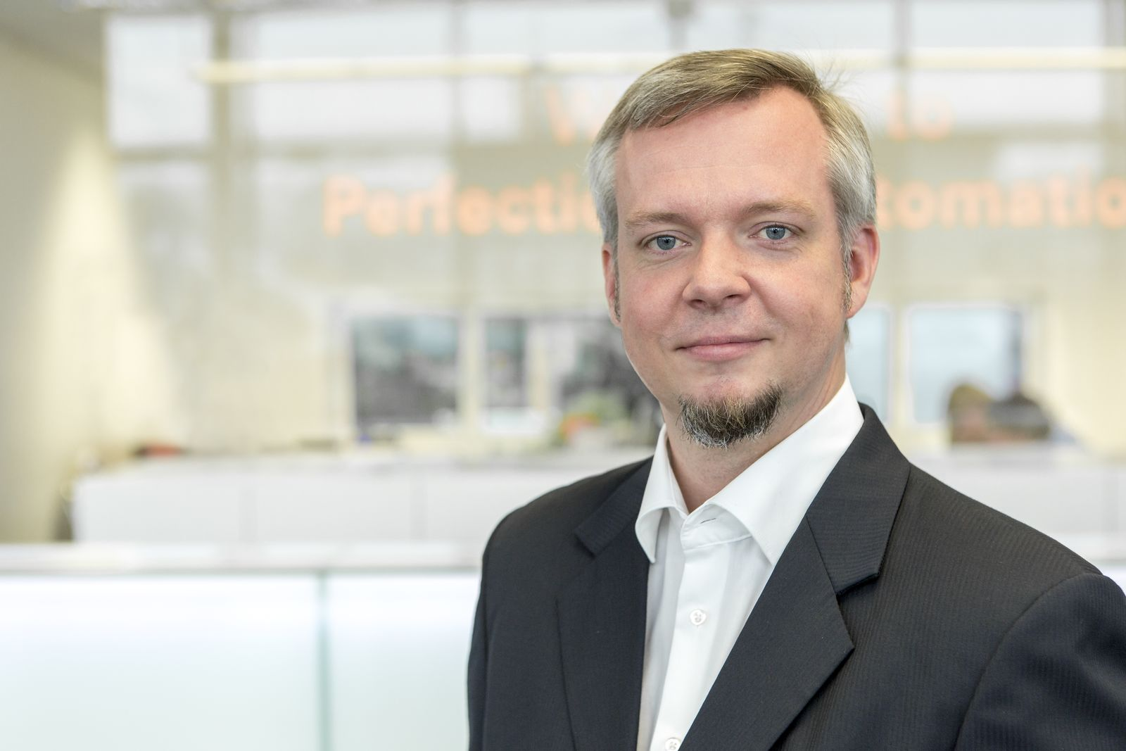
Dr. Dietmar Bruckner represents B&R on the OPC Foundation's Technical Advisory Council.

About B&R
B&R, a division of ABB Group, is a global leader in industrial automation headquartered in Austria. B&R combines state-of-the-art technology with advanced engineering to provide customers in virtually every industry with complete solutions for machine and factory automation, motion control, HMI and integrated safety technology. With Industrial IoT communication standards including OPC UA, POWERLINK and openSAFETY as well as its Automation Studio software, B&R is constantly redefining the future of automation engineering. The innovative spirit that keeps B&R at the forefront of industrial automation is driven by a commitment to simplifying processes and exceeding customer expectations.
For more information, visit www.br-automation.com.

