Batch-of-one flexibility meets mass-production efficiency
New transport system boosts overall equipment effectiveness (OEE)
At the SPS IPC Drives exhibition in Nuremberg, B&R unveiled its new intelligent transport system: ACOPOStrak. ACOPOStrak is the first system on the market to extend the economies of mass production down to batches of one.
Divide and merge product flows
The purely electromagnetic ACOPOStrak diverters divide and merge product flows at full production speed. Among their many advantages is the ability to include a pit lane in the track layout. New shuttles are mounted on the pit lane and then channeled onto the track's actual production lines via a diverter. In the same way, any shuttles that are no longer needed can simply be rerouted to the pit lane. All of this takes place at full production speed. "It becomes possible to perform product changeover with zero downtime," explained B&R's mechatronics manager Robert Kickinger at the spectacular unveiling event that kicked off the exhibition.
Highly dynamic and flexible
ACOPOStrak's absolute design flexibility allows it to morph into all types of open and closed layouts by arranging different combinations of track segments. The system is capable of 5 g acceleration and reaches top speeds in excess of 4 meters per second with a minimum product pitch of only 50 millimeters. No other transport system on the market offers such impressive performance numbers in combination with high-speed diverters and extensive design flexibility.

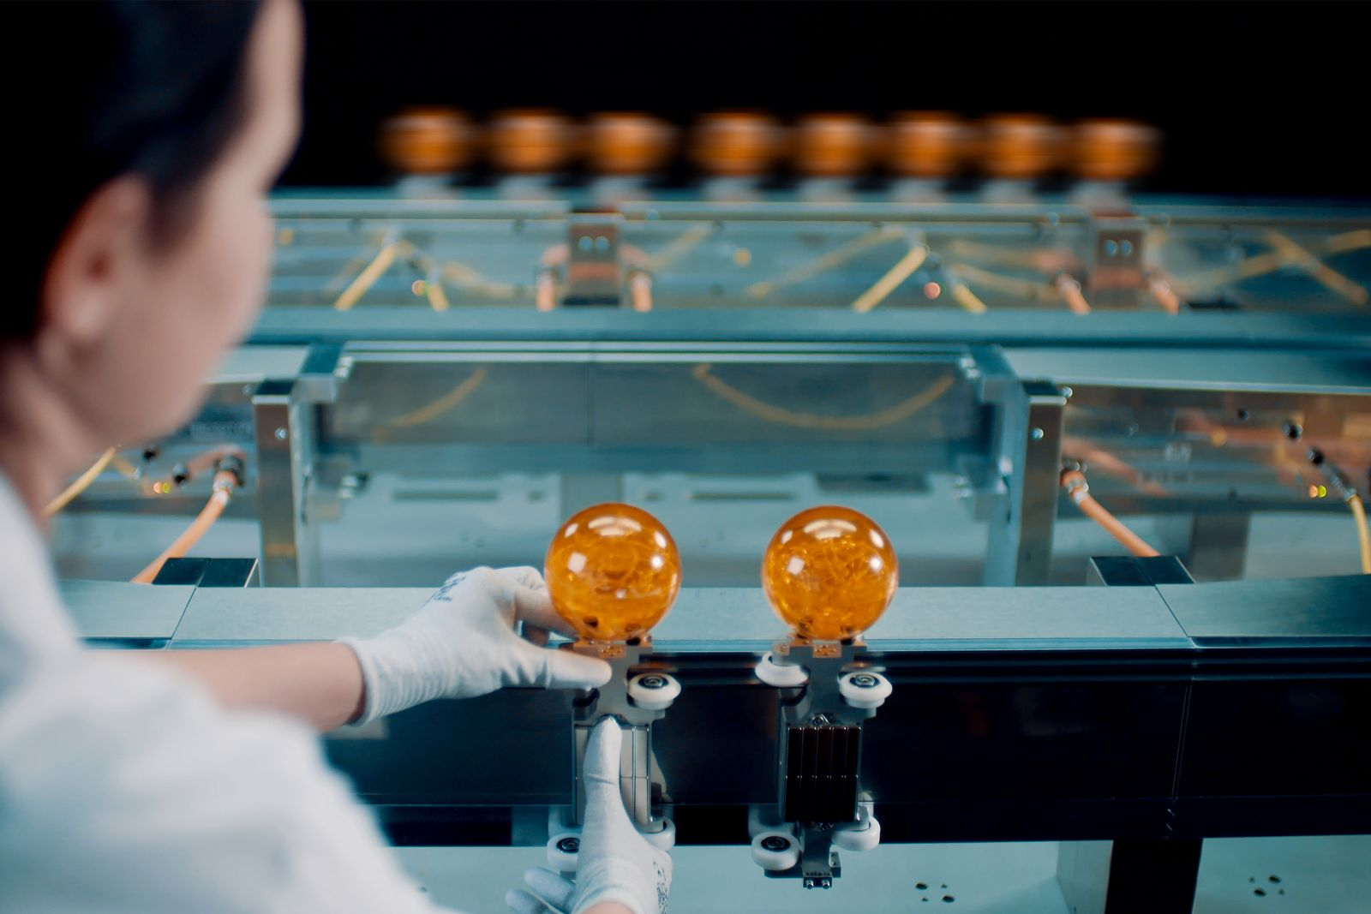
To switch products, the operator simply places the wheels of a new shuttle on the guides of the pit lane, while production continues at full speed on the rest of the track.

About B&R
B&R, a division of ABB Group, is a global leader in industrial automation headquartered in Austria. B&R combines state-of-the-art technology with advanced engineering to provide customers in virtually every industry with complete solutions for machine and factory automation, motion control, HMI and integrated safety technology. With Industrial IoT communication standards including OPC UA, POWERLINK and openSAFETY as well as its Automation Studio software, B&R is constantly redefining the future of automation engineering. The innovative spirit that keeps B&R at the forefront of industrial automation is driven by a commitment to simplifying processes and exceeding customer expectations.
For more information, visit www.br-automation.com.

