New mapp component for database interfaces
B&R optimizes data management with the mapp Technology software toolbox
It is now easier than ever to implement databases in applications. With mapp Database, it is possible to archive data directly from the field level to a database, regardless of whether that database is located on site or in the cloud. This drastically simplifies the management of large volumes of data.
Data archiving directly from the controller
Manufacturing machinery generates huge volumes of data, which must then be visualized, archived or passed on to higher-level systems. Giving mapp functions a database interface makes it possible to send data directly from the controller to databases, where it can be processed or archived. Commonly used database functions, such as stored procedures, allow KPIs to be generated as needed, resulting in a cockpit for optimizing manufacturing processes.
Consistent exchange of data
mapp Database can be connected to any mapp component that saves or reads data. Instead of generating individual files for alarm lists, process values and audit events, all data is sent automatically via mapp Links to a database where it can be easily managed.

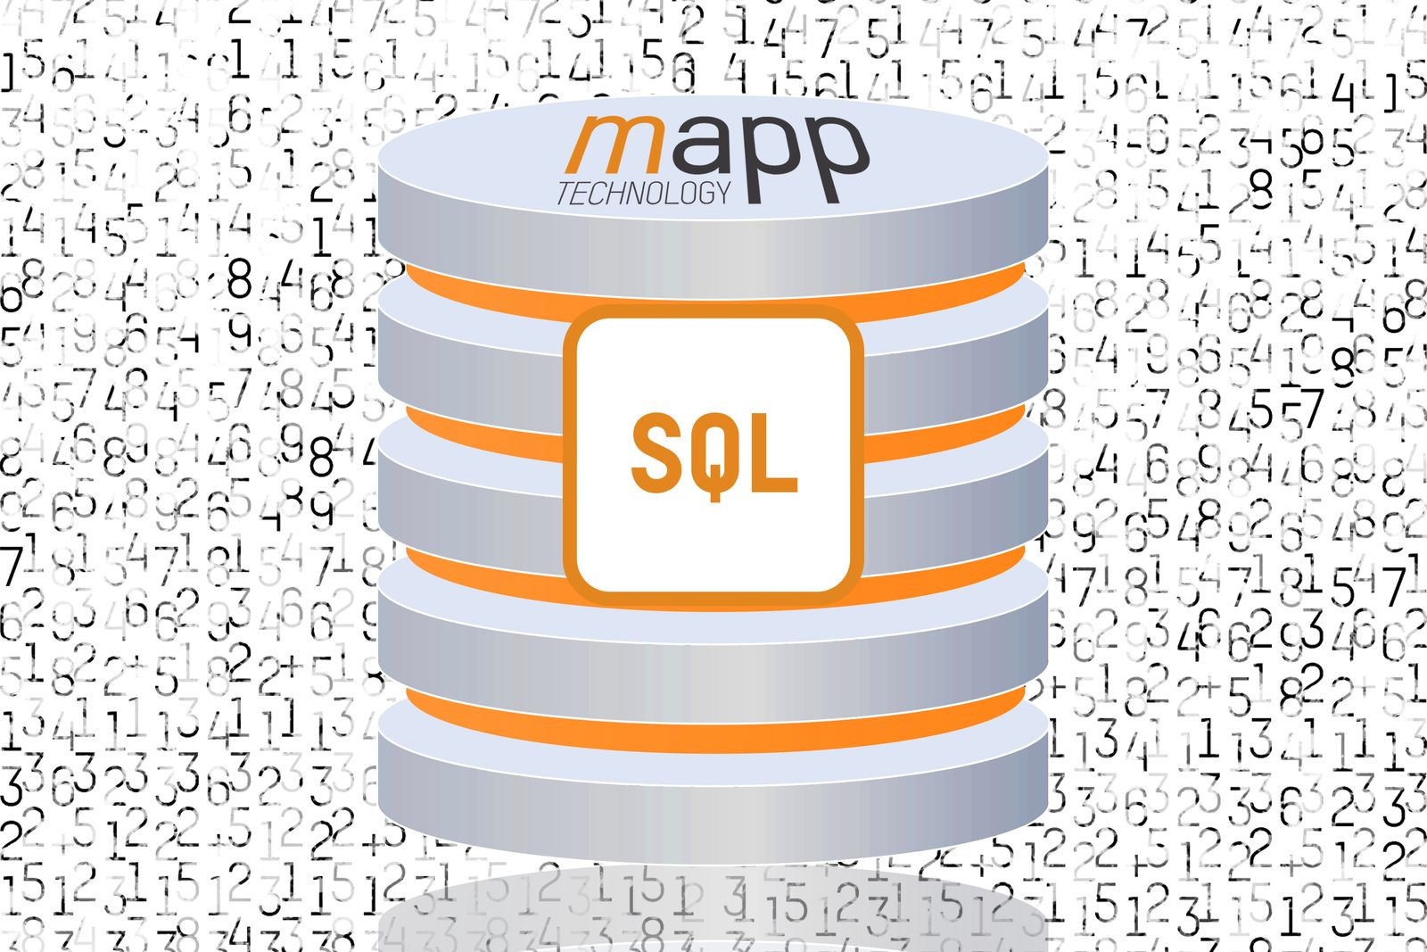
mapp Database allows both user data and data generated by mapps to be managed conveniently in an SQL database.

About B&R
B&R, a division of ABB Group, is a global leader in industrial automation headquartered in Austria. B&R combines state-of-the-art technology with advanced engineering to provide customers in virtually every industry with complete solutions for machine and factory automation, motion control, HMI and integrated safety technology. With Industrial IoT communication standards including OPC UA, POWERLINK and openSAFETY as well as its Automation Studio software, B&R is constantly redefining the future of automation engineering. The innovative spirit that keeps B&R at the forefront of industrial automation is driven by a commitment to simplifying processes and exceeding customer expectations.
For more information, visit www.br-automation.com.

