Digital display transmission with SDL4
B&R presents new generation of HMI panel interface
B&R recently introduced the fourth generation of its display transmission technology, Smart Display Link (SDL). SDL4 is based on HDBaseT 2.0 and can span up to 100 meters between the industrial PC and display device. This makes it easy to equip expansive machines and systems with multiple remote HMI panels.
Up to 100 m
SDL4 makes it possible to transmit display content and other data over much greater distances. It's possible to span up to 100 meters between PC and display. An additional highlight of SDL4 is its use of standard Ethernet cables, which drastically reduces cable costs over longer distances. The thin cable and slim RJ45 connector are a perfect fit in tight situations such as feed-through openings and swing arm systems.
Up to 4 HMI panels per PC
An SDL4 converter allows up to three panels to be connected to one Automation PC. A fourth Automation Panel displaying different content can also be operated via an additional SDL4 interface. This is B&R's response to the needs of modern manufacturing systems, which increasingly feature multiple locally-mounted operator panels.
Independent of operating system and software
The modular design of B&R's PC and panel systems allows any Automation Panel to be equipped with an SDL4 interface. SDL4 transmission technology is independent of software and operating systems and integrates all communication channels – including USB, touch screen and function keys – in one single cable. SDL4 transmits all signals uncompressed and in high resolution for optimum image quality.

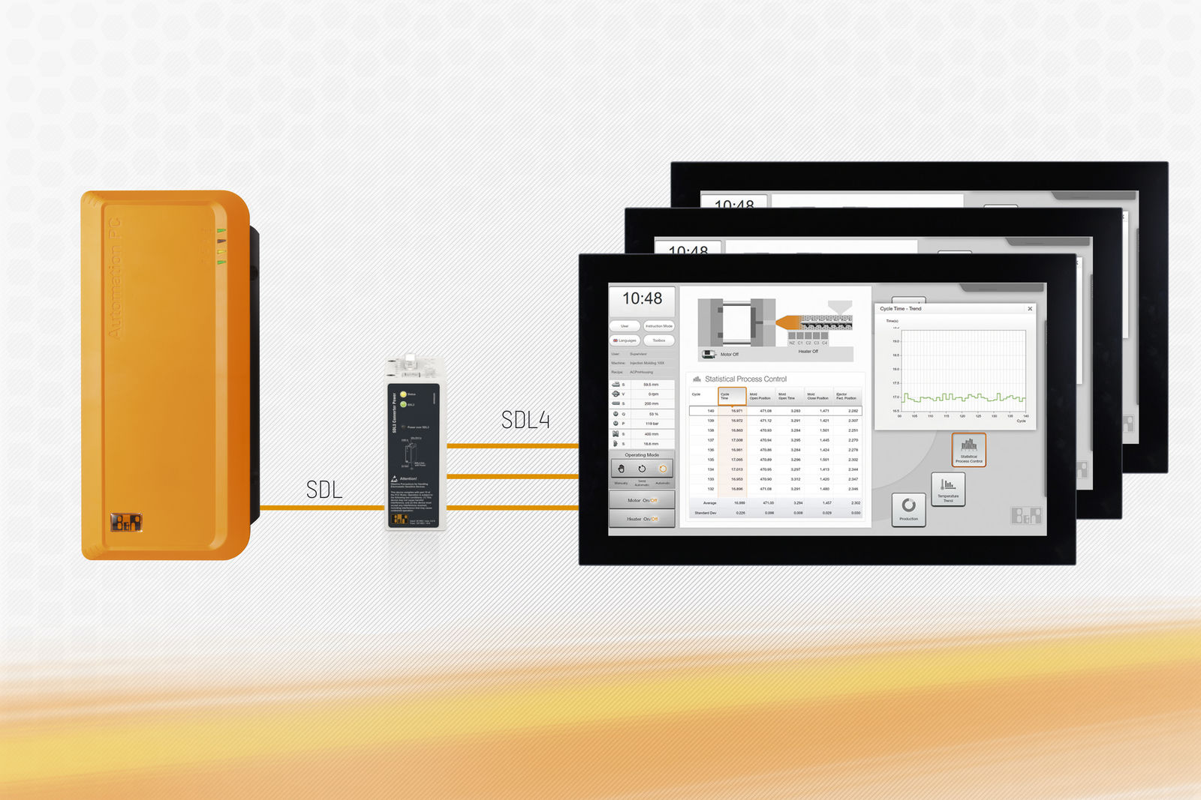
Smart Display Link 4 transmits all communication channels between PC and HMI panel via a standard Ethernet cable and is independent of operating system and software.

About B&R
B&R, a division of ABB Group, is a global leader in industrial automation headquartered in Austria. B&R combines state-of-the-art technology with advanced engineering to provide customers in virtually every industry with complete solutions for machine and factory automation, motion control, HMI and integrated safety technology. With Industrial IoT communication standards including OPC UA, POWERLINK and openSAFETY as well as its Automation Studio software, B&R is constantly redefining the future of automation engineering. The innovative spirit that keeps B&R at the forefront of industrial automation is driven by a commitment to simplifying processes and exceeding customer expectations.
For more information, visit www.br-automation.com.

