Remote I/O expansion for mobile automation
B&R expands the X90 control and I/O system
With its new X90 CAN bus controller, B&R makes it easier to connect remote sensors and actuators to mobile machinery. The scalable X90 control and I/O system allows efficient implementation of automation concepts for construction, agricultural and municipal vehicles. Customers benefit from comprehensive solutions based on the B&R technology platform.
Many possible uses
The standardized CANopen interface and multifunction I/O channels make the X90 bus controller extremely versatile. All functions are configured in the control application using the B&R Automation Studio development environment.
For harsh environments
All products in the X90 family are designed for rugged use in mobile machinery. They can handle operating temperatures from -40 to +85°C (housing surface) and are resistant to vibration, shock up to 50 g, salt, UV light and oil. The housing provides IP69K protection.

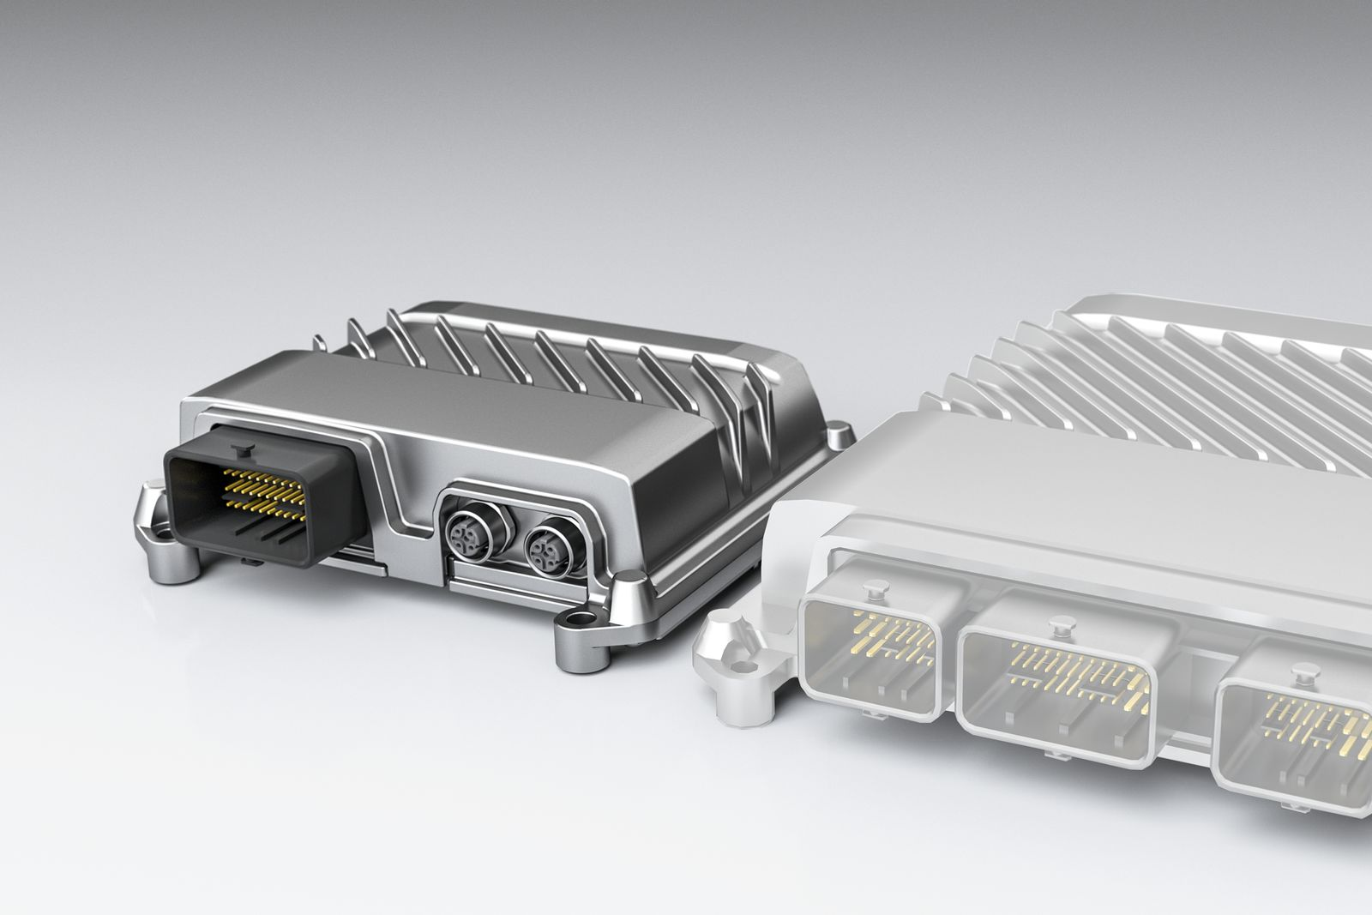
B&R has expanded its X90 control and I/O system to include an I/O module for connecting remote sensors and actuators on mobile equipment.

About B&R
B&R, a division of ABB Group, is a global leader in industrial automation headquartered in Austria. B&R combines state-of-the-art technology with advanced engineering to provide customers in virtually every industry with complete solutions for machine and factory automation, motion control, HMI and integrated safety technology. With Industrial IoT communication standards including OPC UA, POWERLINK and openSAFETY as well as its Automation Studio software, B&R is constantly redefining the future of automation engineering. The innovative spirit that keeps B&R at the forefront of industrial automation is driven by a commitment to simplifying processes and exceeding customer expectations.
For more information, visit www.br-automation.com.

