Centralized factory-level user management
B&R simplifies user management with mapp Technology
B&R has made centralized, factory-level user management substantially easier. With the new software component mapp UserX, it is now possible to use services based on LDAPS (Lightweight Directory Access Protocol via SSL) to implement centralized management of users and user groups, for example using Active Directory from Microsoft.

With mapp UserX, the administrator can easily create users and grant them access to multiple servers using a single username and password. Rather than having to manage user by user on each individual machine, all the user data is stored on a central server and retrieved from there at every login.
State-of-the-art user management
With mapp UserX and LDAPS, user management functions are fully integrated as widgets in the mapp View HMI system. Developers can implement powerful, web-based HMI functionality without having to write a single line of code. That makes is easy to meet the requirements for FDA 21 CFR Part 11 compliance.

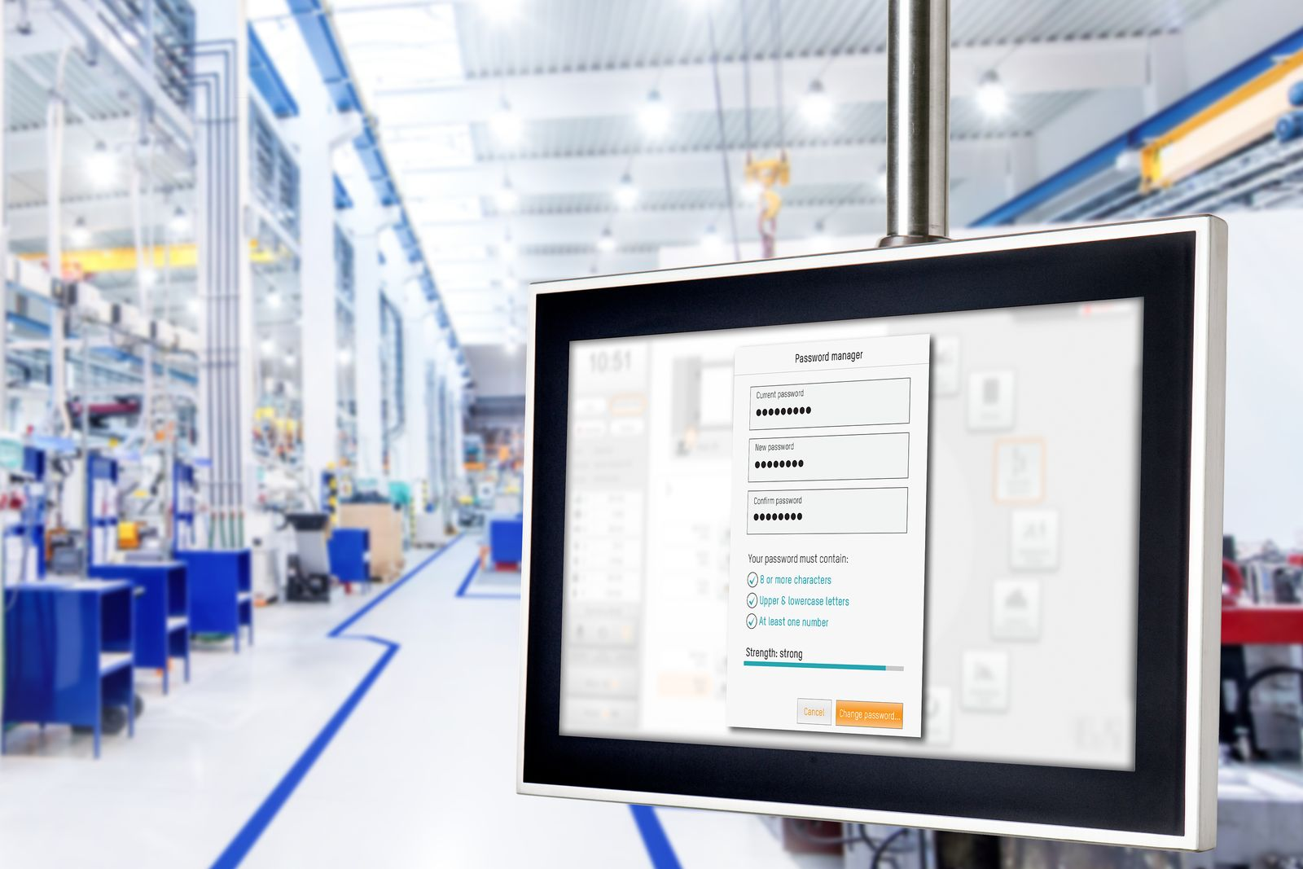
Rather than having to manage user by user on each individual machine, all user data is stored and queried on a central server using mapp UserX and LDAPS.

About B&R
B&R, a division of ABB Group, is a global leader in industrial automation headquartered in Austria. B&R combines state-of-the-art technology with advanced engineering to provide customers in virtually every industry with complete solutions for machine and factory automation, motion control, HMI and integrated safety technology. With Industrial IoT communication standards including OPC UA, POWERLINK and openSAFETY as well as its Automation Studio software, B&R is constantly redefining the future of automation engineering. The innovative spirit that keeps B&R at the forefront of industrial automation is driven by a commitment to simplifying processes and exceeding customer expectations.
For more information, visit www.br-automation.com.

