New functions in SafeDESIGNER
Easier creation of safety applications
B&R makes it easier to create safety applications with a series of new mapp functions in SafeDESIGNER. It is also possible to use a combination of data from the standard application to generate safety-relevant data.
Safety data from standard (non-safety) signals
The Data-to-SafeDATA function determines a safe speed and a safe position using data from the standard application. This is done by comparing speed and position data from two standard (non-safety) I/O modules with each other. With the help of the functions provided, the data can be used as the safe speed for applications up to PL d and the safe position for applications up to PL c .
Easily solve complex calculations
With advanced mathematics functions, B&R makes it easier to make complex calculations in an application. All data is calculated as fixed point numbers. The user does not need to worry about rounding, resolution or buffer overflow errors.

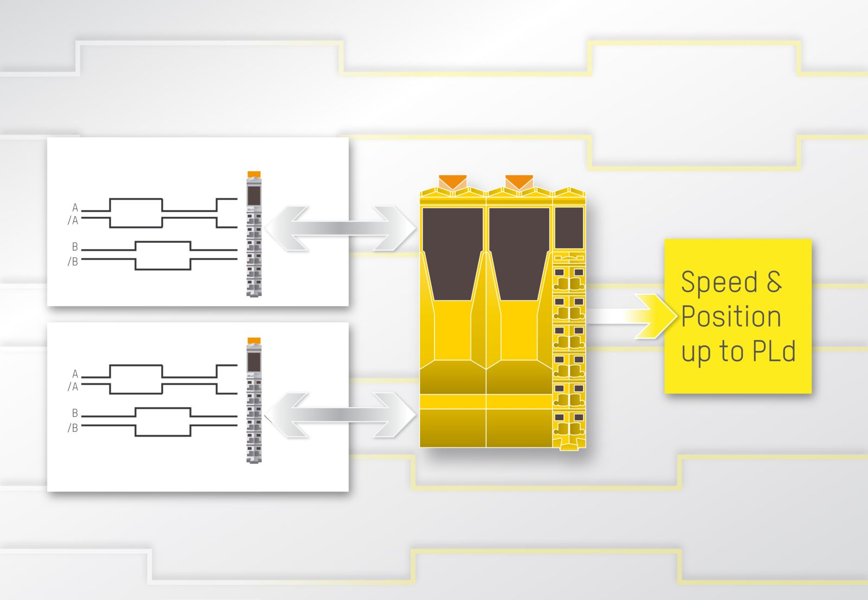
The new Data-to-SafeDATA function in SafeDESIGNER determines a safe speed and a safe position using data from the standard application.

About B&R
B&R, a division of ABB Group, is a global leader in industrial automation headquartered in Austria. B&R combines state-of-the-art technology with advanced engineering to provide customers in virtually every industry with complete solutions for machine and factory automation, motion control, HMI and integrated safety technology. With Industrial IoT communication standards including OPC UA, POWERLINK and openSAFETY as well as its Automation Studio software, B&R is constantly redefining the future of automation engineering. The innovative spirit that keeps B&R at the forefront of industrial automation is driven by a commitment to simplifying processes and exceeding customer expectations.
For more information, visit www.br-automation.com.

