Food-grade mass customization with ACOPOStrak
B&R presents revolutionary product transport and IIoT solutions at Anuga FoodTec 2018
At the Anuga FoodTec exhibition from March 20-23 in Cologne, visitors to Booth A38 B39 in Hall 7.1 will experience a revolution in product transport for adaptive manufacturing. Offering unmatched dimensions of flexibility and usability, ACOPOStrak redefines production economics and equipment effectiveness. ACOPOStrak meets the hygiene requirements of the food industry. Its high-speed diverters make ACOPOStrak the ultimate transport solution for profitable food and beverage production down to batches of one.
Edge computing for the Industrial IoT
B&R's is driving the digital transformation with flexible edge architectures featuring powerful APROL solutions. B&R Edge Controllers implement analytics and business intelligence at the source of the data and provide seamless connectivity from the sensor to the cloud, with transparent access at all operational levels. Well-informed plant operators are able to make targeted adjustments with a direct impact on performance metrics.
Enabling operational excellence
Visitors to the B&R booth will discover the benefits of direct web connectivity down to the sensor. B&R's dedication to open standards like POWERLINK, openSAFETY, OPC UA and PackML enables seamless communication and perfectly orchestrated performance across multi-vendor lines. B&R demonstrates how the future of packaging will bring unprecedented overall equipment efficiency (OEE), reduced total cost of ownership (TCO) and total productive maintenance (TPM).

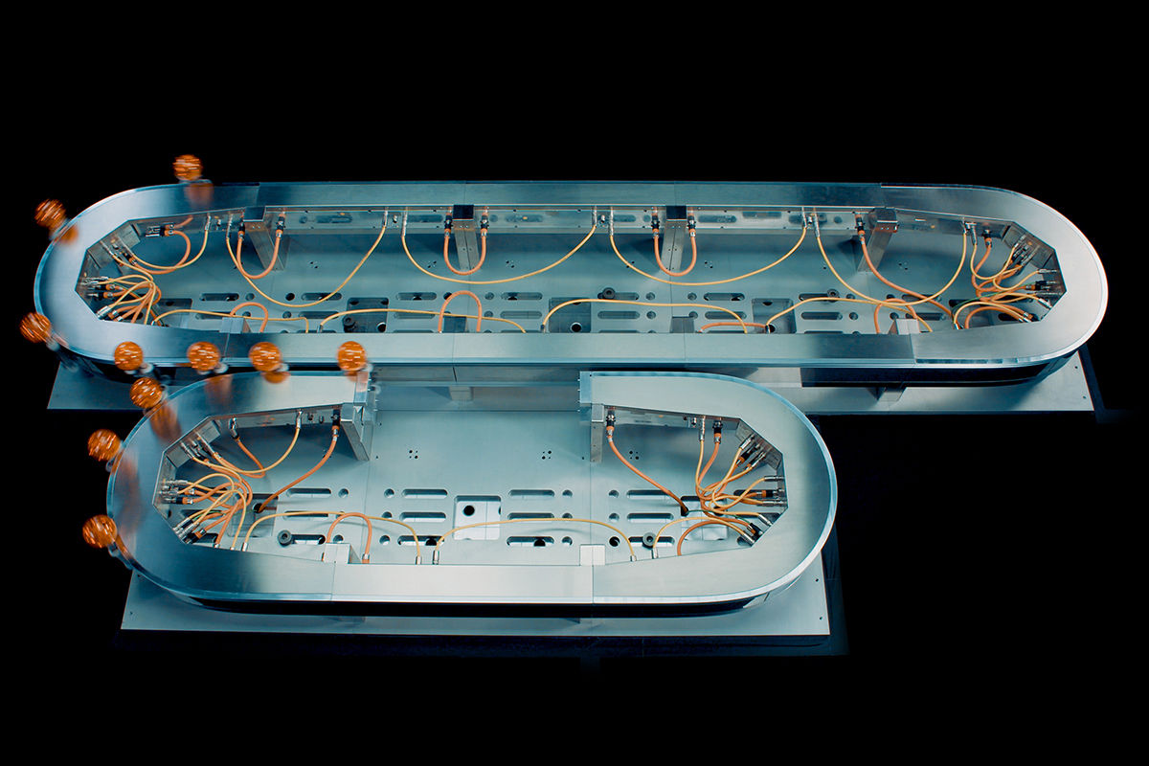
With ACOPOStrak's fully electronic, wear-free diverters, multiple product variants can be produced on the same line and packaged in custom sets with zero downtime for changeover.

About B&R
B&R, a division of ABB Group, is a global leader in industrial automation headquartered in Austria. B&R combines state-of-the-art technology with advanced engineering to provide customers in virtually every industry with complete solutions for machine and factory automation, motion control, HMI and integrated safety technology. With Industrial IoT communication standards including OPC UA, POWERLINK and openSAFETY as well as its Automation Studio software, B&R is constantly redefining the future of automation engineering. The innovative spirit that keeps B&R at the forefront of industrial automation is driven by a commitment to simplifying processes and exceeding customer expectations.
For more information, visit www.br-automation.com.

