Manage hardware configurations with ease
New software component simplifies management of machine variants
Modular applications can now be implemented even more easily. B&R's new software component, mapp IO, makes it possible to add I/O modules at any time. This can happen before a machine is delivered or even at runtime, thereby greatly simplifying the task of managing variants of machinery and equipment.
Configuring variants
With mapp IO, I/O configurations can be generated directly from an ERP or order management system. No engineering tools are required, even if third-party drives or modules are added. Additional variants and options are configured directly on the machine using mapp IO and then programmed using mapp mapp CodeBox. With mapp CodeBox, you can program options in ladder logic without affecting the machine's primary application. The machine can be commissioned without having to modify the original machine software.

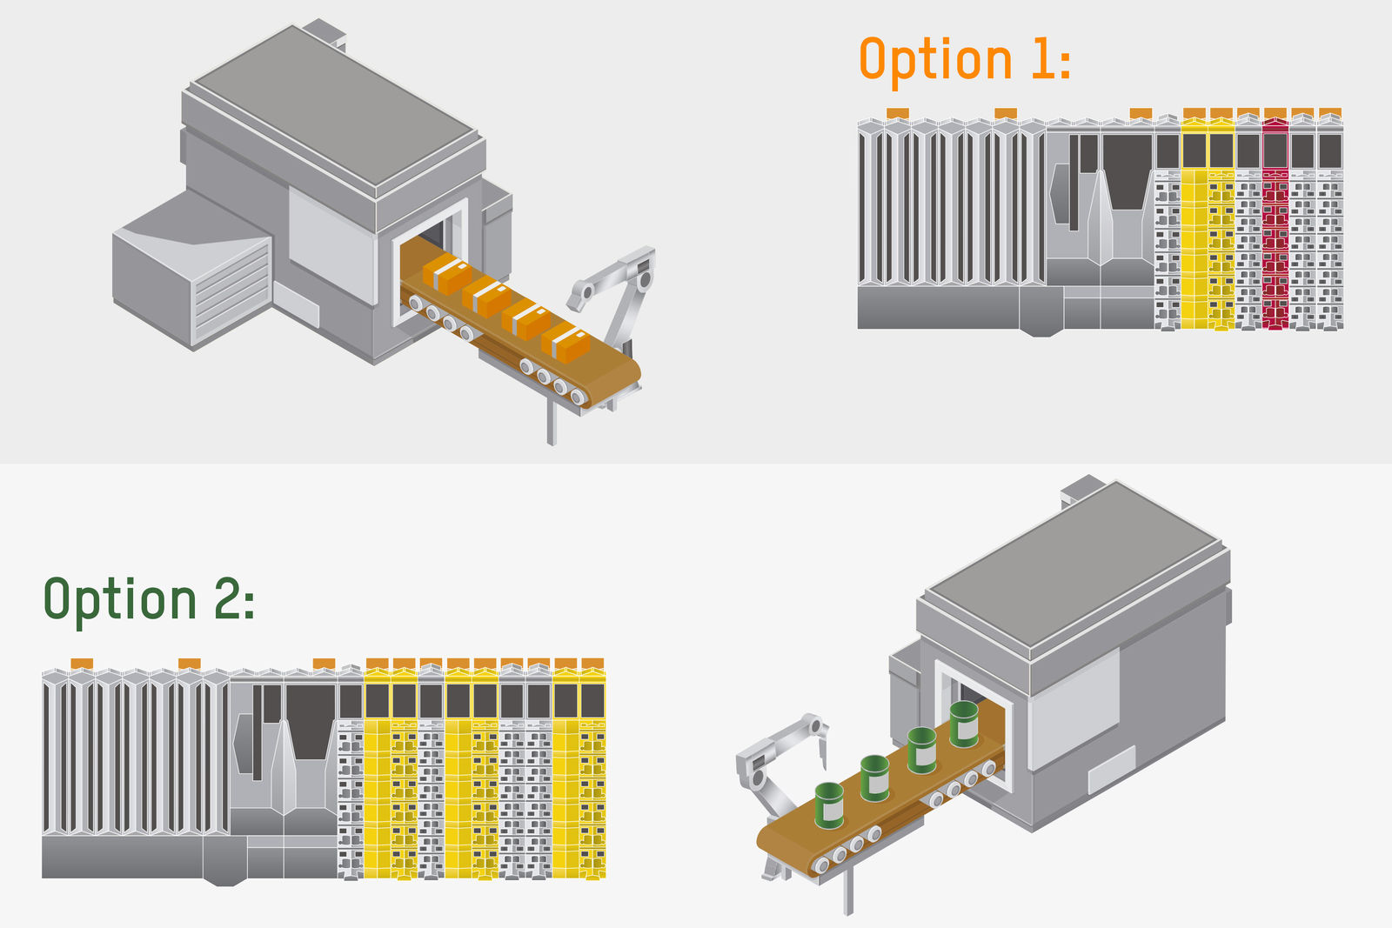
With the new software component mapp IO, B&R's entire hardware portfolio can be added to machinery and equipment at runtime.

About B&R
B&R, a division of ABB Group, is a global leader in industrial automation headquartered in Austria. B&R combines state-of-the-art technology with advanced engineering to provide customers in virtually every industry with complete solutions for machine and factory automation, motion control, HMI and integrated safety technology. With Industrial IoT communication standards including OPC UA, POWERLINK and openSAFETY as well as its Automation Studio software, B&R is constantly redefining the future of automation engineering. The innovative spirit that keeps B&R at the forefront of industrial automation is driven by a commitment to simplifying processes and exceeding customer expectations.
For more information, visit www.br-automation.com.

