More efficiency, more communication
Process and factory automation: APROL R 4.2 offers numerous new software functions
B&R has published a new major release of its APROL process control system. APROL R 4.2 contains numerous new software functions, including improved cloud communication via OPC UA and MQTT. It also offers a modern new "Dark style" interface design option.
APROL R 4.2 includes additional SSL/TLS communication options, as well as numerous new functions for optimizing the efficiency of plants and processes. These include asset performance monitoring, new condition monitoring features, an extensive business intelligence solution and optimized alarm management. B&R has also expanded its advanced process control solution with new features such as a PID tuning block based on the finite frequency method.
At a glance
The new "Dark style" design gives the operator station a clean, modern interface and makes operation easier and more intuitive. It is now also possible to view the overall state of a process in a convenient spider chart. Key process variables are displayed in a pattern that makes the plant operator's job considerably easier.
Redundancy at every level
The full range of redundancy options are now integrated as standard APROL features. This makes high-availability systems an attractive option, even for smaller applications. APROL supports redundancy at every level. Operator bus, process bus, runtime server and controllers can all be laid out redundantly using standard components. No expensive special hardware is required.

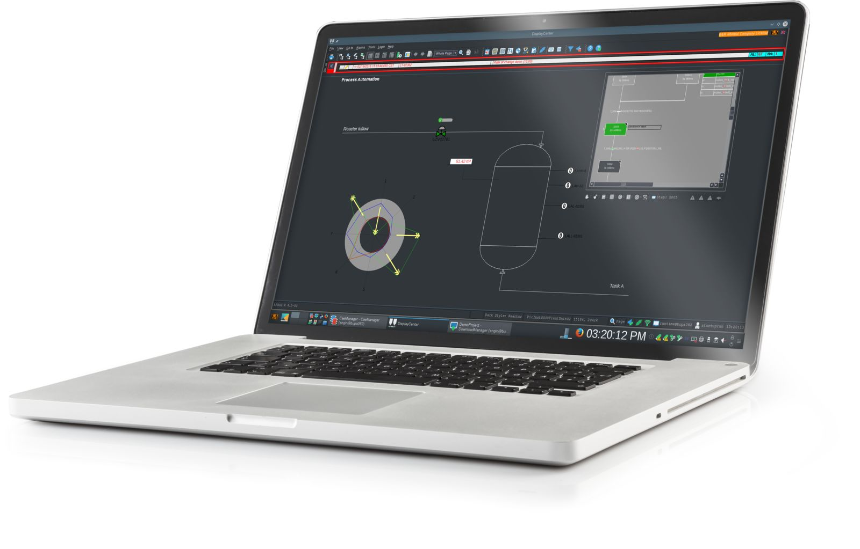
The new "Dark style" interface design and convenient spider chart ensure operators a quick and clear overview of plant status.

About B&R
B&R, a division of ABB Group, is a global leader in industrial automation headquartered in Austria. B&R combines state-of-the-art technology with advanced engineering to provide customers in virtually every industry with complete solutions for machine and factory automation, motion control, HMI and integrated safety technology. With Industrial IoT communication standards including OPC UA, POWERLINK and openSAFETY as well as its Automation Studio software, B&R is constantly redefining the future of automation engineering. The innovative spirit that keeps B&R at the forefront of industrial automation is driven by a commitment to simplifying processes and exceeding customer expectations.
For more information, visit www.br-automation.com.

