EUROMAP interfaces for Industry 4.0
Plastics machines speak OPC UA
The plastics industry is one step closer to a unified standard for communication between extrusion lines and MES systems. In a meeting held at the headquarters of Austrian automation specialist B&R, the EUROMAP 84 working group specified a new set of definitions for communication between extrusion lines and MES systems based on the open OPC UA standard.
Standardized interfaces for efficient networking
As manufacturing machinery and processes grow ever more complex, the limitations of existing hardware interfaces become increasingly evident. The EUROMAP 84 working group is therefore developing new interfaces based on OPC UA. Standardized interfaces are a fundamental requirement for effective and efficient networking of machinery and plants. In the age of Industry 4.0, it is not enough to simply define OPC UA as the transmission technology. It is also necessary to develop information models that define which machine and process data is transferred and which functions are provided.
Key milestone: K 2019
EUROMAP working groups will be presenting numerous new interfaces over the coming year. K 2019 is an important milestone for presenting their first batch of accomplishments. Lead by German manufacturing association VDMA, European plastics industry umbrella organization EUROMAP is currently working on numerous projects. Among them are OPC UA interfaces for exchanging data between injection molding machines and MES systems, between injection molding machines and robots, between injection molding machines and peripherals, and between blow molding machines and MES systems. Under the leadership of its "Plattform Industrie 4.0" initiative, the VDMA is working to develop general definitions for communication interfaces to be applied throughout the machine manufacturing industry.

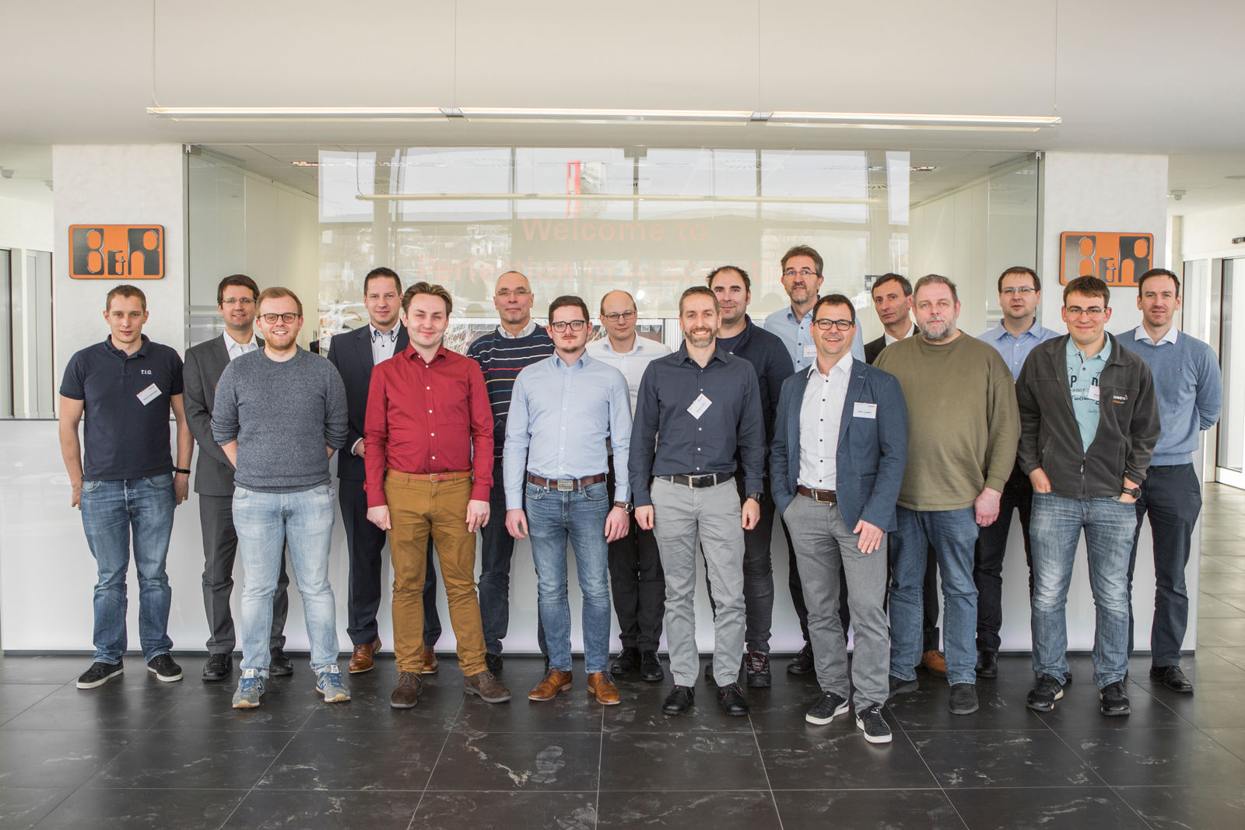
The EUROMAP 84 working group is currently working on a specification for communication between extrusion lines and MES systems based on the open OPC UA standard.

About B&R
B&R, a division of ABB Group, is a global leader in industrial automation headquartered in Austria. B&R combines state-of-the-art technology with advanced engineering to provide customers in virtually every industry with complete solutions for machine and factory automation, motion control, HMI and integrated safety technology. With Industrial IoT communication standards including OPC UA, POWERLINK and openSAFETY as well as its Automation Studio software, B&R is constantly redefining the future of automation engineering. The innovative spirit that keeps B&R at the forefront of industrial automation is driven by a commitment to simplifying processes and exceeding customer expectations.
For more information, visit www.br-automation.com.

