B&R expands Gilgenberg site
Automation specialist invests in production, office space and logistics
B&R is investing in its Gilgenberg site, located a few kilometers from the B&R headquarters in Eggelsberg. The expansion adds new offices, training rooms and production space. A new logistics hall has also been opened at the site.
The aim is to establish Gilgenberg as a competence center for the development and production of electromechanical products. B&R motors are already assembled there. In the future, Gilgenberg will also host development and production of the intelligent ACOPOStrak transport system.
B&R's expansion project in Gilgenberg is in response to increasing demand for production and office space. To keep pace with its steady growth, the company is already planning further investments in infrastructure and production facilities.

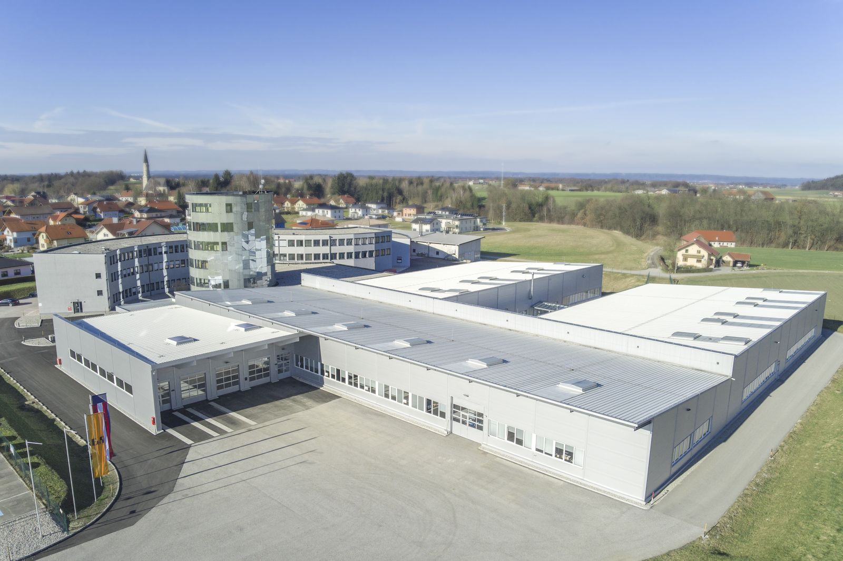
B&R has added new offices, training rooms and production space at its Gilgenberg site.

About B&R
B&R, a division of ABB Group, is a global leader in industrial automation headquartered in Austria. B&R combines state-of-the-art technology with advanced engineering to provide customers in virtually every industry with complete solutions for machine and factory automation, motion control, HMI and integrated safety technology. With Industrial IoT communication standards including OPC UA, POWERLINK and openSAFETY as well as its Automation Studio software, B&R is constantly redefining the future of automation engineering. The innovative spirit that keeps B&R at the forefront of industrial automation is driven by a commitment to simplifying processes and exceeding customer expectations.
For more information, visit www.br-automation.com.

