More performance for compact industrial PC
B&R introduces successor to Automation PC 2100
Automation PC 2200 is the latest generation of B&R's successful 2000 series of compact industrial PCs. Equipped with Intel Atom processors from the Apollo Lake generation, the Automation PC 2200 is available in either box PC or panel PC format.
Despite its compact dimensions, the Automation PC 2200 is a full-fledged PC system. Available with either dual or quad core processors, the Automation PC 2200 offers fully scalable processing power. Thanks to B&R Hypervisor, the Automation Runtime real-time operating system can run simultaneously alongside Windows 10 IoT Enterprise or Linux. The Automation PC 2200 is perfectly suited as an IoT gateway or as a full-fledged edge controller or edge device.
Flexible HMI connection
In its box PC format, the Automation PC 2200 can be equipped with an optional SDL4 interface. This digital transmission technology allows HMI panels to be operated at distances of up to 100 meters.
Totally maintenance-free
All variants of the Automation PC 2200 are free of fans and other rotating parts, making them completely maintenance free. Other standard features include two Gigabit Ethernet interfaces and two USB 3.0 ports. Fieldbus connections like POWERLINK and CAN can be configured individually. Compact CFast cards with up to 256 GB are used for data storage.

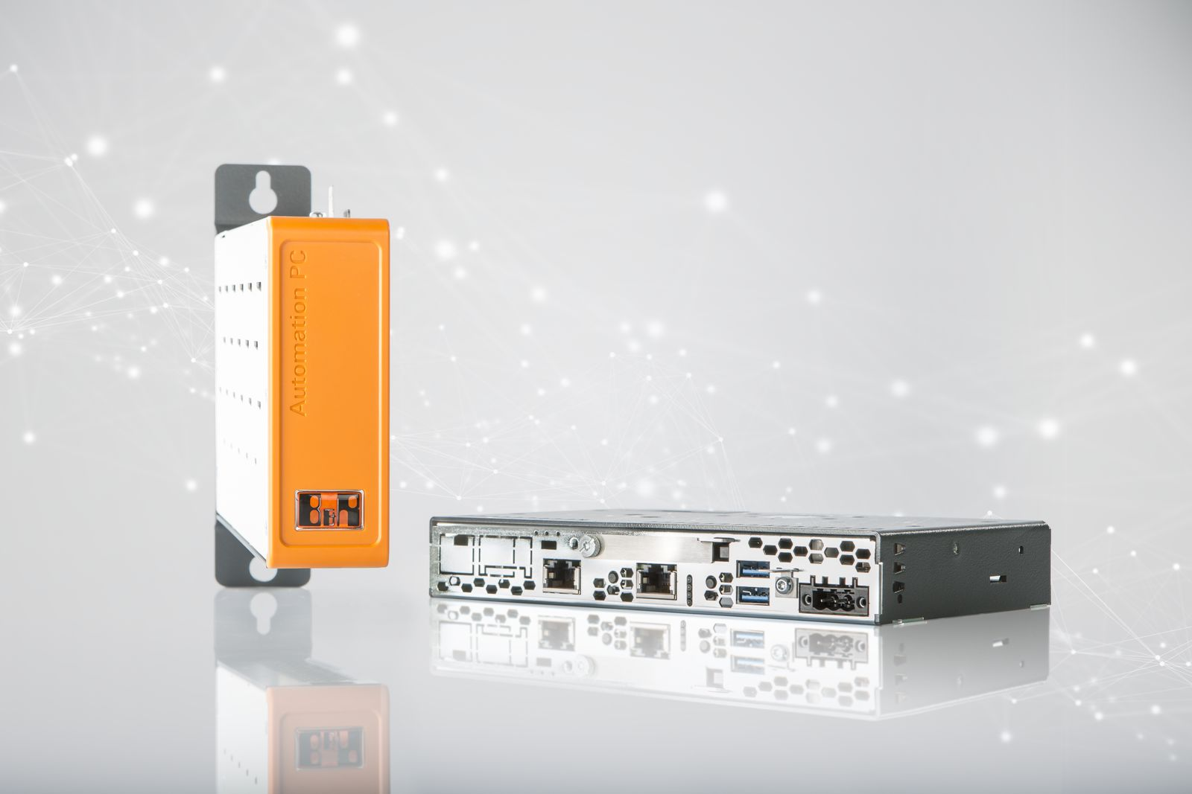
Equipped with Intel Atom processors from the Apollo Lake generation, the Automation PC 2200 is available in either box PC or panel PC format.

About B&R
B&R, a division of ABB Group, is a global leader in industrial automation headquartered in Austria. B&R combines state-of-the-art technology with advanced engineering to provide customers in virtually every industry with complete solutions for machine and factory automation, motion control, HMI and integrated safety technology. With Industrial IoT communication standards including OPC UA, POWERLINK and openSAFETY as well as its Automation Studio software, B&R is constantly redefining the future of automation engineering. The innovative spirit that keeps B&R at the forefront of industrial automation is driven by a commitment to simplifying processes and exceeding customer expectations.
For more information, visit www.br-automation.com.

