Just the right dose of intelligence
This product is not available for sale in the USA until September 2018.
Hybrid transport makes personalized mass production profitable
At the Hannover Messe, B&R showed for the first time how ACOPOStrak can be combined with conventional conveyor belts. This brings the flexibility of the intelligent ACOPOStrak track system together with the low cost of a conveyor system – the perfect recipe for more cost-effective mass customization.
Seamless shuttle hand-off
One intelligent station on the path through the production line is all it takes to create a mass customized product. Product transport is handled almost entirely by low-cost conveyor belts – except for the one station where the products are personalized. That's where the intelligent ACOPOStrak comes into play. Since both systems use the same guide rails, the transitions between them are seamless.
Mass customization for brownfield plants
ACOPOStrak combines the motor and electronics into a single unit with the power electronics and a powerful processor integrated right in the motor housing. No additional inverters or motion control units are required, making the intelligent transport system extremely compact. Thanks to the modular design, it is easy to integrate ACOPOStrak segments of various lengths into an existing plant.

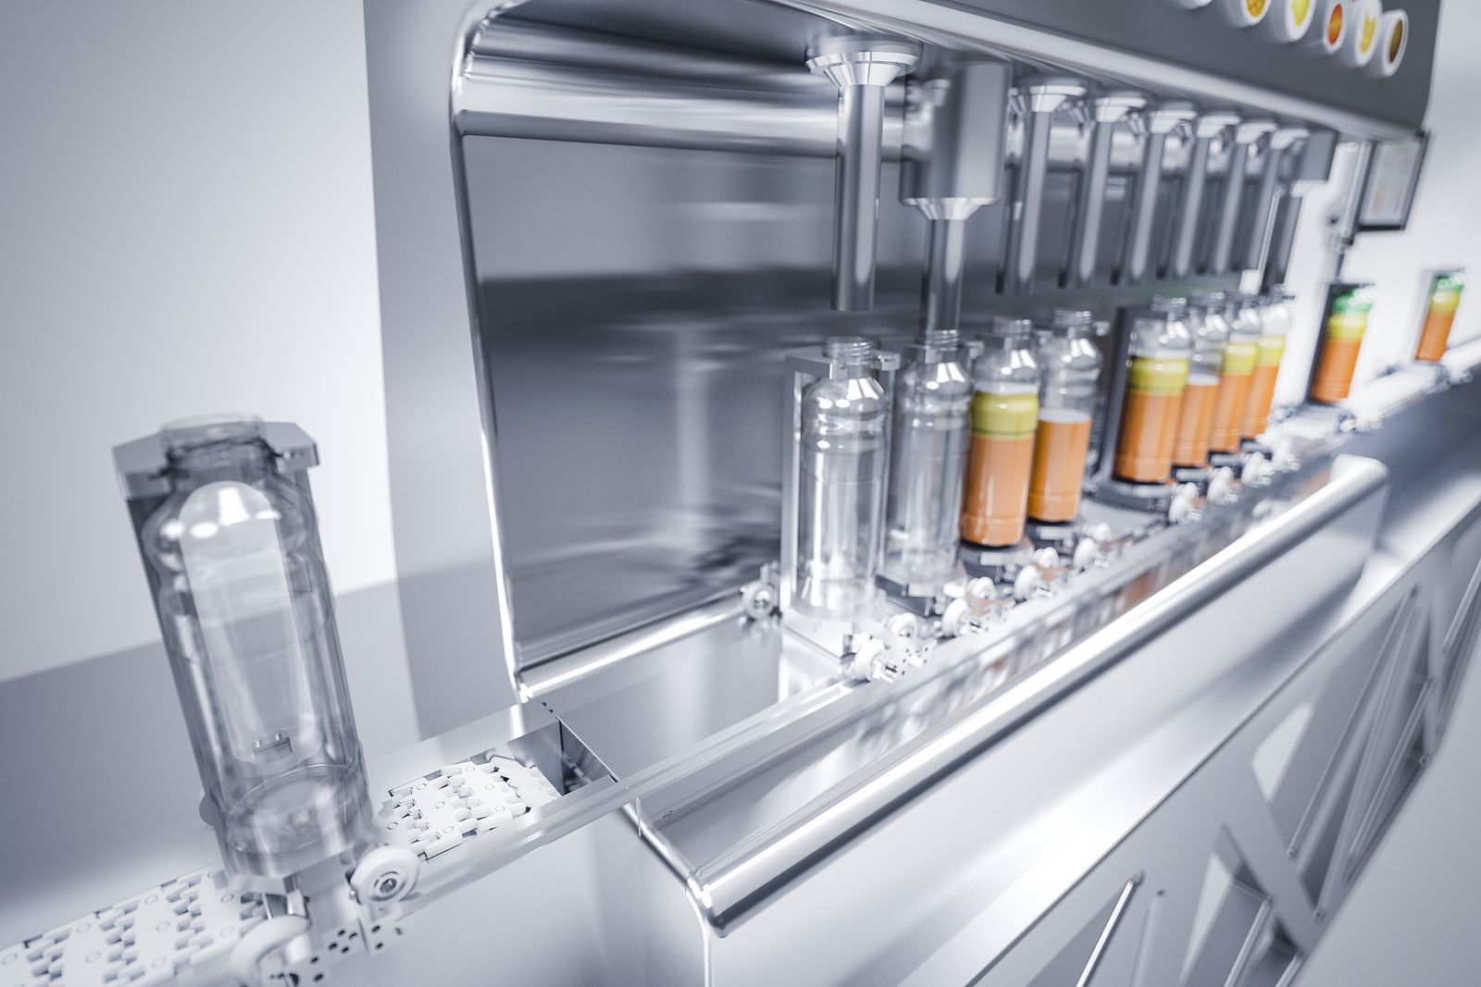
Mass customization done economically: The intelligent ACOPOStrak transport system combines perfectly with conventional conveyors.

About B&R
B&R, a division of ABB Group, is a global leader in industrial automation headquartered in Austria. B&R combines state-of-the-art technology with advanced engineering to provide customers in virtually every industry with complete solutions for machine and factory automation, motion control, HMI and integrated safety technology. With Industrial IoT communication standards including OPC UA, POWERLINK and openSAFETY as well as its Automation Studio software, B&R is constantly redefining the future of automation engineering. The innovative spirit that keeps B&R at the forefront of industrial automation is driven by a commitment to simplifying processes and exceeding customer expectations.
For more information, visit www.br-automation.com.

