Data acquisition, evaluation and transmission to the cloud
B&R presents powerful Edge Controller at Hannover Messe
A single device to acquire data, evaluate it and send it to the cloud – that's now possible with B&R's Edge Controller. The powerful industrial PC can even be used for big data analysis and machine learning, while at the same time serving as a full-fledged industrial controller.
B&R's Edge Controller is based on the robust Automation PC 910, whose high-performance variant is equipped with an Intel XEON processor able to handle resource-intensive tasks like machine learning. The Edge Controller runs a hardened operating system – a commercial Linux variant with guaranteed long-term support. Cloud transmission occurs via MQTT.
Full-fledged industry controller
B&R Hypervisor makes it possible to simultaneously run a real-time operating system on the Edge Controller. That turns the edge device into a full-fledged industrial controller with cycle times in the sub-millisecond range. An unlimited number of I/O modules or controllers can be connected via the POWERLINK Industrial Ethernet protocol, OPC UA or other fieldbus systems. With the Edge Controller, this will soon also be possible with OPC UA TSN.

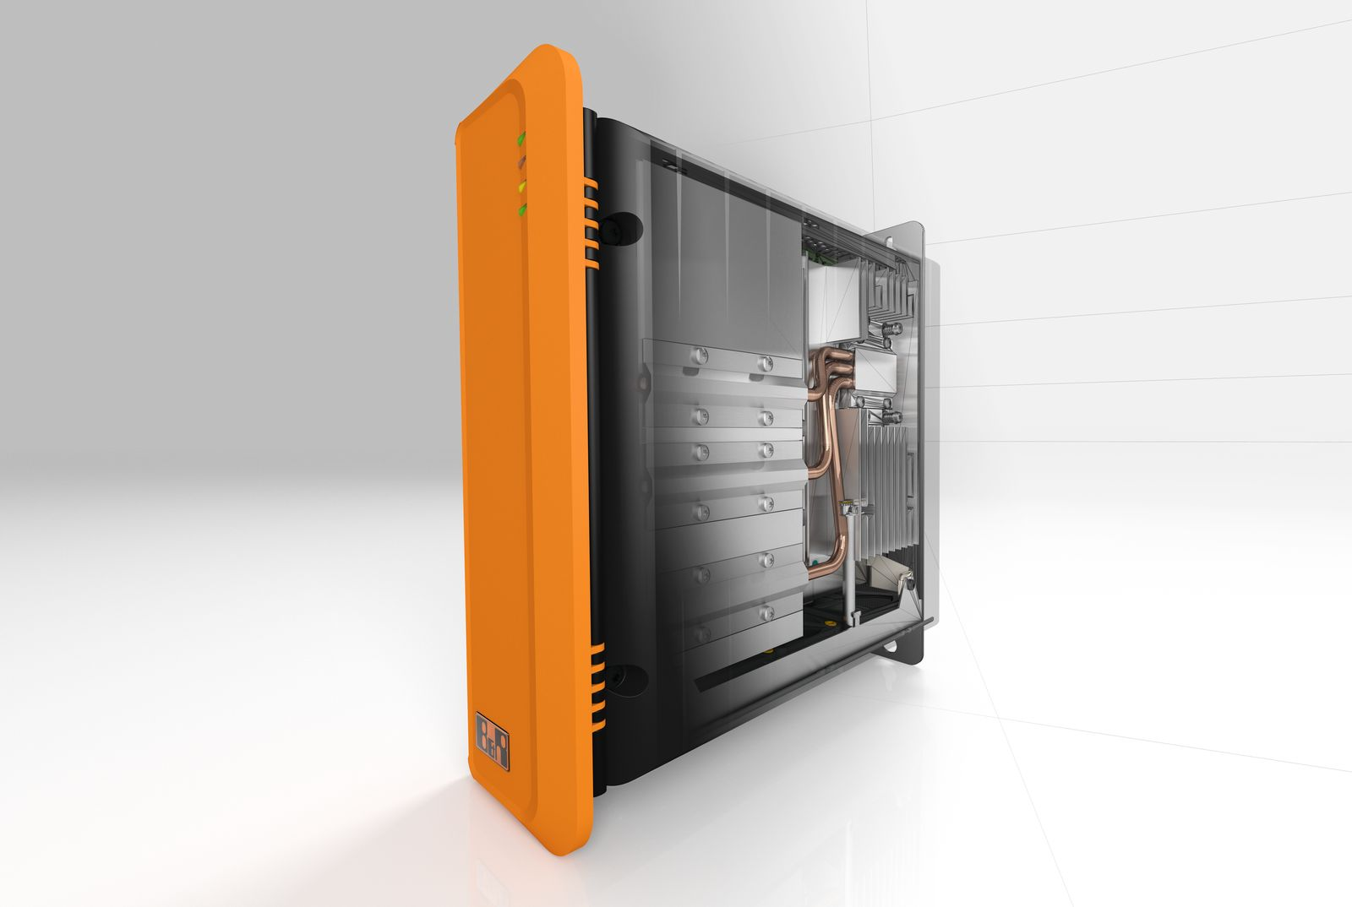
The Edge Controller makes it possible to acquire data, evaluate it and then send it to the cloud.

About B&R
B&R, a division of ABB Group, is a global leader in industrial automation headquartered in Austria. B&R combines state-of-the-art technology with advanced engineering to provide customers in virtually every industry with complete solutions for machine and factory automation, motion control, HMI and integrated safety technology. With Industrial IoT communication standards including OPC UA, POWERLINK and openSAFETY as well as its Automation Studio software, B&R is constantly redefining the future of automation engineering. The innovative spirit that keeps B&R at the forefront of industrial automation is driven by a commitment to simplifying processes and exceeding customer expectations.
For more information, visit www.br-automation.com.

