More functions for the process control industry
B&R presents APROL R4.2 at ACHEMA in Frankfurt
B&R presents version R4.2 of its APROL process control system at ACHEMA. Other highlights at Booth A63 in Hall 11.1 include an Edge Controller for cloud communication and the intelligent transport system ACOPOStrak.
APROL R4.2 offers numerous new software functions, including improved cloud communication via OPC UA and MQTT. It also brings new options for optimizing the efficiency of plants and processes, such as asset performance monitoring, additional condition monitoring options, a control performance monitor, an integrated business intelligence solution and optimized alarm management.
Edge Controller
The B&R Edge Controller makes it possible to acquire data, evaluate it and then send it to the cloud. The powerful industrial PC can even be used for big data analysis and machine learning, while at the same time serving as a full-fledged industrial controller.
B&R is also taking the opportunity at ACHEMA to show how the intelligent ACOPOStrak transport system enables economic mass customization down to batches of one. The system's fully electronic diverters divide and merge product flows at full speed.

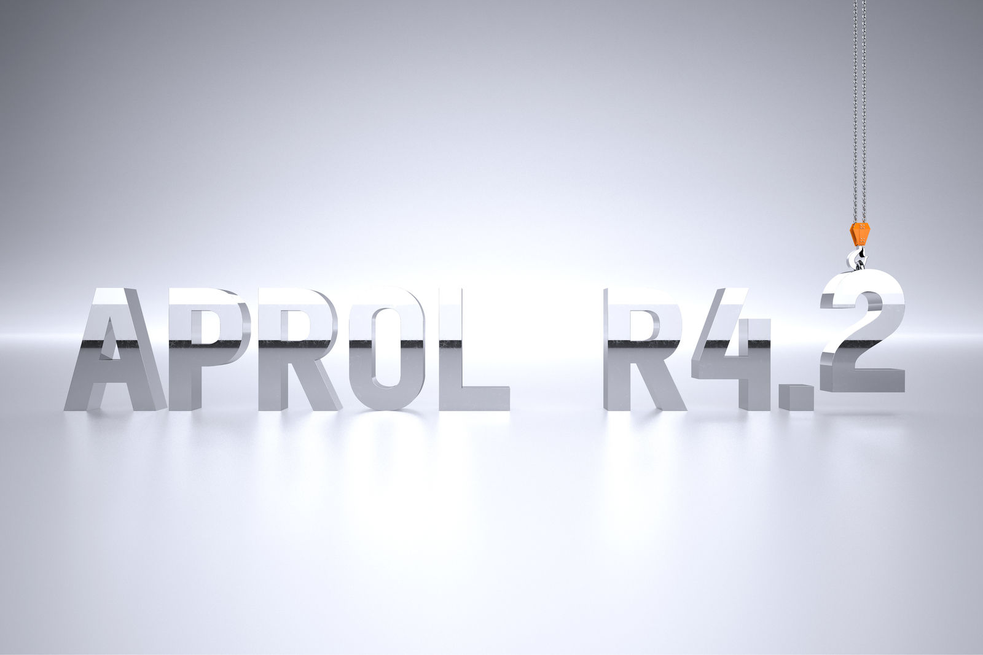
APROL R4.2 offers numerous new software functions, including improved cloud communication via OPC UA and MQTT as well as new options for optimizing the efficiency of plants and processes.

About B&R
B&R, a division of ABB Group, is a global leader in industrial automation headquartered in Austria. B&R combines state-of-the-art technology with advanced engineering to provide customers in virtually every industry with complete solutions for machine and factory automation, motion control, HMI and integrated safety technology. With Industrial IoT communication standards including OPC UA, POWERLINK and openSAFETY as well as its Automation Studio software, B&R is constantly redefining the future of automation engineering. The innovative spirit that keeps B&R at the forefront of industrial automation is driven by a commitment to simplifying processes and exceeding customer expectations.
For more information, visit www.br-automation.com.

