ABB invests €100 million in global innovation and training campus
ABB makes largest organic investment in industrial automation at home of B&R in Austria
• €100 million investment shapes ABB’s leadership position in machine and factory automation
• Investment in the development of the factory of the future to create 1,000 new jobs
• State-of-the-art innovation and training campus to be built in Eggelsberg, Austria, by 2020
• ABB builds on the B&R success story on the first anniversary of the acquisition announcement
One year after announcing its acquisition of B&R (Bernecker + Rainer Industrie-Elektronik GmbH), ABB is to invest €100 million in Austria to build a state-of-the-art innovation and training campus at the home of B&R in Eggelsberg, Upper Austria. It is the largest organic investment in industrial automation in ABB’s more than 130-year history and lays the foundation for around 1,000 new high-tech jobs in Austria.
The new innovation and training campus will develop technologies for the factory of the future, based on ABB AbilityTM, in which production will be undertaken autonomously by smart and cloud-connected machines and robots. With this investment, ABB is delivering on its Next Level strategy, which defines innovation as a key driver of profitable growth. The company invests $1.4 billion in R&D annually, and has a team of around 30,000 R&D and application engineers. B&R has more than 1,000 employees working in R&D and application development.
The new 35,000-square-meter research and development center will be home to a variety of cutting-edge facilities. In addition to state-of-the-art laboratories for development and testing of new automation technology – from industrial controllers to machine learning and artificial intelligence – the site will also house an "Automation Academy", where customers, partners and employees will be trained in the application of these technologies. Ground will be broken this summer, and operation will commence in 2020. Upon completion, Eggelsberg will count among the largest R&D hubs operated by ABB.
With the new campus, the world’s second-largest provider of industrial automation solutions will further expand its leadership position in machine and factory automation. The development of disruptive technologies will enable ABB to better serve the highly attractive $20-billion machine and factory automation market segment.
ABB acquired B&R, then the largest independent provider of product- and software-based open-architecture solutions for machine and factory automation worldwide, in July 2017. Today, B&R is integrated into ABB’s Industrial Automation division as its global Machine & Factory Automation business unit. With the combined portfolios, ABB is today the only industrial automation provider offering customers the entire spectrum of technology and software solutions around measurement, control, actuation, robotics, electrification and digitalization.
"B&R is off to an exceptional start under the umbrella of ABB and is exceeding our expectations We're on pace to achieve our sales target of $1 billion very soon," said ABB CEO Ulrich Spiesshofer at a press conference held with the Austrian Chancellor in Linz. "Our €100-million investment will further catalyze this growth and strengthen the cornerstones of B&R's success story: its innovations and its employees. In addition to the new R&D center, we are also expanding the B&R Automation Academy, which offers an exceptional educational and training curriculum for customers, partners and employees from all around the world."
"With a definitive display of commitment to the location, ABB has established itself as Austria's market leader in automation," said Austrian Chancellor Sebastian Kurz. "The group's investment is of particular significance for Austria's regional policy and international positioning. It signals the beginning of a broader, concerted effort to place us at the forefront in the key economic segment of digital industry. It will play a significant role in creating highly qualified new jobs and establishing Austria as a hub for high-tech industry."
This will also be beneficial for the country`s educational landscape. „Further strengthening our good relationships with universities, universities of Applied Sciences and higher technical education institutes is part of our innovation and research strategy. This way we can further accelerate our speed of growth and innovation as well as extend our technology leadership,” said Hans Wimmer, Managing Director of B&R.
“This is a great day for B&R,” said Josef Rainer, Co-founder of Bernecker & Rainer Industrie-Elektronik GmbH. “The smooth integration shows that the company Erwin Bernecker and I founded 39 years ago is in excellent hands. I am delighted that ABB continues to write and accelerate our success story with this historic investment.”

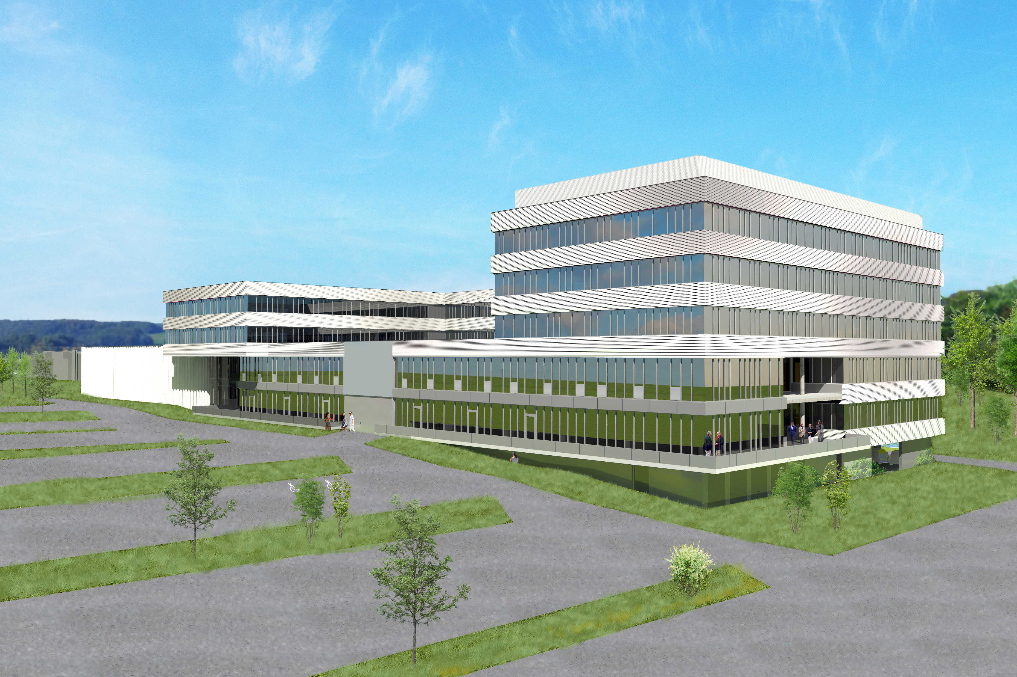

About B&R
B&R, a division of ABB Group, is a global leader in industrial automation headquartered in Austria. B&R combines state-of-the-art technology with advanced engineering to provide customers in virtually every industry with complete solutions for machine and factory automation, motion control, HMI and integrated safety technology. With Industrial IoT communication standards including OPC UA, POWERLINK and openSAFETY as well as its Automation Studio software, B&R is constantly redefining the future of automation engineering. The innovative spirit that keeps B&R at the forefront of industrial automation is driven by a commitment to simplifying processes and exceeding customer expectations.
For more information, visit www.br-automation.com.

