B&R India has a dedicated customer support hotline
A dedicated hotline ensures high-quality support and accelerated response times
B&R India has World Class Support – a dedicated support hotline that serves as a single point of contact for its customers nationwide. Customers served by B&R India headquarters in Pune and its six branch offices have a single number to call, ensuring that they receive a consistently high level of support with the fastest possible response times. "We are proud of the best-in-class service and support we offer our customers," says Jhankar Dutta, Managing Director of B&R India. "Our World-Class Support hotline further enhances our customers' experience, in turn enabling them to offer their customers faster service and reduced machine downtime."
Just a call away
B&R's online Support Portal allows customers worldwide to create and track support requests and share support documentation via the B&R website. With the new hotline, customers of B&R India also benefit from streamlined telephone support from a local team of experts. "Our highly qualified support team is committed to our customers' success and has the expertise it takes to help them gain a competitive edge in their market," says Ravishankar Gawhade, head of national support, B&R India.
The number for the World Class Support hotline is +91 83 80 800 008.

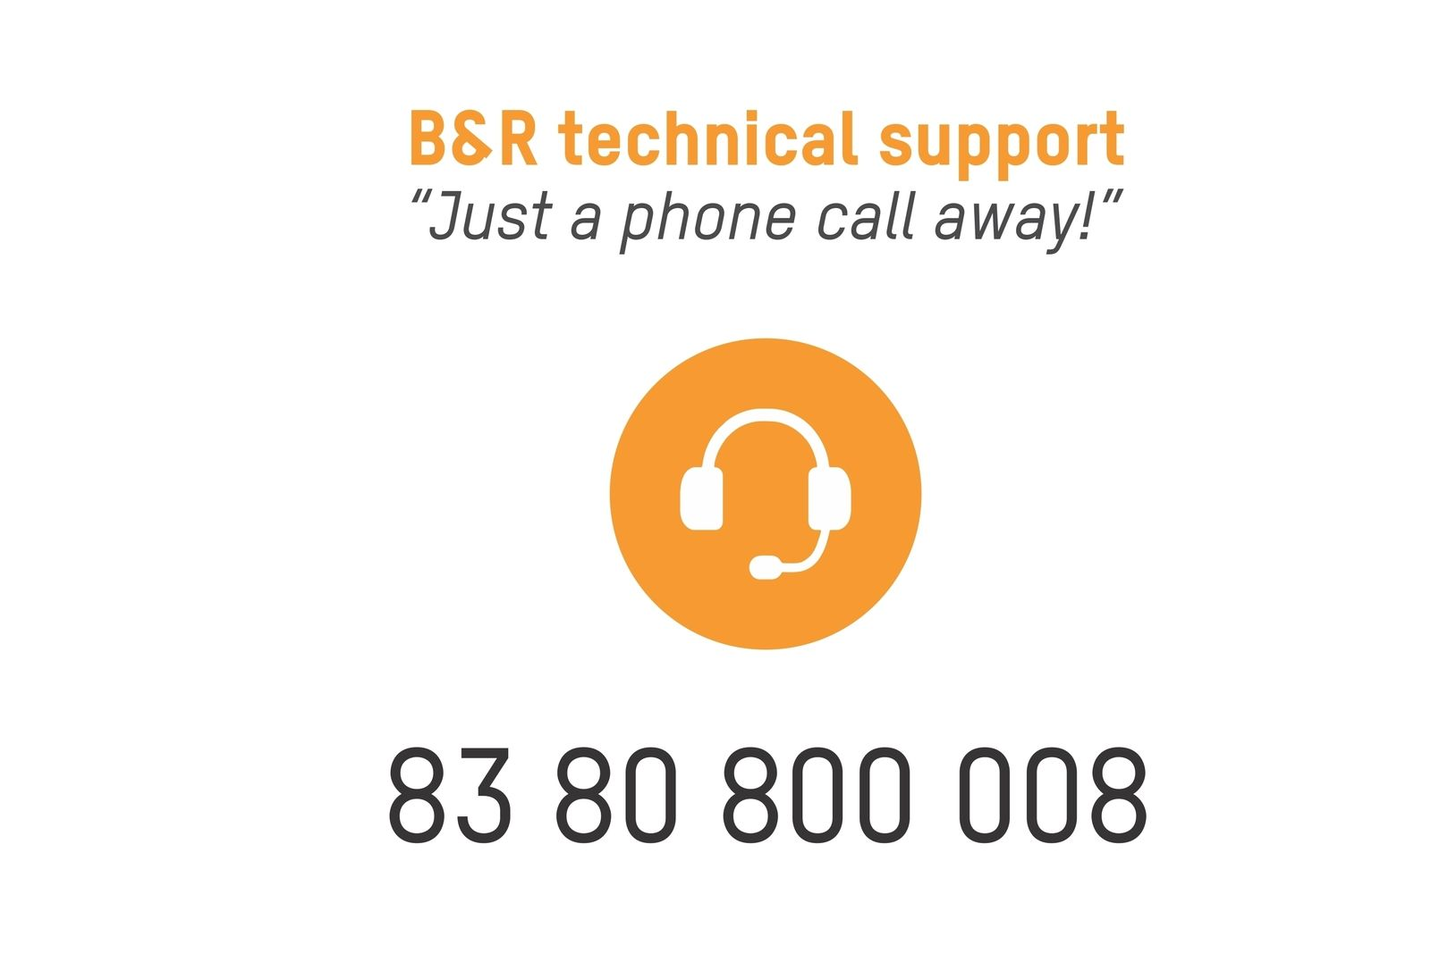
World-Class Support hotline to enhance customer experience

About B&R
B&R, a division of ABB Group, is a global leader in industrial automation headquartered in Austria. B&R combines state-of-the-art technology with advanced engineering to provide customers in virtually every industry with complete solutions for machine and factory automation, motion control, HMI and integrated safety technology. With Industrial IoT communication standards including OPC UA, POWERLINK and openSAFETY as well as its Automation Studio software, B&R is constantly redefining the future of automation engineering. The innovative spirit that keeps B&R at the forefront of industrial automation is driven by a commitment to simplifying processes and exceeding customer expectations.
For more information, visit www.br-automation.com.

