B&R joins Huawei's OPC UA TSN testbed
Practical testing for seamless smart factory communication
B&R has joined the OPC-UA-TSN testbed of Chinese network equipment vendor Huawei. The Austrian automation specialist is now participating in all three of the world's most significant platforms for practical testing of the new communication technology. The two other testbeds are those organized by the Industrial Internet Consortium (IIC) in the USA and Labs Network Industrie 4.0 (LNI) in Europe.
"Huawei's testbed gives us the opportunity to advance the standardization of OPC UA TSN in Asia," explained B&R Marketing Manager Stefan Schönegger during the presentation of the testbed at the Hannover Messe. "In doing so, we're making another important contribution toward globally harmonized industrial communication."
From the sensor to the cloud
Huawei's testbed will feature an OPC UA TSN network simulating all aspects of smart factory communication – from individual sensors to the ERP system and on into the cloud. Data will be transmitted exclusively via OPC UA TSN – regardless of whether it is real-time motion control data or aggregated performance metrics for executive management. There is no need for communication interfaces of any kind.

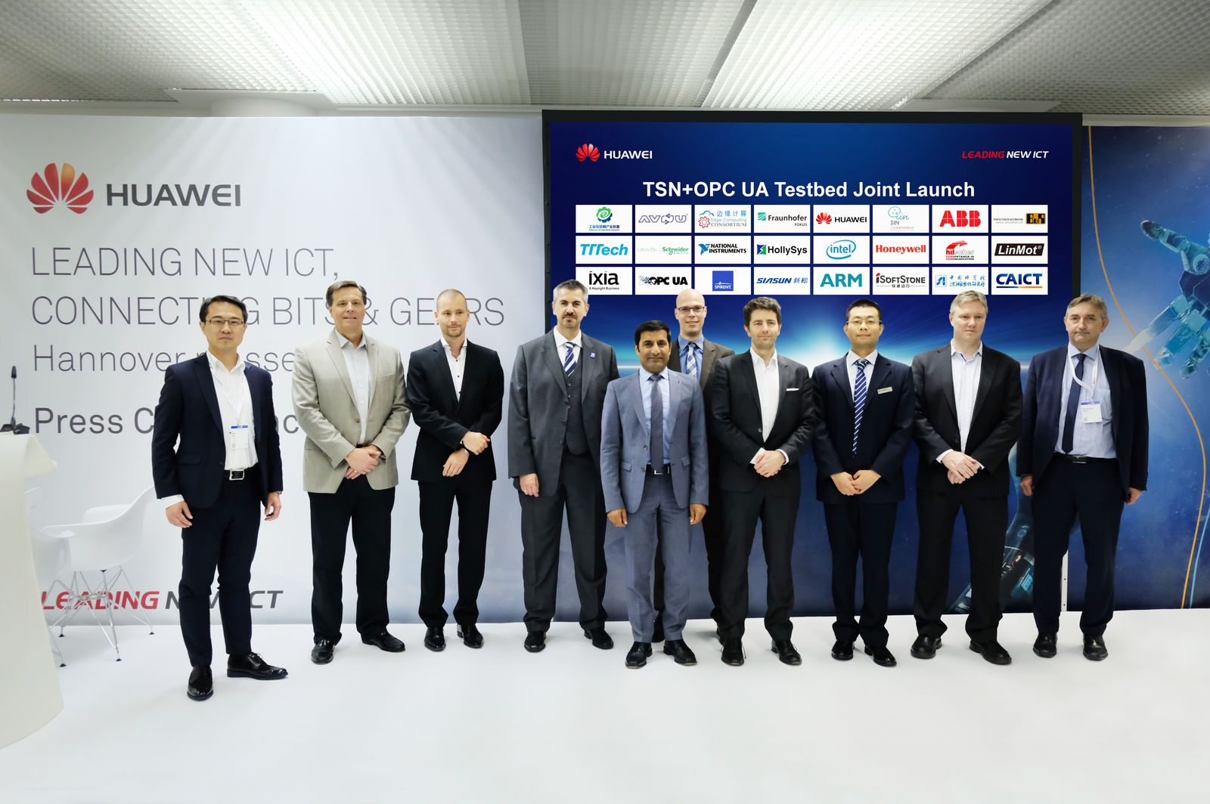
The new OPC UA TSN testbed was introduced at the Hannover Messe. Source: Huawei

About B&R
B&R, a division of ABB Group, is a global leader in industrial automation headquartered in Austria. B&R combines state-of-the-art technology with advanced engineering to provide customers in virtually every industry with complete solutions for machine and factory automation, motion control, HMI and integrated safety technology. With Industrial IoT communication standards including OPC UA, POWERLINK and openSAFETY as well as its Automation Studio software, B&R is constantly redefining the future of automation engineering. The innovative spirit that keeps B&R at the forefront of industrial automation is driven by a commitment to simplifying processes and exceeding customer expectations.
For more information, visit www.br-automation.com.

