Collect and present machine data
mapp component automatically generates PDF reports
The mapp Report software component can be used to automatically generate PDF reports based on any machine data. The data, layout and design of the reports can be customized. The user can freely define the language and units used.
mapp Report collects all statistical machine data as well as information from other mapp components and presents it in the form of PDF reports. The content and layout can be customized as desired.
For all audiences
The design options offered by mapp Report make it possible to customize reports for the needs different users, such as service technicians and management. Graphical elements such as images and tables can also be included in the reports. To protect against unauthorized access, it is possible to encrypt the files with a password.
Send reports automatically
The reports can be sent automatically via e-mail at a defined time or triggered by a specific event. In addition, reports can be saved to external storage media such as a USB flash drive or sent directly from the machine to network printers.

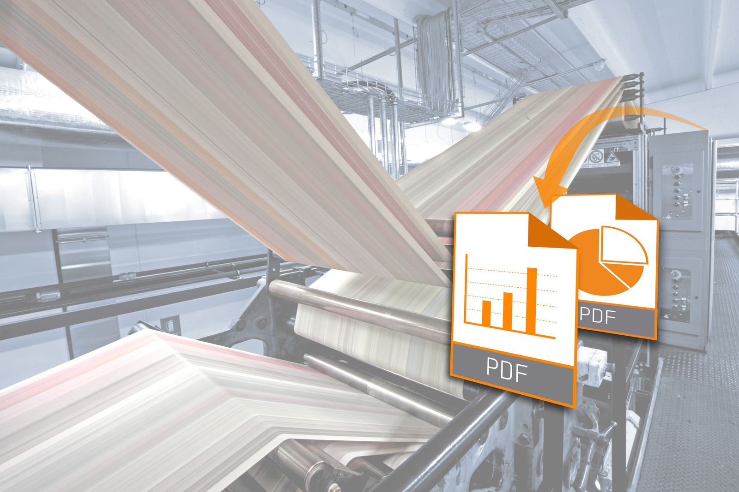
The mapp Report software component can be used to automatically generate PDF reports based on any machine data.

About B&R
B&R, a division of ABB Group, is a global leader in industrial automation headquartered in Austria. B&R combines state-of-the-art technology with advanced engineering to provide customers in virtually every industry with complete solutions for machine and factory automation, motion control, HMI and integrated safety technology. With Industrial IoT communication standards including OPC UA, POWERLINK and openSAFETY as well as its Automation Studio software, B&R is constantly redefining the future of automation engineering. The innovative spirit that keeps B&R at the forefront of industrial automation is driven by a commitment to simplifying processes and exceeding customer expectations.
For more information, visit www.br-automation.com.

