Clear display of online parameters
Convenient online parameter management for process control technology
The new version R4.2 of the APROL automation platform provides a powerful and convenient system for managing online parameters. APROL DisplayCenter displays a clear overview of online parameters and facilitates the commissioning of measurement and control loops. Online parameters can be dragged and dropped to other systems.

Different views allow a clear display and uncomplicated modification of the online parameters. The faceplate view offers a well-structured user interface. The system logic is displayed in the control module view. Parameters can be entered and control modules can be enabled in the list view. Depending on the requirements, the appropriate view can be selected or you can switch between the views.
Transfer parameters
The new operating dialog boxes not only provide a better overview of the parameters, but also allow existing online parameters to be transferred to other measuring points. To ensure seamless traceability, when online parameters are fed back into the APROL project engineering tool CaeManager, a new version is created automatically with a corresponding comment.

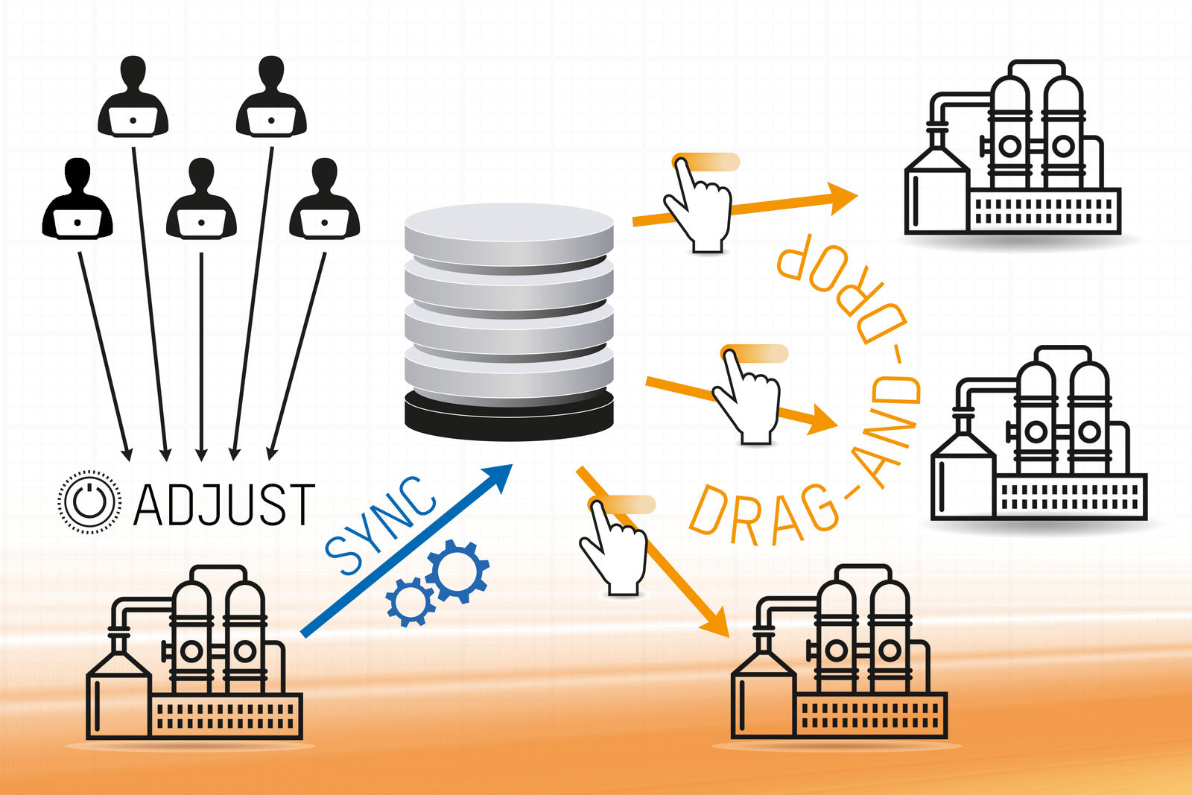
Get a clear overview of online parameters and apply them to other systems via drag-and-drop.

About B&R
B&R, a division of ABB Group, is a global leader in industrial automation headquartered in Austria. B&R combines state-of-the-art technology with advanced engineering to provide customers in virtually every industry with complete solutions for machine and factory automation, motion control, HMI and integrated safety technology. With Industrial IoT communication standards including OPC UA, POWERLINK and openSAFETY as well as its Automation Studio software, B&R is constantly redefining the future of automation engineering. The innovative spirit that keeps B&R at the forefront of industrial automation is driven by a commitment to simplifying processes and exceeding customer expectations.
For more information, visit www.br-automation.com.

