B&R at Automation Expo 2018 | Mumbai, Aug 29 - Sep 01
Industrial IoT becomes reality with Edge Architectures
B&R will be presenting its comprehensive Edge architectures and the next-generation industrial transport system at Automation Expo 2018 in Hall 1 stall S1 from 29 August to 1 September 2018. Edge architectures from the automation specialist makes it simple to shape a complete Industrial IoT solution into machines and factories with both flexibility and intelligence.
Connected factories generates and analyses enormous amount of data boosting performance of machines as well as insight of the overall equipment effectiveness (OEE). With Edge architectures from B&R, machine data from its source is seamlessly transferred to the cloud safely and securely. Being based on open connectivity standards, edge architectures are cloud agnostic. Visit the B&R stall to witness deployment of various open source connectivity solutions such as OPC UA, MQTT, POWERLINK and openSAFETY for securely transferring data from field to the cloud.
Enabling operational excellence
B&R brings out the revolution in product transport for adaptive manufacturing live at its booth. The visitors will experience B&R’s flexible transport system designed to deliver ultimate production effectiveness – from mass production down to batches of one. The system will be able to merge with full production speed using its electromagnetic diverters, ensuring unmatched dimensions of flexibility and usability.
In addition, discover more solutions from B&R for building smart machines & factories exclusively at Hall 2 in the Industry 4.0 zone at Automation Expo 2018.

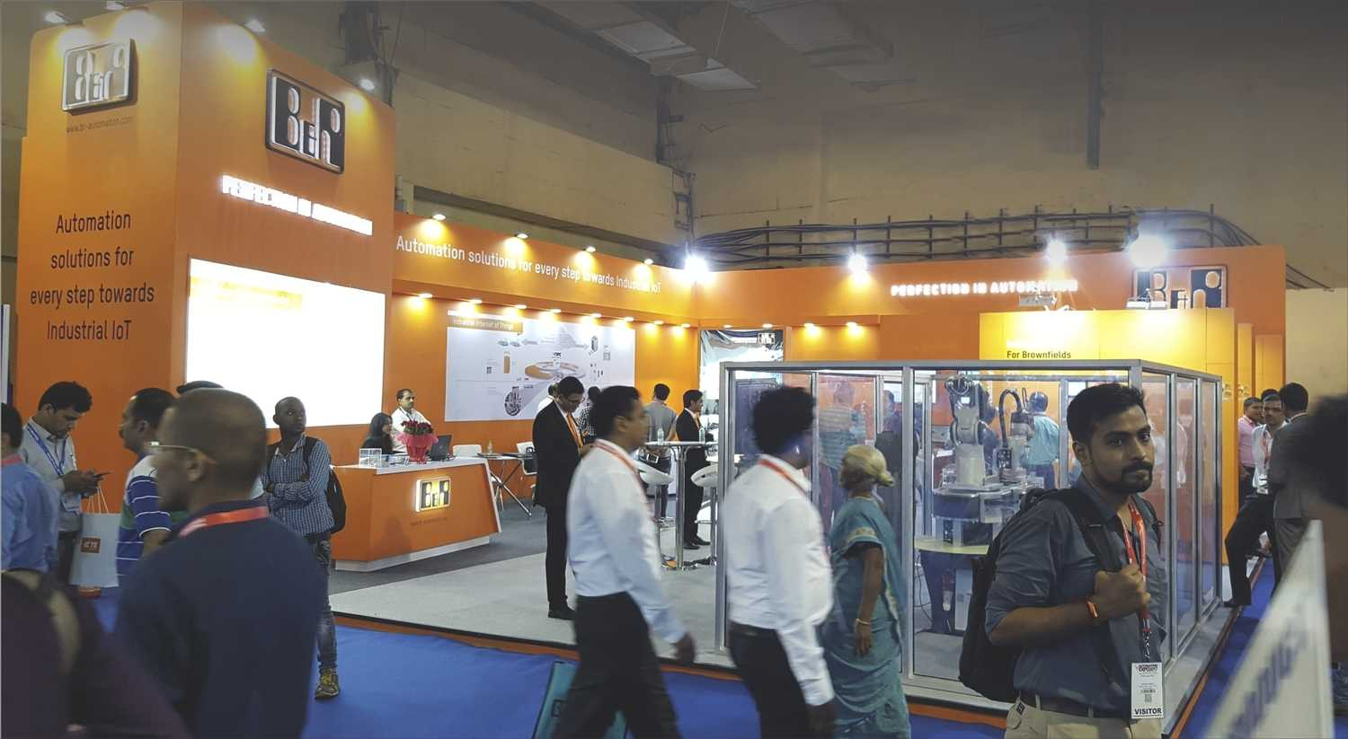
At the exhibition, B&R will be presenting complete Industrial IoT solutions along with edge architecture making your machines and factories smart.

About B&R
B&R, a division of ABB Group, is a global leader in industrial automation headquartered in Austria. B&R combines state-of-the-art technology with advanced engineering to provide customers in virtually every industry with complete solutions for machine and factory automation, motion control, HMI and integrated safety technology. With Industrial IoT communication standards including OPC UA, POWERLINK and openSAFETY as well as its Automation Studio software, B&R is constantly redefining the future of automation engineering. The innovative spirit that keeps B&R at the forefront of industrial automation is driven by a commitment to simplifying processes and exceeding customer expectations.
For more information, visit www.br-automation.com.

