20 years of growth and innovation with customers
B&R India oraganizes CEO Summit 2018
To mark a glorious milestone of 20 years in India, B&R Industrial Automation, recently organised ‘CEO summit 2018’, which bought together CEOs from leading companies in machine building for an evening of business presentations, talk from renowned leadership speaker and candid conversations. This summit focused on taking advantage of the expertise of its attendees with opportunities for participants to share their knowledge and learn from each other.
Joining hands for a successful tomorrow
B&R management from Austria and India shared their perspectives on industry trends, business growth with delegates. Peter Gucher, Chairman B&R India and Member of Management, B&R Austria set the tone of the event and thanked customers and partners for being part of 20 years journey of B&R India. He focused on the importance of long-term strong and solid partnership with customers. Commenting on ABB- B&R synergy he stated, “B&R has closed the historic gap within ABB’s automation offering. This is a perfect fit and will make ABB Group the only industrial automation provider offering customers the entire spectrum of technology and industrial automation solutions.”
Speaking on the occasion, Jhankar Dutta, Managing Director, B&R India spoke at length on B&Rs focus on innovation, partnerships and collaboration enabling customers to join hands for a successful tomorrow. He mentioned, “Since last 20 years, many machine builders have placed their trust in B&R’s world class products and technologies. We are in pole position today to get the maximum benefit out of technology evolutions and adoption, which are supported by policies of Indian government. We aim at doubling business in coming three years.”
Innovations : Making the difference
Delegates gained an inspiration for personal and business growth with insights from renowned speaker R. Gopalkrishnan, who is a senior corporate leader and an author of several books. He has led businesses at Hindustan Unilever Limited; and is a former Executive Director, Tata Sons. By giving examples of teashops, blue jays and colloidal science, he distinguished between fulfilment and success.
The summit also witnessed the launch of the 3rd edition of “automotion INDIA”, a B&R technology magazine, comprising of customer success stories from various industries as plastics, automotive, printing, packaging and pharmaceuticals. The launch took place at the hands of B&R management and customers who contributed towards the articles published in the magazine.
Conference concluded with two pleasant entertainment acts specially organised for delegates. Artist portrayed B&R’s 20 years journey of growth and success through sand and UV light art. He highlighted B&R’s strength in terms of company’s global presence, world-class integrated manufacturing facility, high tech products, long term partnerships, and up to date technology which helps Indian manufacturers to gain a competitive advantage in global market.

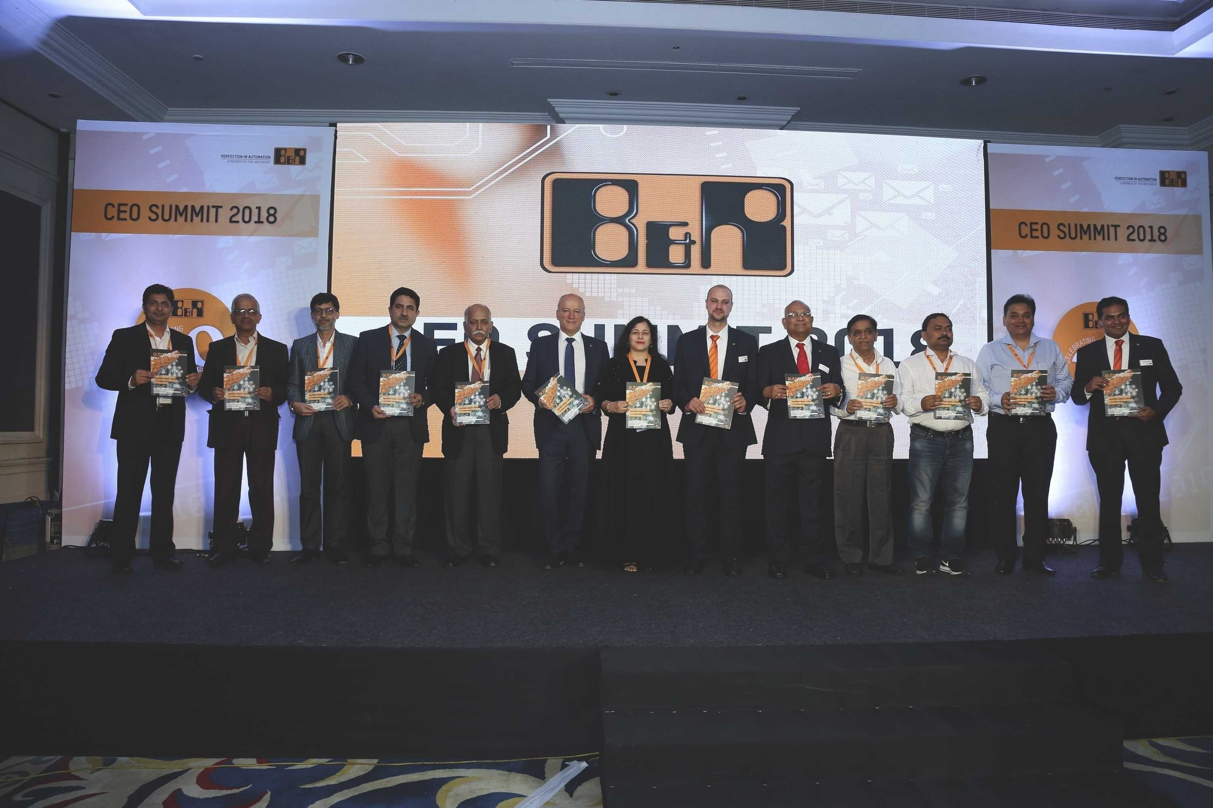
automotion INDIA 3rd edition launched at CEO Summit 2018
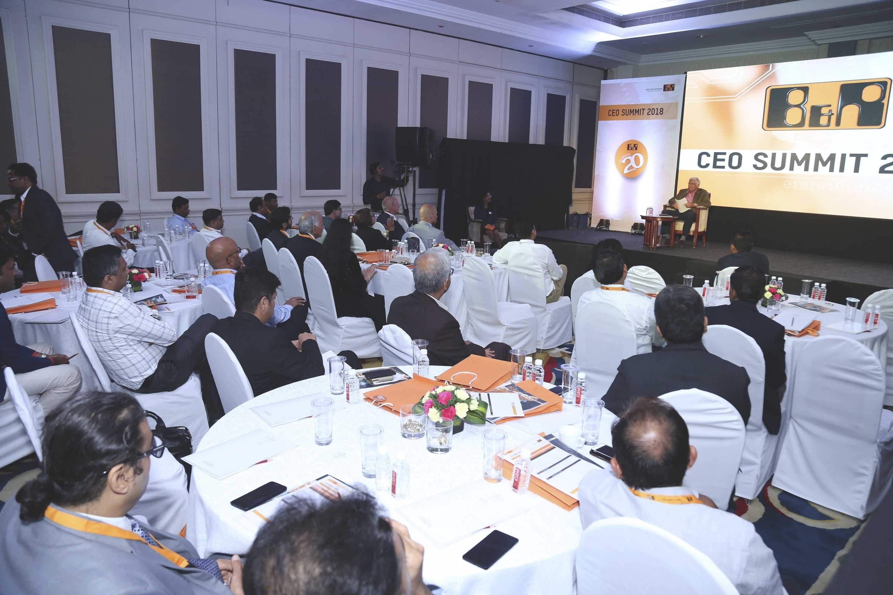
R. Gopalkrishnan mesmerized the audience with his talk providing a different perspective on Innovations

About B&R
B&R, a division of ABB Group, is a global leader in industrial automation headquartered in Austria. B&R combines state-of-the-art technology with advanced engineering to provide customers in virtually every industry with complete solutions for machine and factory automation, motion control, HMI and integrated safety technology. With Industrial IoT communication standards including OPC UA, POWERLINK and openSAFETY as well as its Automation Studio software, B&R is constantly redefining the future of automation engineering. The innovative spirit that keeps B&R at the forefront of industrial automation is driven by a commitment to simplifying processes and exceeding customer expectations.
For more information, visit www.br-automation.com.

