B&R features automation advances to maximize packaging flexibility at PACK EXPO 2018
A new generation of intelligent track technology enables adaptive packaging machine design for cost effective mass customization, plus integrated functionalities ranging from machine vision to IIoT connectivity to blackout safety.
At this year’s PACK EXPO International show, Booth N-5625, October 14-17, McCormick Place, Chicago, IL, B&R Industrial Automation Corp. will exhibit automation technologies that raise the bar on packaging machinery design. B&R specializes in standards-based, scalable and modular control systems integrating intelligent track technology, logic, motion, open and mapp robotics, human-machine interface (HMI), networked safety, I/O and data acquisition in a unified software development environment.
B&R track technology is the missing link in direct-to-consumer e-commerce for the emerging 'demand marketplace.' The new generation of consumer, the digital native, wants what they want, when they want it, ordered and fulfilled online.
B&R's new generation of intelligent track systems enable what has become known as The Adaptive Machine, representing the fourth generation of packaging machinery technology – enabling cost effective mass customization. CPGs are implementing the IoT systems needed to meet the commercial demand, but cost-effective batch size one production and packaging have proven elusive.
B&R track technology bridges this gap with a whole new level of IIoT enabled automation that makes build-to-order customization practical not just for high value goods, but food, beverage, personal and pet care consumables. The sky is the limit for customization in traditionally high margin industries such as cosmetics, fragrance, jewelry, optics, athletic equipment and medical implants.
After visiting B&R’s booth, don’t miss out on B&R’s Innovation Stage presentation, “The Adaptive Machine enables a new consumer business model: Batch Size One” on Monday, October 15th at 2 PM CDT.
Increased machine availability: B&R continues to expand its mapp (modular application) Technology software framework. With the new mapp Tweet function, a machine application can now send information via text message or email.
Find out more about machine vision integrated directly into the machine control network, real-time operating system and mapp Technology software development environment, rather than a separate vision system interfaced to the machine controller. The result is simplified implementation with sub-microsecond synchronization for increased performance.
Full safety functionality following network failure: B&R has set yet another benchmark in integrated safety technology with its new blackout mode. This feature allows safety applications to continue to run after a failure of the network or main controller.
B&R supports CPG makers’ corporate Internet of Things strategies through standards such as PackML, OPC UA and best practices being identified by the Industrial Internet Consortium (IIC). B&R co-chairs the IIC’s new Smart Factory Task Group.

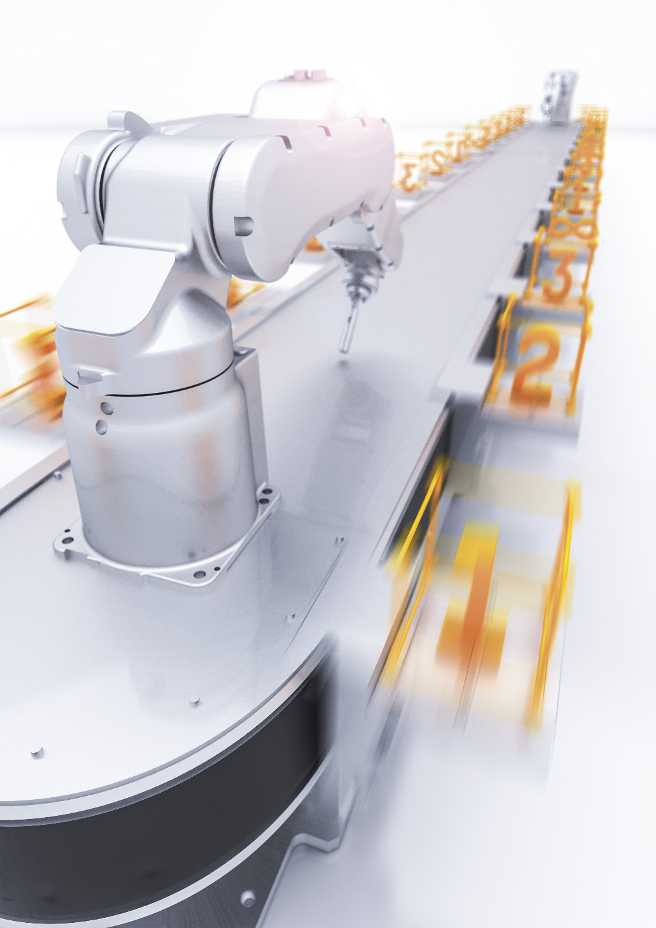
An adaptive machine will handle radical and unforeseen requirements through modularity. Learn more at B&R's booth N-5625 at Pack Expo 2018.

About B&R
B&R, a division of ABB Group, is a global leader in industrial automation headquartered in Austria. B&R combines state-of-the-art technology with advanced engineering to provide customers in virtually every industry with complete solutions for machine and factory automation, motion control, HMI and integrated safety technology. With Industrial IoT communication standards including OPC UA, POWERLINK and openSAFETY as well as its Automation Studio software, B&R is constantly redefining the future of automation engineering. The innovative spirit that keeps B&R at the forefront of industrial automation is driven by a commitment to simplifying processes and exceeding customer expectations.
For more information, visit www.br-automation.com.

