B&R organized a conference on next generation technologies
20 years of growth and innovation
B&R Industrial Automation has reached an exciting milestone as the company celebrates 20 years of delivering innovative technology and solutions to the Indian manufacturing industry. To mark this, B&R recently organised a daylong technology conference in Mumbai. The primary objective of this conference was to showcase next generation automation technologies and innovations to customers in Mumbai and nearby region. Technology focused presentations and live demos of automation solutions were displayed to extend an avenue to connect with customers and to help them map their future technology requirements. The event brought together over 100 experts from machine manufacturers, system integrators and end users from a wide variety of industries.
Global and innovative automation partner
Peter Gucher, Chairman B&R India and Member of Management, B&R Austria, provided a global perspective on automation trends and its impact on industries along with ground-breaking innovations by B&R, which help customers become ready for the future. He spoke on B&R Austria becoming the new global centre for machine and factory automation for the ABB Group. “ABB and B&R are united in their innovation and customer focus. These will be central factors as we evolve together going forward. Ensuring its ability to handle the steadily increasing demand for B&R's advanced automation solutions, ABB is investing in a new R&D centre at B&R headquarters in Eggelsberg as well as expanded production capacity a few kilometers away in Gilgenberg.” Adding further on ABB, B&R synergy, he mentioned, “ABB is investing €100 million in global innovation and training campus in Egglesberg. This ‘factory of future’ will be new high-tech innovation & technology center and will be fully operational in 2020.”
While discussing ambitious plans for company doubling business in next three years, Jhankar Dutta, Managing Director, B&R India averred, “Since last 20 years, many manufacturers have placed their trust in B&R’s world class products and technologies.” Jhankar further deliberated on what Industrial IoT means to our Indian ecosystem and more importantly how it influences the way we run businesses. He further appreciated the government’s proactive initiatives and stressed, “With government’s ‘Make in India’ initiatives, Indian machine builders and factories are becoming aware about the requirement and benefits of technology and are willing to invest in same. B&R is an innovative company, and we ready with innovative products and solutions to be part of our customers Industrial IoT story.” He stressed the importance of equipping B&R to handle the market growth, and informed, “To strengthen our market position we are expanding our office space to 16000 sq. ft. in Pune at the same time investing on manpower across India to match our growth plans.” He opined that B&R aspire to be one of the most customer-oriented company, not only with innovative approach but also with the dedicated support. “We have always been close to our customers and trust in long term partnerships. To maintain this close cooperation with customers B&R India has launched World-Class Customer Support with a dedicated number. It will also help us in our endeavor to be close to customers and enabling them to reach us at all times,” he elaborated.
Providing customers a competitive edge
Dheeraj Taneja, Director, PET PLAST India, spoke at the conference on a topic focusing on benefits of technology for building efficient machines, which was of great help to delegates in understanding the importance of efficiency, quality and productivity. Speaking about collaboration and partnerships he said, “Collaborating with B&R has given us access to latest technology and made our machines competitive on the global market. Our partnership has already led to great success, and we look forward to achieving even more in the future.”
The subsequent speakers at the conference presented various topics such as, Integration of long-stator linear motors in packaging lines, efficiency in machine development, Edge architecture enabling IT / OT convergence and importance of uniform, open and secure shop floor communications. The presentations showcased that building a digital enterprise will bring about operational excellence and cut costs across the value chain, giving diverse perspective on building smarter machines and factories.
With around 100+ delegates including customers and journalists, the conference provided the know-how and an easy path for successful implementation of Industrial IoT for machine builder and factories.

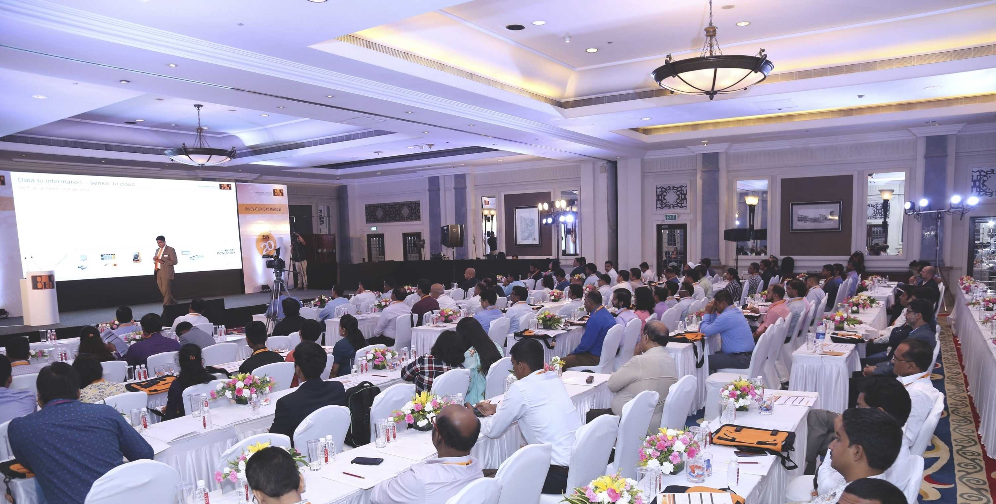
Conference witnessed 100+ delegates including customers and journalists
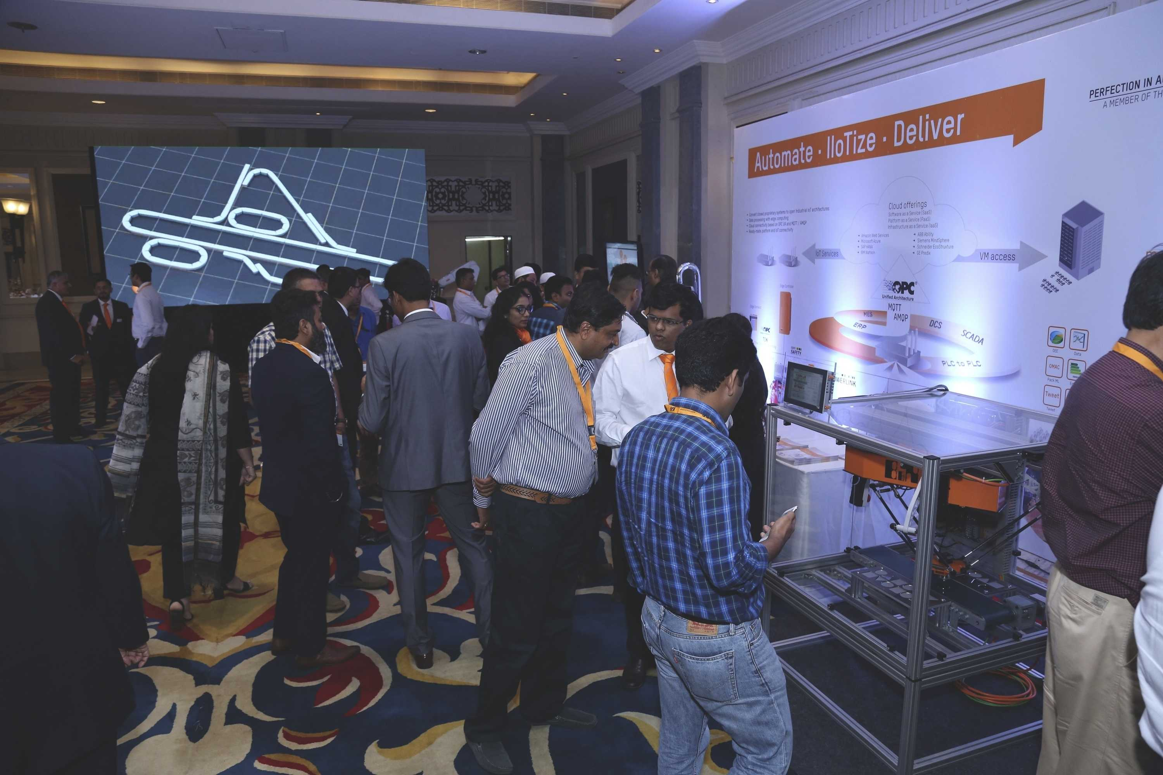
Live demonstration area enabled comprehensive interactions

About B&R
B&R, a division of ABB Group, is a global leader in industrial automation headquartered in Austria. B&R combines state-of-the-art technology with advanced engineering to provide customers in virtually every industry with complete solutions for machine and factory automation, motion control, HMI and integrated safety technology. With Industrial IoT communication standards including OPC UA, POWERLINK and openSAFETY as well as its Automation Studio software, B&R is constantly redefining the future of automation engineering. The innovative spirit that keeps B&R at the forefront of industrial automation is driven by a commitment to simplifying processes and exceeding customer expectations.
For more information, visit www.br-automation.com.

