Cost-effective safety function
Virtual sensor reads safe speed
B&R has developed a virtual sensor for its ACOPOS P3 servo drive: the Safe Speed Observer. It determines speed in accordance with SIL 2 / PL d / CAT 3 requirements, reducing the cost of implementing the Safely Limited Speed safety function by eliminating the need for a safe encoder.

From the electrical variables of a permanent magnet synchronous motor, the Safe Speed Observer uses two redundant models of the motor to calculate the safe speed – achieving a high safety level. The virtual sensor can be used for both linear and rotary synchronous motors.
Easy configuration
In the Automation Studio engineering environment the Safe Speed Observer is easy to configure via the respective encoder interface and safe motor parameter settings. The user can implement the safety functions available for the safe axis from the safety library. This new solution is made possible by the drive-integrated safety technology of SafeMOTION.

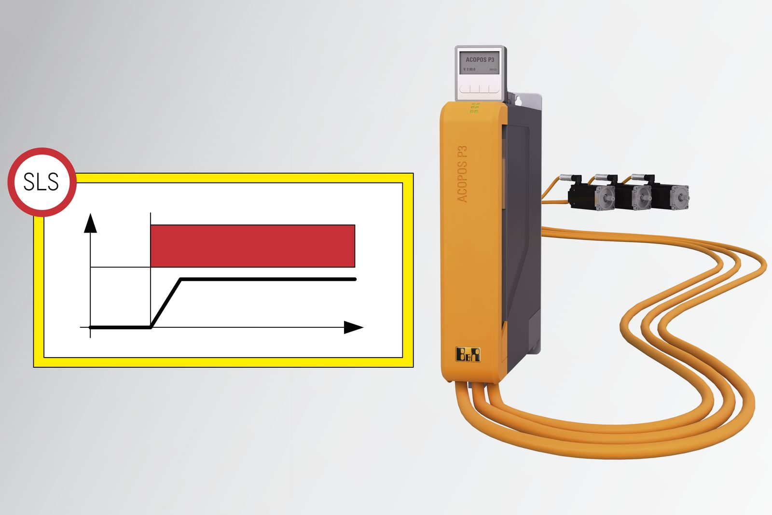
The Safe Speed Observer makes it possible to use the Safely Limited Speed safety function.

About B&R
B&R, a division of ABB Group, is a global leader in industrial automation headquartered in Austria. B&R combines state-of-the-art technology with advanced engineering to provide customers in virtually every industry with complete solutions for machine and factory automation, motion control, HMI and integrated safety technology. With Industrial IoT communication standards including OPC UA, POWERLINK and openSAFETY as well as its Automation Studio software, B&R is constantly redefining the future of automation engineering. The innovative spirit that keeps B&R at the forefront of industrial automation is driven by a commitment to simplifying processes and exceeding customer expectations.
For more information, visit www.br-automation.com.

