Precise control of temperature processes
New software component for easy access to temperature control
With mapp Temperature, B&R offers temperature control that combines maximum usability and powerful control algorithms. Integrated simulation capabilities allow virtual commissioning in minutes. mapp Temperature also provides heating current monitoring.

With mapp Temperature, it is possible to define zones and groups for temperature control. A zone is a unit consisting of an actuator, a temperature process and a sensor for measuring the temperature. Multiple zones can be combined into a physical group and controlled and optimized together. This gives the user maximum flexibility and scalability to meet any temperature control requirement.
Autotuning and integrated simulation
If applications cover a wide temperature range, simple tuning is often not sufficient to optimally adjust the parameters. mapp Temperature therefore includes a multi-stage autotuning process. The user can define several operating points and optimize them individually. The integrated simulation capability enables simple virtual commissioning without any hardware. This option makes it possible to test the application's logic, error handling and HMI system in advance to significantly accelerate on-site commissioning.
Heating current monitoring
B&R's temperature control system also offers heating current monitoring to enable early detection of faults through predictive maintenance. By monitoring the current of the heating elements, it is possible to react to a fault at an early stage without stopping the entire process. This ensures a high level of operational reliability and helps prevent extended downtime.

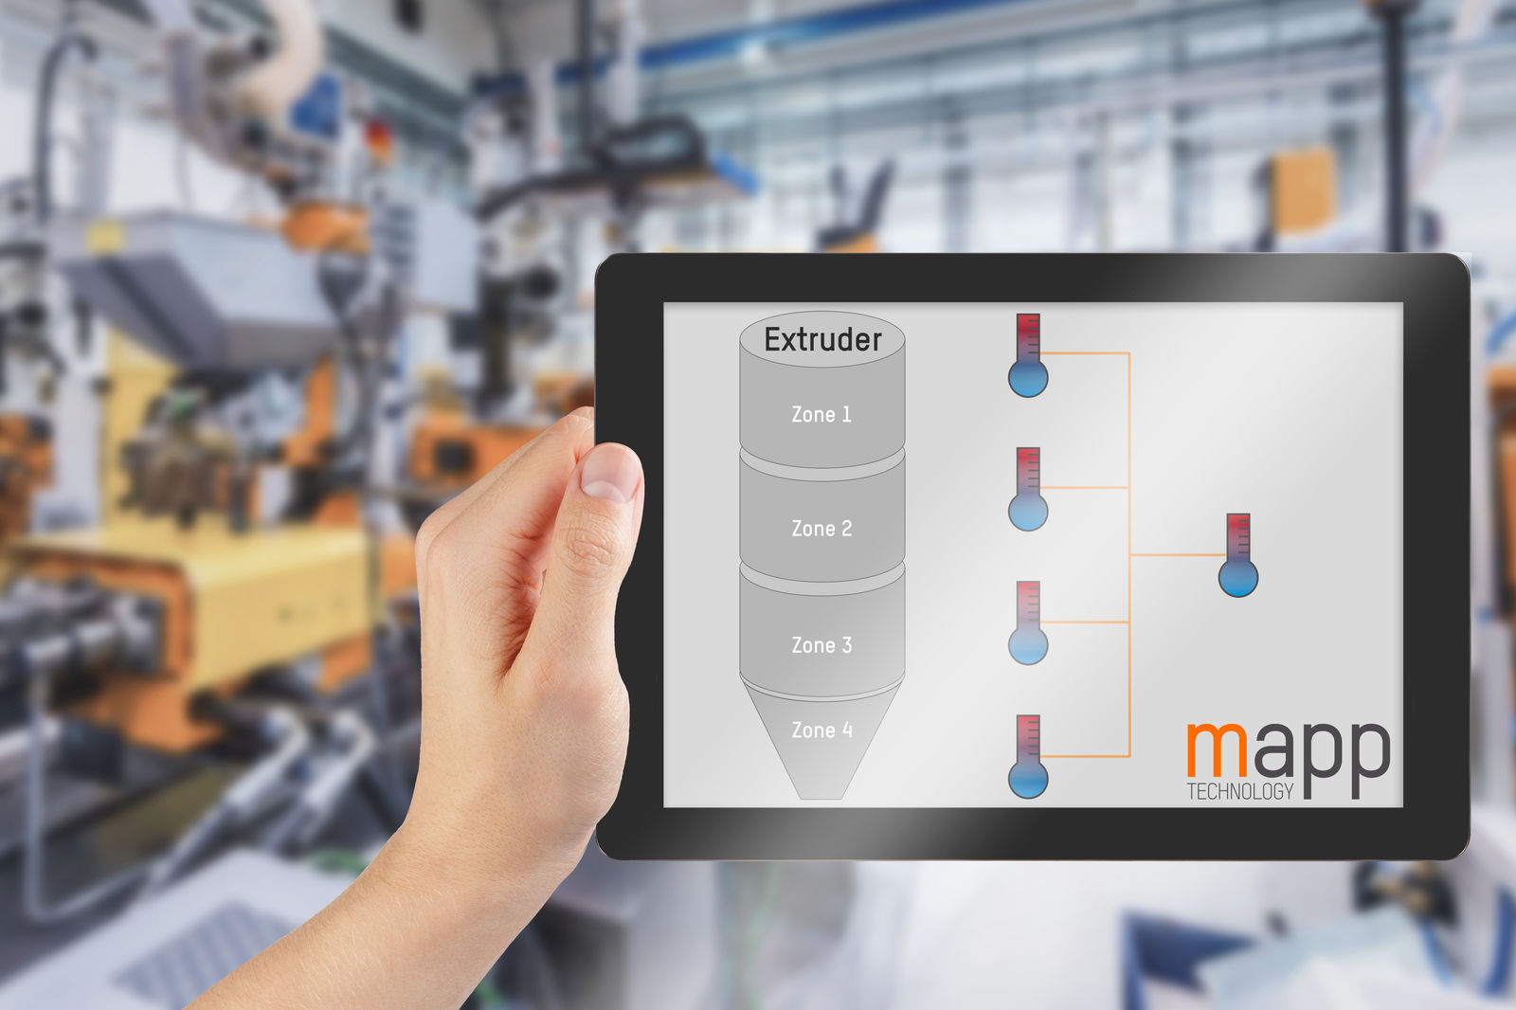
B&R's temperature control component covers every requirement with maximum flexibility and scalability.

About B&R
B&R, a division of ABB Group, is a global leader in industrial automation headquartered in Austria. B&R combines state-of-the-art technology with advanced engineering to provide customers in virtually every industry with complete solutions for machine and factory automation, motion control, HMI and integrated safety technology. With Industrial IoT communication standards including OPC UA, POWERLINK and openSAFETY as well as its Automation Studio software, B&R is constantly redefining the future of automation engineering. The innovative spirit that keeps B&R at the forefront of industrial automation is driven by a commitment to simplifying processes and exceeding customer expectations.
For more information, visit www.br-automation.com.

