Teachers expand their knowledge of automation technology.

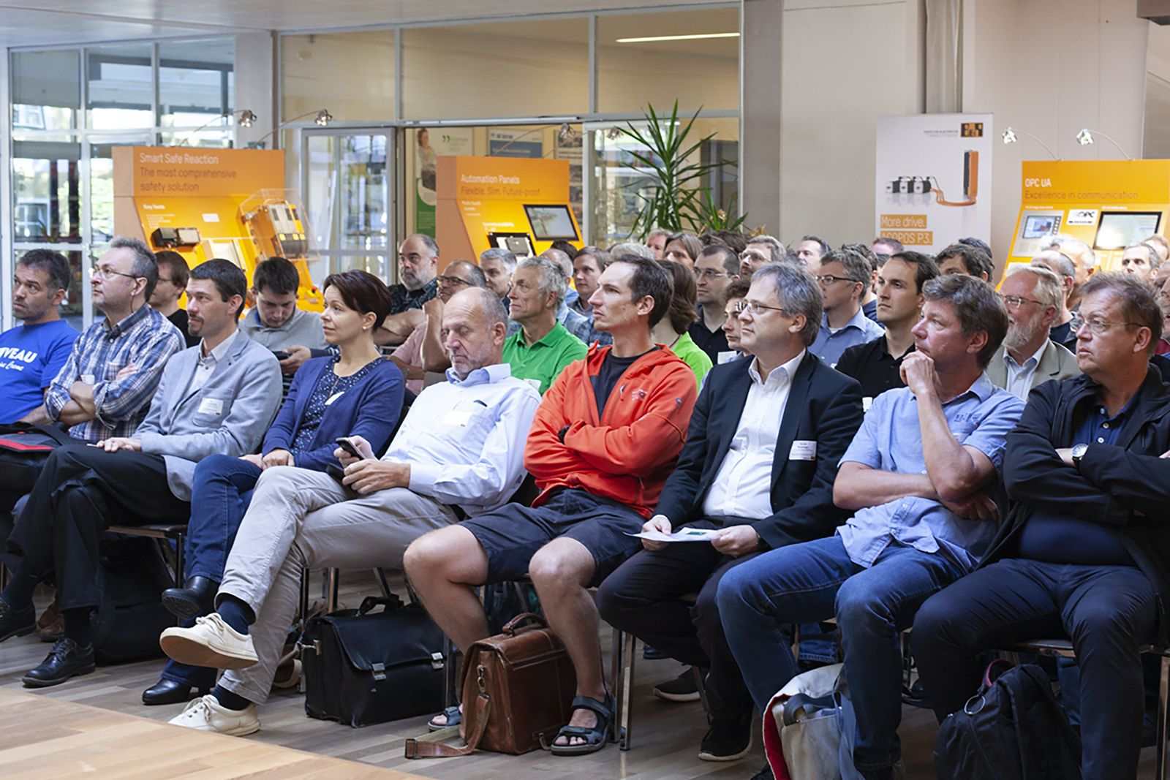
Around 100 teachers from technical educational institutions brushed up their knowledge of automation technology.

In six different workshops, teachers were shown how to use innovative automation technologies through practical examples and exercises. Karl Mohr, department head at HTBLuVA Graz Göstling, took part in the workshop for the sixth time: "Our laboratory at the school is fully equipped with B&R hardware. The knowledge that I gain at the workshop can also be passed on to the students through practical exercises," explains the department head.

The three-day seminars focused on the following topics: basic knowledge for industrial automation, electrical drive technology, mechatronic functions, integrated safety technology and visualization. In addition, the "Data management and connectivity" workshop focused on Industry 4.0 and the smart factory of the future. "Participating in the summer workshop is an ideal way for me to collect new ideas for upcoming student projects," says Martina Stadlmeier, a teacher at BIT Gendorf (Germany).
Further education and networking
The participants used the summer workshop not only to boost their expertise, but also to talk to colleagues and exchange ideas. "The B&R Summer Workshop is the perfect opportunity to prepare for the coming school year and to connect with our fellow colleagues," says Roman Froschauer, professor at the Wels University of Applied Sciences.

