Easily in touch with your machines
B&R cloud application powered by ABB Ability opens new opportunities for OEMs
Asset Performance Monitor is B&R's first cloud application based on ABB AbilityTM, ABB's unified, cross-industry offering of digital solutions. By giving OEMs a reliable overview of all their machines in the field, it allows them to identify potential improvements, take service operations to the next level and unlock new business models and revenue streams.

Around the clock, Asset Performance Monitor delivers data about production rate, energy consumption and temperature. Users can define which information is required, and the application automatically calculates key performance indicators (KPIs) such as overall equipment effectiveness and provides opportunities for improvement. Asset Performance Monitor prepares the data and displays it in a clearly organized dashboard. OEMs can then use this data to implement well-targeted machine upgrades and offer their customers next-level service.
Open architecture
An edge device is installed on site to collect data from a machine or production line. It receives data from the machine controller via OPC UA and passes it on to the cloud using the MQTT protocol. The edge device automatically establishes a connection to the ABB Ability cloud and installs the necessary software. Simply logging in with a username and password gives the OEM access to Asset Performance Monitor and all the features it has to offer.
ABB Ability platform
B&R's cloud applications run on ABB Ability. Security and data integrity are guaranteed by state-of-the-art security standards and transfer protocols. The Microsoft Azure infrastructure ensures reliable access to ABB Ability services all around the world, which includes all the prerequisites for future cloud applications featuring artificial intelligence and machine learning.

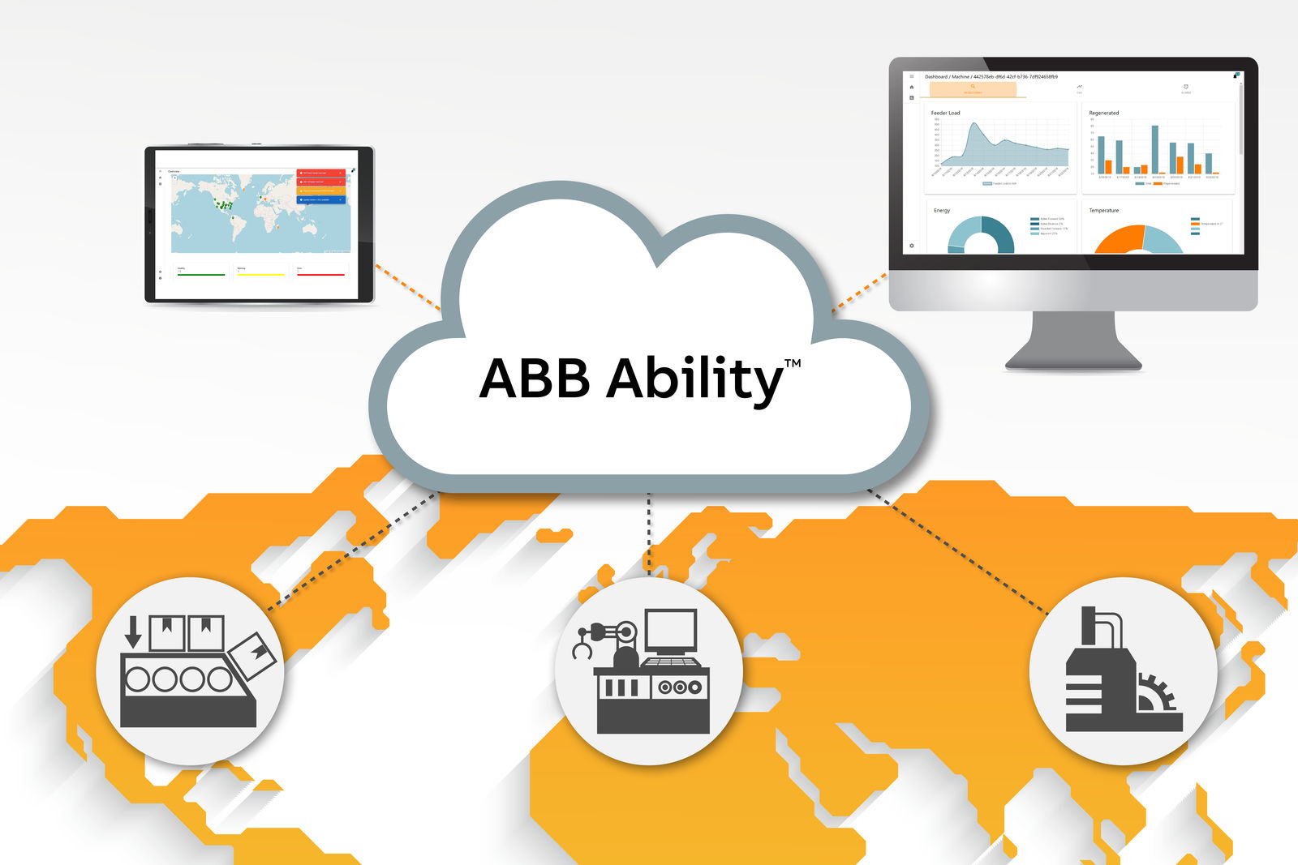
The cloud application collects machine data around the clock and displays it in a clearly organized dashboard.

About B&R
B&R, a division of ABB Group, is a global leader in industrial automation headquartered in Austria. B&R combines state-of-the-art technology with advanced engineering to provide customers in virtually every industry with complete solutions for machine and factory automation, motion control, HMI and integrated safety technology. With Industrial IoT communication standards including OPC UA, POWERLINK and openSAFETY as well as its Automation Studio software, B&R is constantly redefining the future of automation engineering. The innovative spirit that keeps B&R at the forefront of industrial automation is driven by a commitment to simplifying processes and exceeding customer expectations.
For more information, visit www.br-automation.com.

