Humans and ACOPOStrak, hand-in-hand
Safety functions enable human-track collaboration
The flexible ACOPOStrak transport system and B&R's human-track collaboration open up new dimensions in safe productivity at collaborative workstations. Intelligent safety technology keeps these workstations reliably risk-free without the need for safety barriers.

B&R has integrated five safety features in its ACOPOStrak system: Safe Torque Off (STO), Safely Limited Speed (SLS), Safely Limited Force (SLF), Safe Direction (SDI) and Safe Maximum Speed (SMS). These functions limit the speed and force of ACOPOStrak shuttles as they pass manual workstations and then continue around the remainder of the track with full dynamic performance.
Flexible safety solution
What truly sets B&R's human-track collaboration apart is its flexibility. The limit values for safe speed and safe force are calculated dynamically by the safety application at runtime and can be activated or deactivated as needed. The safe speed calculations even take the weight of the shuttle into account. This allows shuttles of different weights to travel at their respective maximum safe speeds without posing a danger.
Safe setup with zero downtime
The safety functions of ACOPOStrak also enable implementation of a safe setup mode. In setup mode, the speed and force limits are activated as needed for the respective track sections. Once humans have left the safe zones, the restrictions are lifted. It is possible to switch between safely limited speed and full-speed operation at any time. Other systems have track elements that are able to limit the speed intrinsically, but this restriction cannot be disabled or adjusted.
OEE and ROI
Due to ACOPOStrak's extremely short error response time, safety clearances can be much smaller. Even with collaborative manual workstations and safe setup mode, the machine surrounding the track can be kept to compact dimensions. This increases return on investment and shrinks the machine footprint. Human-track collaboration takes ACOPOStrak's ultimate production effectiveness to a new level.
Note: Human-track collaboration is an ongoing conceptual study. For details, please contact your B&R representative.

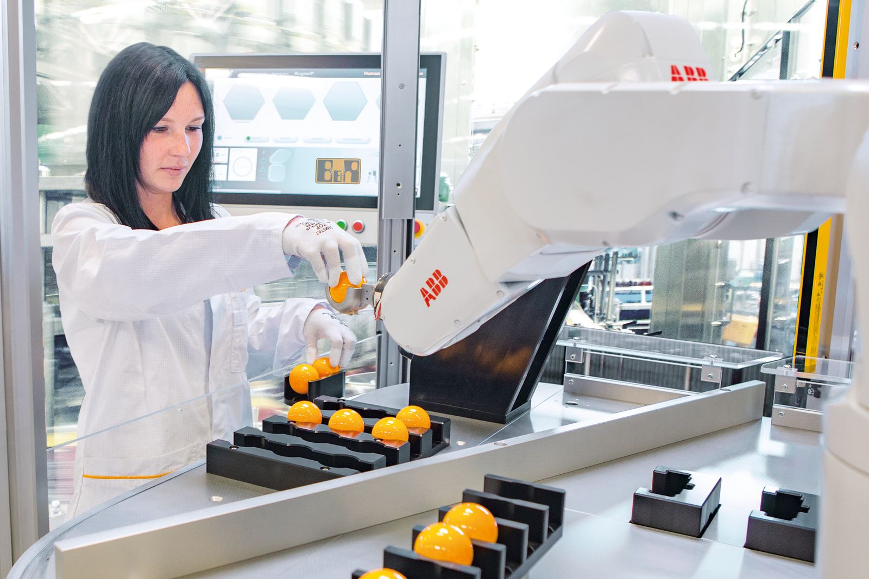
Intelligent safety technology keeps operators safe when interacting with machinery.

About B&R
B&R, a division of ABB Group, is a global leader in industrial automation headquartered in Austria. B&R combines state-of-the-art technology with advanced engineering to provide customers in virtually every industry with complete solutions for machine and factory automation, motion control, HMI and integrated safety technology. With Industrial IoT communication standards including OPC UA, POWERLINK and openSAFETY as well as its Automation Studio software, B&R is constantly redefining the future of automation engineering. The innovative spirit that keeps B&R at the forefront of industrial automation is driven by a commitment to simplifying processes and exceeding customer expectations.
For more information, visit www.br-automation.com.

