More than embedded: fully integrated
B&R presents complete machine vision portfolio at SPS IPC Drives
B&R will be presenting intelligent cameras, innovative lighting and advanced image processing algorithms at the SPS IPC Drives fair. The comprehensive machine vision solution is seamlessly integrated in the B&R control system. Other highlights on display at the B&R booth (Hall 7 / Booth 206/114) include B&R's first cloud application for OEMs safe human-track collaboration.

B&R's first cloud application allows OEMs to collect data from their global fleet around the clock and view it in a convenient dashboard. They can use it to make well-targeted machine upgrades, offer next-level service and unlock new revenue streams. The cloud application indicates where maintenance is necessary and provides the basis for tailor-made maintenance service.
Human-track collaboration
B&R is the first manufacturer of intelligent track systems to introduce human-track collaboration. Five integrated safety functions allow humans to work directly alongside the track with no safety barriers – without impairing productivity.

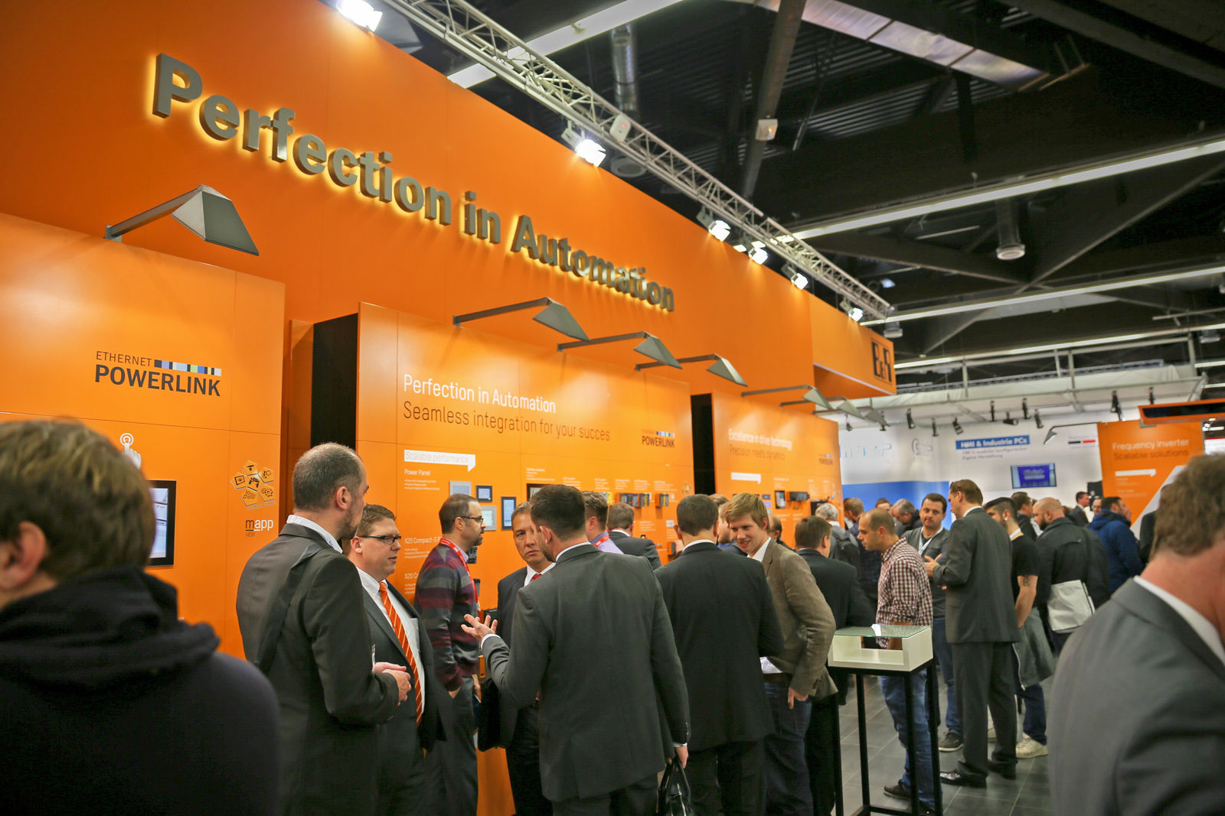
Among B&R's exhibition highlights will be its first cloud application for OEMs.

About B&R
B&R, a division of ABB Group, is a global leader in industrial automation headquartered in Austria. B&R combines state-of-the-art technology with advanced engineering to provide customers in virtually every industry with complete solutions for machine and factory automation, motion control, HMI and integrated safety technology. With Industrial IoT communication standards including OPC UA, POWERLINK and openSAFETY as well as its Automation Studio software, B&R is constantly redefining the future of automation engineering. The innovative spirit that keeps B&R at the forefront of industrial automation is driven by a commitment to simplifying processes and exceeding customer expectations.
For more information, visit www.br-automation.com.

