The eye of the machine
B&R presents fully integrated cameras at SPS IPC Drives
B&R's entry into the machine vision market is led by two camera variants: Smart Sensor and Smart Camera. Since the hardware is fully integrated in the automation system, the cameras can be synchronized to machine functions with microsecond precision.
The Smart Sensor is designed to implement a single machine vision functionality, such as QR code reading or position detection. Unlike many other devices in its class, there is no need to install dedicated hardware for each function. Instead, the user simply configures the desired Smart Sensor function in the Automation Studio development environment. OEMs only have to stock a single camera type and are nevertheless able to support a wide range of applications.
Scalable hardware
In cases where more than one functionality is required, it is easy to switch to the more powerful Smart Camera. The existing application software, parameters and models can continue to be used. Whichever camera type is selected, installation could hardly be easier: Simply hook the camera up to the machine network, and it automatically obtains all the settings it needs from the controller.
Optimum image quality
Smart Sensor and Smart Camera can each be equipped with one of three image sensors, ranging from 1.3 to 5 megapixels. All three sensors are characterized by their large pixel size, high light sensitivity and low noise. This guarantees optimum image quality – even in high-speed applications. Lighting can be implemented in the form of integrated LEDs or external barlights and backlights.
Housing variants are available with either an integrated lens or a standard C mount. The integrated lenses have electronic focus adjustment and are available in focal lengths from 4.6 to 25 mm. All B&R lenses are specially optimized for the image sensors used to achieve maximum sharpness and optimal imaging performance.
One cable is all you need
The camera only needs a single cable. The camera is integrated into the machine network via an M12 hybrid connector which also supplies the necessary 24 VDC power. A second hybrid connection enables easy daisy-chain cabling with additional cameras or B&R lighting elements.

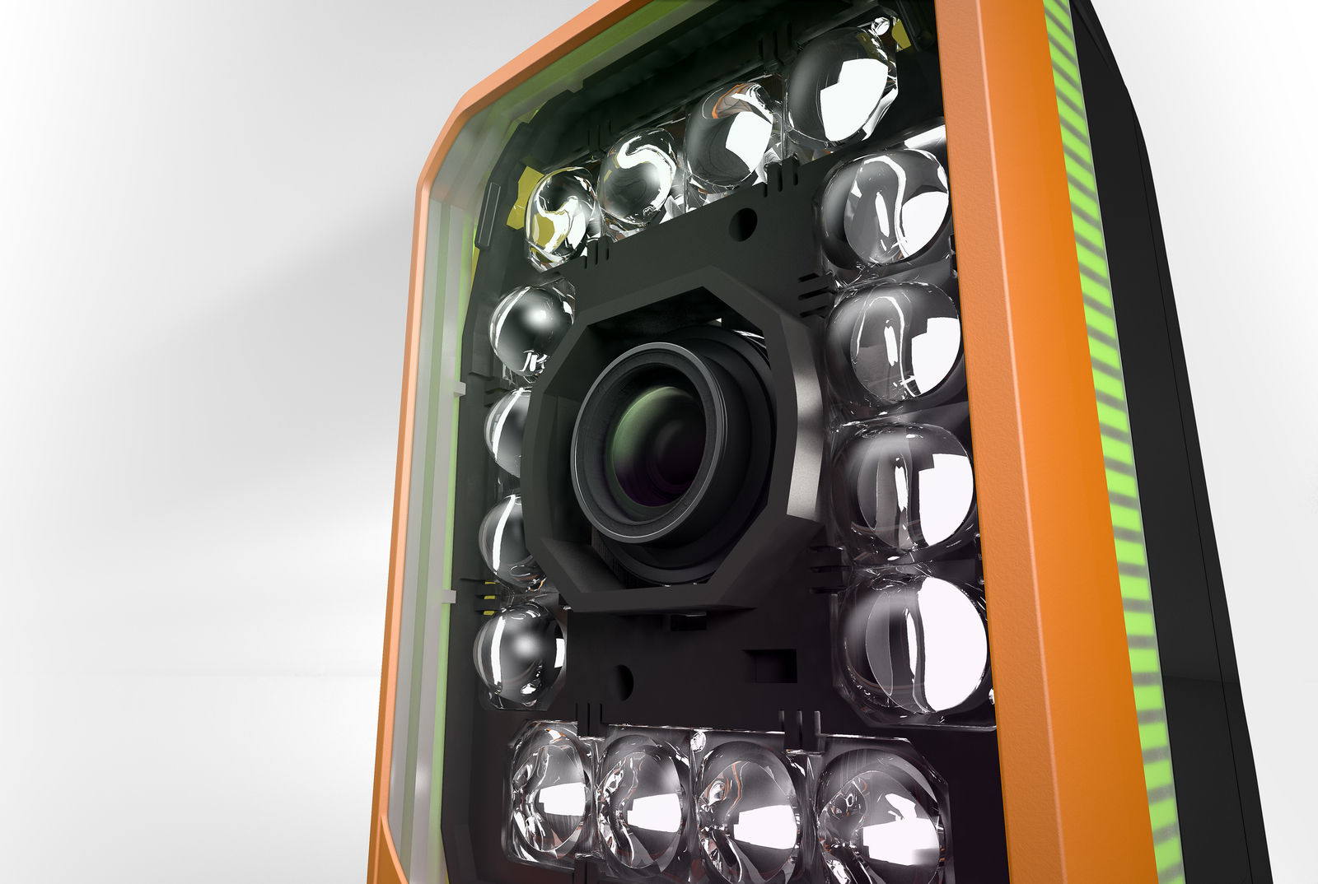
B&R's cameras are also available with integrated lighting.

About B&R
B&R, a division of ABB Group, is a global leader in industrial automation headquartered in Austria. B&R combines state-of-the-art technology with advanced engineering to provide customers in virtually every industry with complete solutions for machine and factory automation, motion control, HMI and integrated safety technology. With Industrial IoT communication standards including OPC UA, POWERLINK and openSAFETY as well as its Automation Studio software, B&R is constantly redefining the future of automation engineering. The innovative spirit that keeps B&R at the forefront of industrial automation is driven by a commitment to simplifying processes and exceeding customer expectations.
For more information, visit www.br-automation.com.

