Focus on connectivity
MES association visits B&R
Seamless connectivity for manufacturing processes was the focus of the "MES im Fokus" event that took place at Austrian automation specialist B&R in December. The participants were particularly impressed by the extensive connectivity between the B&R's own ERP system, MES system and production facilities.

Eleven lectures painted a clear picture of the benefits MES solutions and introduced the latest trends and successful implementations in the areas of MES and IIoT. Among the topics addressed was the question of how to collect, process and analyze operating data from digitally isolated brownfield plants. B&R's solution for integrating existing equipment into the smart factory was met with great interest. The Orange Box is designed to bring easy connectivity to brownfield plants without any modifications to the existing hardware and software.
OPC UA over TSN
Konstantin Klein, B&R's product manager for Industrial IoT network solutions introduced the participants to the new unified communication standard for the Industrial IoT. OPC UA over TSN is now the vendor-agnostic, interface-free solution for industrial communication. B&R has been a main player in the initiative to develop and standardize OPC UA over TSN for communication at the controller and field level, and will be assuming a leadership role in the responsible standardization bodies: OPC Foundation, IEC/IEEE and VDMA.

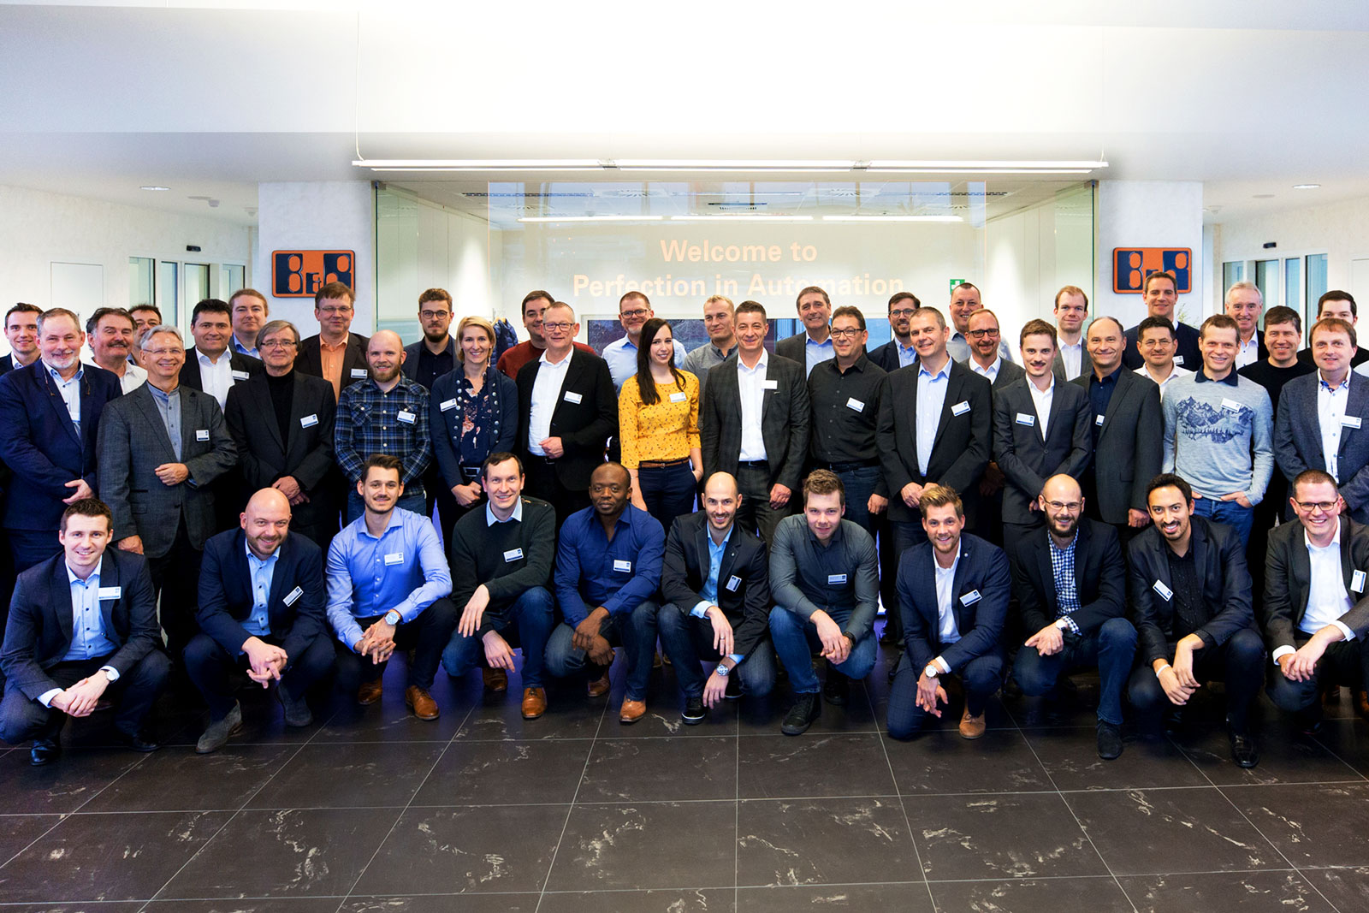
This was the second time the "MES im Fokus" event was hosted in Austria by automation specialist B&R.

About B&R
B&R, a division of ABB Group, is a global leader in industrial automation headquartered in Austria. B&R combines state-of-the-art technology with advanced engineering to provide customers in virtually every industry with complete solutions for machine and factory automation, motion control, HMI and integrated safety technology. With Industrial IoT communication standards including OPC UA, POWERLINK and openSAFETY as well as its Automation Studio software, B&R is constantly redefining the future of automation engineering. The innovative spirit that keeps B&R at the forefront of industrial automation is driven by a commitment to simplifying processes and exceeding customer expectations.
For more information, visit www.br-automation.com.

