B&R brings safety to mobile equipment
New safety controller offers intelligent safety functions for outdoor applications
The X90 control and I/O system for mobile equipment is now available with integrated safety technology. Intelligent safety functions and extremely short response times are the key to a whole new realm of possibilities for the safe operation of outdoor plants and mobile machinery.

The control system meets the ISO 13849 mobile machinery requirements up to PL d as well as the ISO 25119 requirements up to AgPL d. All 48 of the I/O channels on the X90 controller can be used where appropriate for safe or non-safe functions or combinations of the two. The housing on the controller is extremely robust and features IP69K protection.
Safe communication
With the bus-independent openSAFETY protocol, the safe X90 system offers the option of connecting decentralized safe I/Os or sensors. For this, B&R highly recommends using POWERLINK – the real-time capable industrial Ethernet. The communication corresponds to SIL 3 and is also secured via non-safe modems wirelessly.
Central safety software
B&R provides pre-certified software components for a variety of TÜV safety functions. The task of safety programming itself is thus reduced to simple configuration and linking of the safe software blocks via ladder diagram. The machine manufacturer only has to prove to TÜV that this work has been carried out in accordance with the guidelines for safe development. This reduces the complexity, workload and time required for certification.

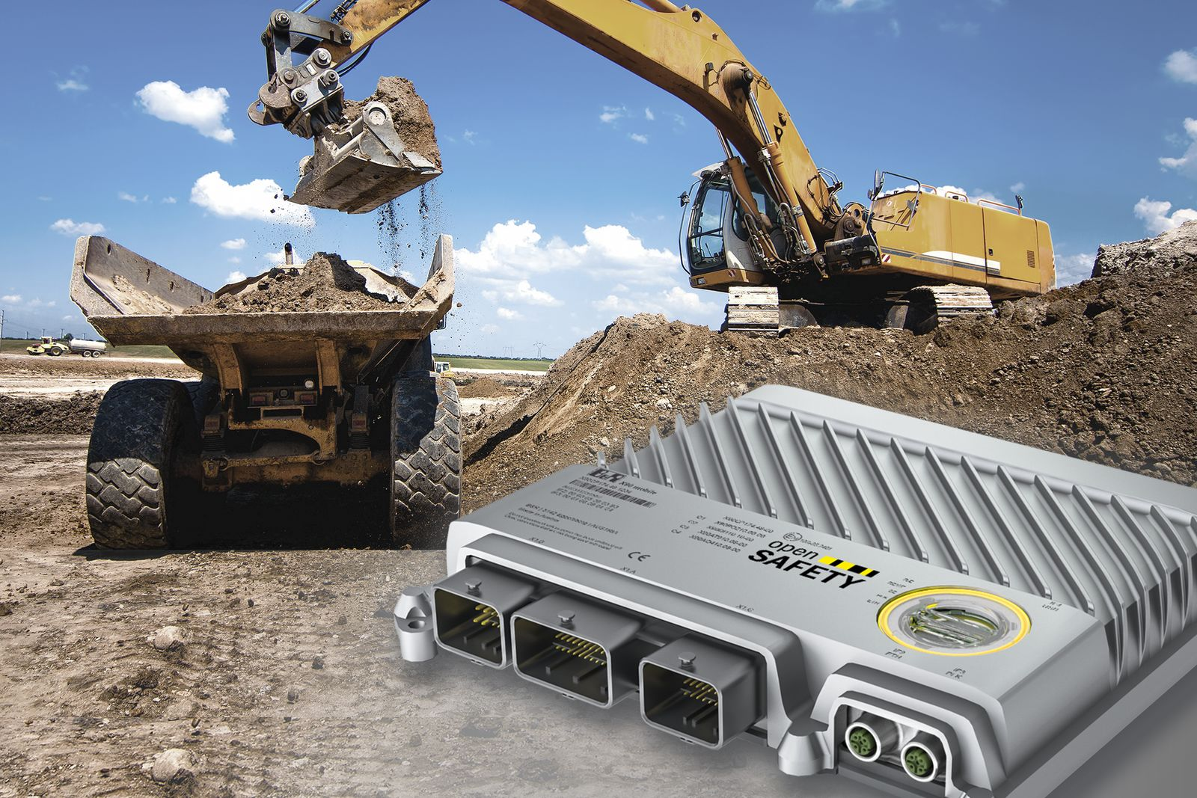
Intelligent safety functions and extremely short response times are the key to a whole new realm of possibilities for the safe operation of outdoor equipment and mobile machinery.

About B&R
B&R, a division of ABB Group, is a global leader in industrial automation headquartered in Austria. B&R combines state-of-the-art technology with advanced engineering to provide customers in virtually every industry with complete solutions for machine and factory automation, motion control, HMI and integrated safety technology. With Industrial IoT communication standards including OPC UA, POWERLINK and openSAFETY as well as its Automation Studio software, B&R is constantly redefining the future of automation engineering. The innovative spirit that keeps B&R at the forefront of industrial automation is driven by a commitment to simplifying processes and exceeding customer expectations.
For more information, visit www.br-automation.com.

