Integrated automation solutions smart manufacturing
B&R presents complete portfolio for batch-size-one manufacturing
At the Hannover Messe trade fair, B&R will show how a conventional plant can become a smart factory in Hall 9, Booth D26. B&R enables the automation of all production areas and allows them to interact seamlessly. B&R's portfolio makes it easy to implement efficient, high-quality production down to batch size one, ensure safe human-machine collaboration, and obtain a clear overview of machine performance data in the cloud.

B&R's first cloud application allows OEMs to collect data from their global fleet around the clock and view it in a convenient dashboard. They can use it to make well-targeted machine upgrades, offer next-level service and unlock new revenue streams. The cloud application indicates where maintenance is necessary and provides the basis for tailor-made maintenance service.
Integrated machine vision
In addition, B&R will be exhibiting the world's first machine vision solution to be fully integrated into the automation landscape. B&R's machine vision solution includes intelligent cameras, image processing algorithms, and an innovative selection of lighting technology. With these products, B&R serves a broad spectrum of applications: from simple machine vision sensors to high-end smart cameras. Ready-made software components are available for creating applications with minimal new programming.
Human-track collaboration
B&R is the first manufacturer of intelligent track systems to introduce human-track-collaboration. Visitors to the B&R booth will see how five integrated safety functions allow humans to work directly alongside the track with no safety barriers – without impairing productivity.

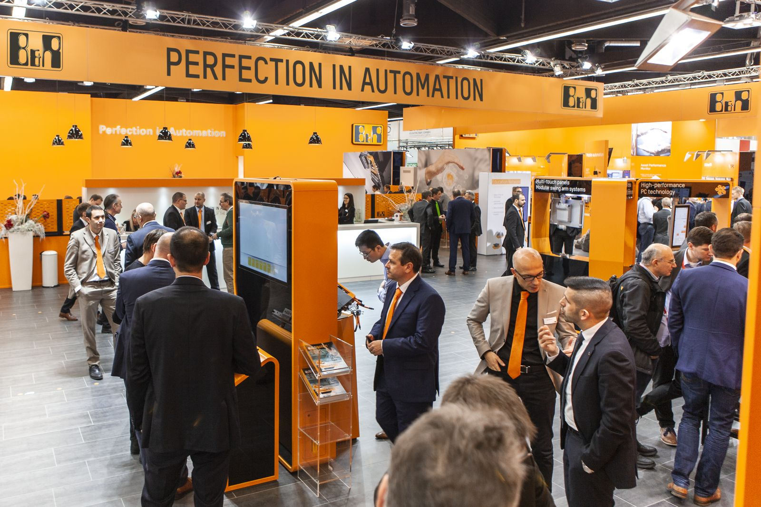
At the Hannover Messe, B&R will demonstrate how easy it is to produce exceptional quality with mass production efficiency down to batch size 1.

About B&R
B&R, a division of ABB Group, is a global leader in industrial automation headquartered in Austria. B&R combines state-of-the-art technology with advanced engineering to provide customers in virtually every industry with complete solutions for machine and factory automation, motion control, HMI and integrated safety technology. With Industrial IoT communication standards including OPC UA, POWERLINK and openSAFETY as well as its Automation Studio software, B&R is constantly redefining the future of automation engineering. The innovative spirit that keeps B&R at the forefront of industrial automation is driven by a commitment to simplifying processes and exceeding customer expectations.
For more information, visit www.br-automation.com.

