Hand-in-hand with tripods
B&R brings safety to delta kinematics
B&R now offers SafeROBOTICS functions for tripods to safely monitor all types of delta kinematic systems. Serial axes can also be included in the calculations, for example when tripods are mounted on moving platforms.

Safe robot monitoring is implemented using the safety functions Safely Limited Position, Safely Limited Orientation, Safely Limited Joint Position and Safely Limited Speed. The user can choose whether to monitor the tool center point (TCP), individual joints or any other point on the robot. It is also possible to safely monitor multiple points with regard to speed, orientation and position in space. SafeROBOTICS functions are based on a generic description of the kinematic chain in which the geometric properties of the robot are defined.
Exchange tools without reprogramming
The safety application can be isolated from the geometric definitions. This makes it possible to switch to another tool with a different contour without having to touch the safety application itself. This saves the time-consuming process of recertification. All monitoring functions are predictive in nature, making it possible to stop movements at the right time. SafeROBOTICS guarantees that protected spaces are not violated.

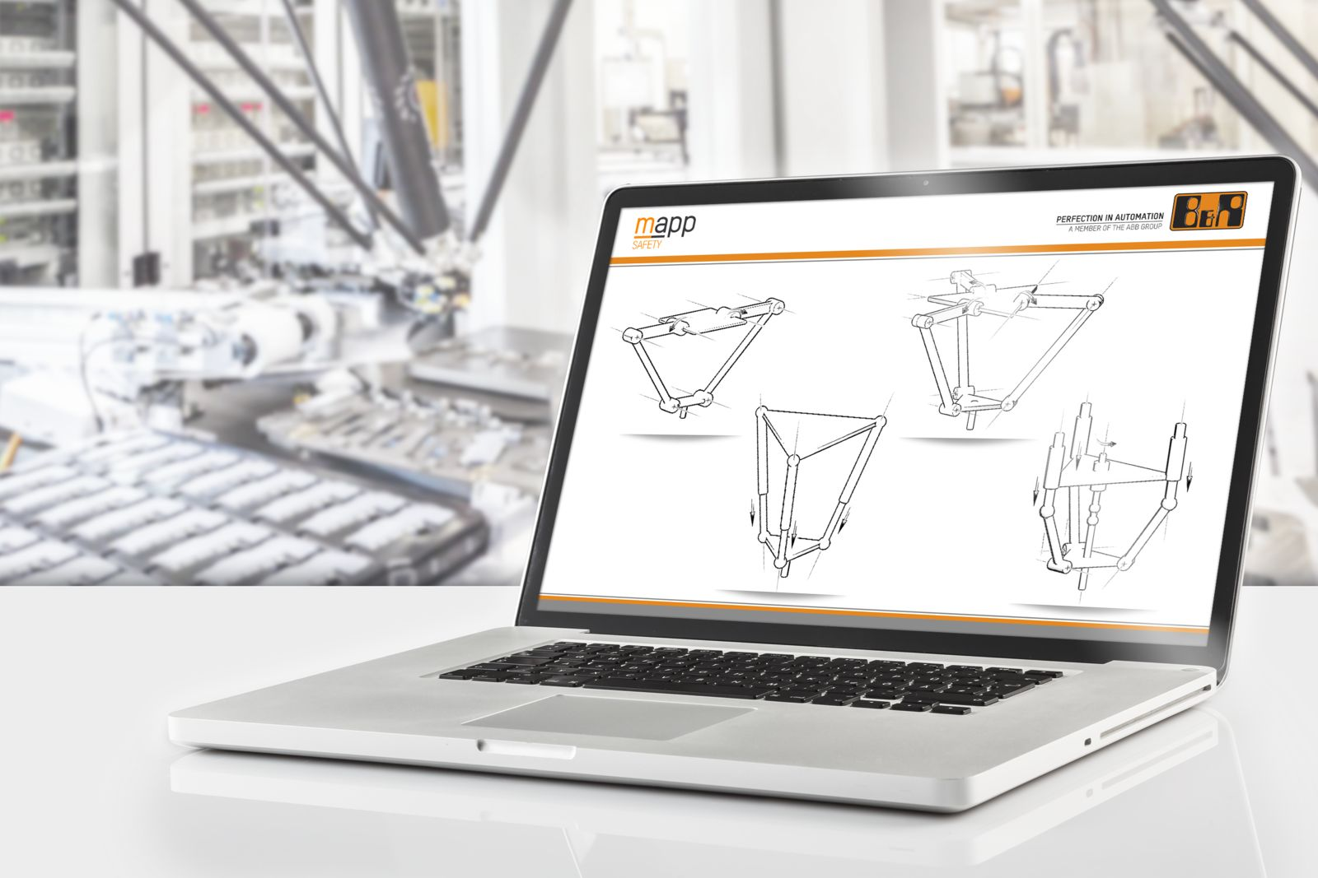
SafeROBOTICS for tripods provide safety monitoring for all types of delta kinematic systems.

About B&R
B&R, a division of ABB Group, is a global leader in industrial automation headquartered in Austria. B&R combines state-of-the-art technology with advanced engineering to provide customers in virtually every industry with complete solutions for machine and factory automation, motion control, HMI and integrated safety technology. With Industrial IoT communication standards including OPC UA, POWERLINK and openSAFETY as well as its Automation Studio software, B&R is constantly redefining the future of automation engineering. The innovative spirit that keeps B&R at the forefront of industrial automation is driven by a commitment to simplifying processes and exceeding customer expectations.
For more information, visit www.br-automation.com.

