Safety for mobile equipment
B&R presents X90 controller with integrated safety at bauma 2019
B&R has added an easy-to-implement safety solution to its portfolio for mobile equipment. At bauma 2019, the company will present the first X90 controller with integrated safety technology. Other highlights on display at the B&R booth (Hall A2 / Booth 127) will include an integrated vibration-based condition monitoring system and option boards with additional interfaces.
B&R has integrated a full-fledged safety PLC in the new X90 controller. To create the corresponding safety application, the user simply connects ready-made software components using ladder diagram. This brings all the advantages of networked safety technology without any traditional programming and makes it substantially easier to achieve compliance with the European Machinery Directive.
Condition monitoring
B&R will also be showcasing a new option board that evaluates vibration data to provide early detection of mechanical damage. This advanced condition system simplifies maintenance and helps minimize unscheduled downtime.

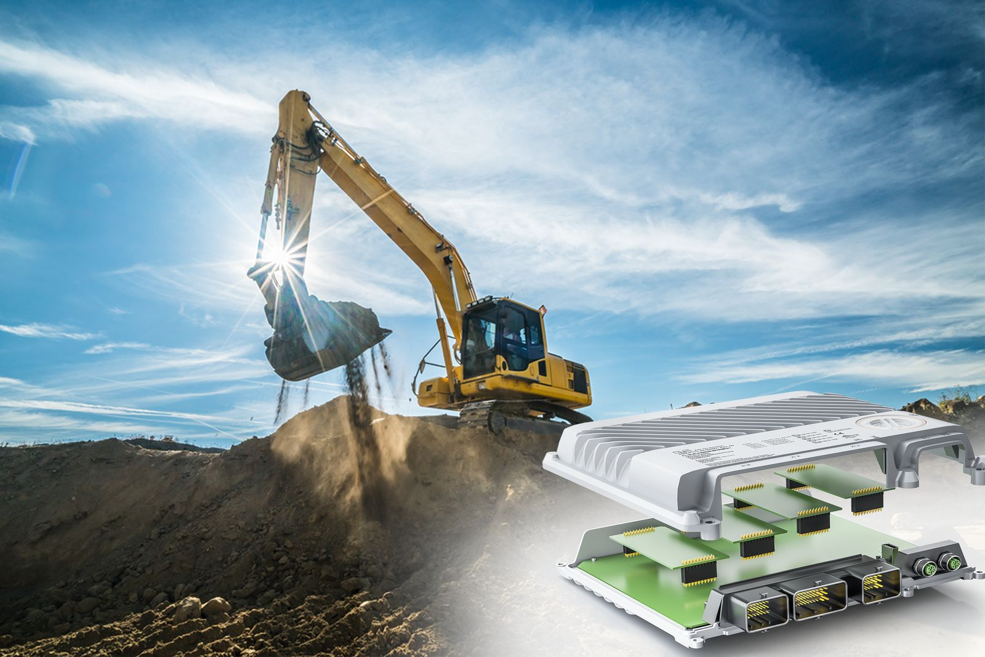
At bauma 2019, B&R will present the first X90 control and I/O system with integrated safety technology

About B&R
B&R, a division of ABB Group, is a global leader in industrial automation headquartered in Austria. B&R combines state-of-the-art technology with advanced engineering to provide customers in virtually every industry with complete solutions for machine and factory automation, motion control, HMI and integrated safety technology. With Industrial IoT communication standards including OPC UA, POWERLINK and openSAFETY as well as its Automation Studio software, B&R is constantly redefining the future of automation engineering. The innovative spirit that keeps B&R at the forefront of industrial automation is driven by a commitment to simplifying processes and exceeding customer expectations.
For more information, visit www.br-automation.com.

