Clear overview of complex systems
B&R expands its library of HMI widgets
The new Skyline widget from B&R's mapp View HMI software package displays a clear overview of extensive manufacturing systems. The widget can also be linked to an alarm system. With important information about their machines available at a glance, plant operators are able to react promptly to error messages. This prevents downtime and increases the productivity of the plant.

The interactive HMI element is suitable for modular machines and plants in any industry. The developer simply drags the widget into place on the HMI screen and configures it as needed. They can choose pictures to represent the various parts of the machine and adjust their sizes. The Skyline widget can be configured at runtime, making it exceptionally fast and flexible to use.
Avoid downtime
For an improved overview of particularly complex plants, multiple instances of a given machine can be grouped together. The widget can also be configured to display important statistical information or the current status when a component is selected. The operator is able to react quickly to any errors that occur on the machine and resolve the situation before it results in extended downtime.

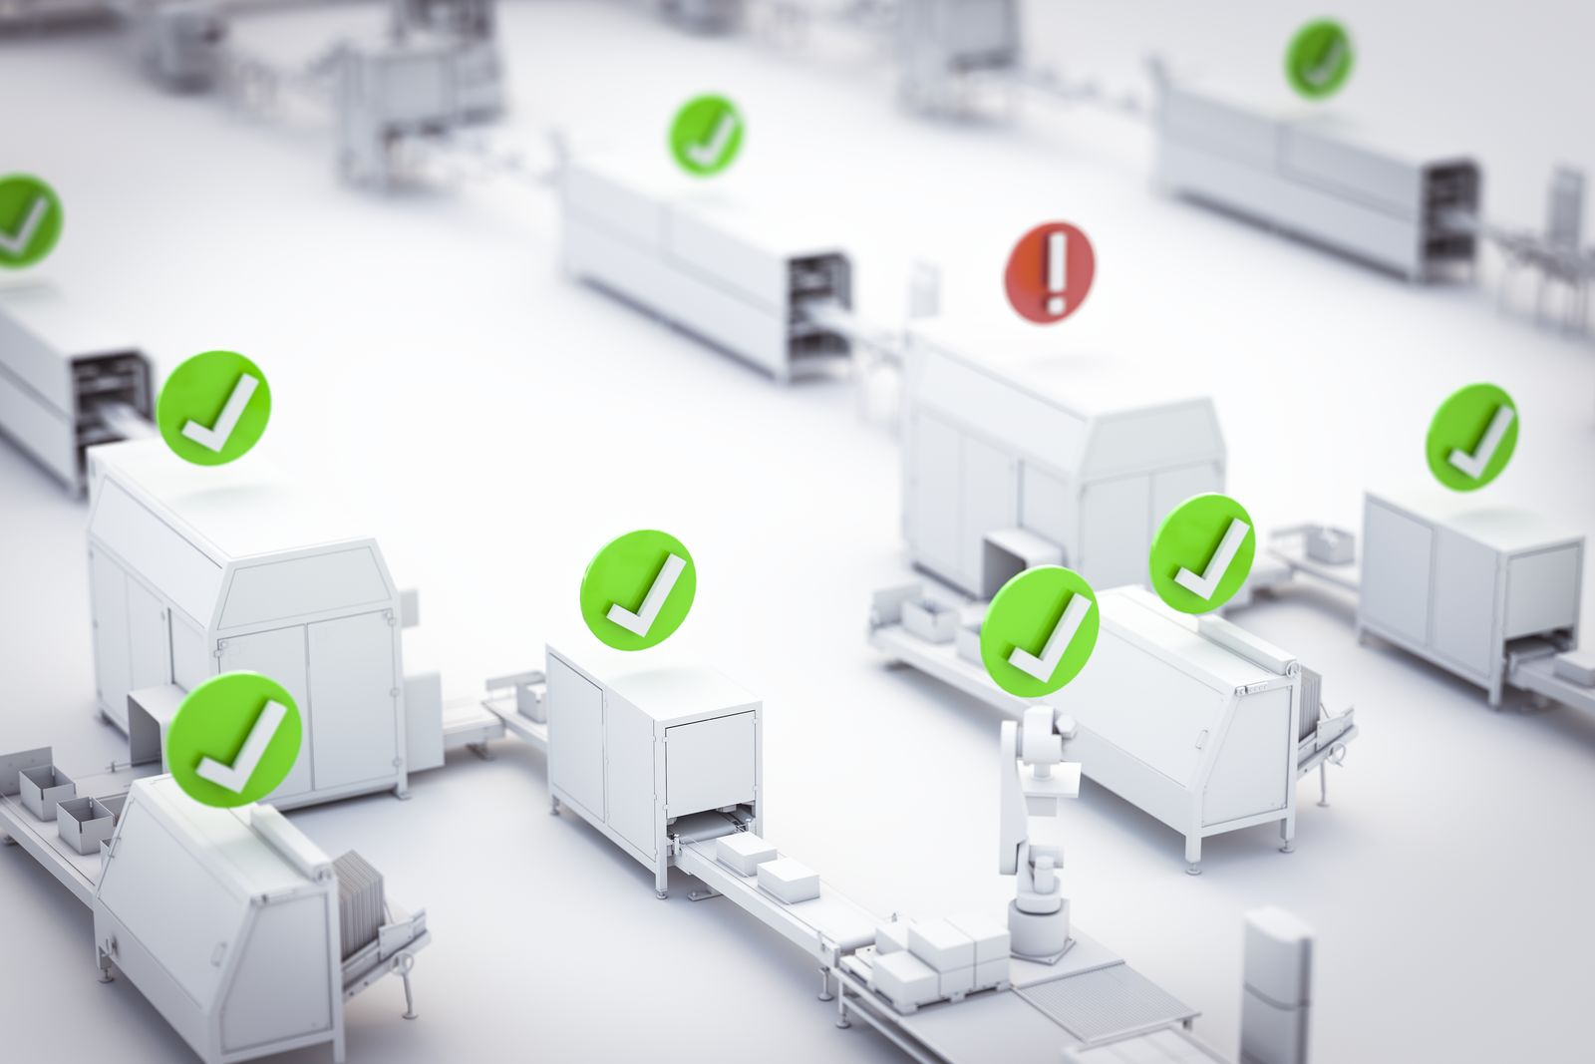
The new Skyline widget from B&R's mapp View software package displays a clear overview of extensive manufacturing systems.

About B&R
B&R, a division of ABB Group, is a global leader in industrial automation headquartered in Austria. B&R combines state-of-the-art technology with advanced engineering to provide customers in virtually every industry with complete solutions for machine and factory automation, motion control, HMI and integrated safety technology. With Industrial IoT communication standards including OPC UA, POWERLINK and openSAFETY as well as its Automation Studio software, B&R is constantly redefining the future of automation engineering. The innovative spirit that keeps B&R at the forefront of industrial automation is driven by a commitment to simplifying processes and exceeding customer expectations.
For more information, visit www.br-automation.com.

