Solution for smart autonomous parking
B&R supports young talent at international makeathon
The Austrian automation specialist B&R supported university students from Kempten (DE), Wels (AT), Munich (DE) and Brno (CZ) at the 2019 Smart Green Island makeathon. During the four-day event in Las Palmas, Gran Canaria, the students worked on implementing their smart autonomous parking solution. The Smart Green Island makeathon serves to encourage talented students in the field of technology. More than 270 students from 21 nations and 70 universities participated in the event.

The fourth Smart Green Island makeathon was dedicated to the topics of digitalization and climate change, with the concrete objective of developing ideas and solutions in the areas of Smart Home, Smart Production, Smart Mobility, Smart Farming and Green Energy. The student teams designed the first prototypes of their ideas and presented them to around 400 visitors from science and industry.
Autonomous parking
The eleven-person team sponsored by B&R, consisting of university students from Kempten, Munich and Brno, dedicated its Smart Green Island makethon project to the topic of Smart Urban Autonomous Parking. The students developed a model that shows how a self-driving vehicle drives into a parking garage and autonomously pulls into and out of a parking space. The integrated control system uses machine vision to recognize the nearest free parking space.
Finding young talent
The event, organized by the engineering and consulting company ITQ and supported financially by B&R, is a good platform for companies to find and recruit young talent. Patrick Haberstroh, who heads B&R's Education Network, provided on-site support for the students: "In addition to expanding the participants' technical knowledge, the event is also the perfect opportunity for networking and getting to know each other. This allowed us to make initial contact with some talented young people who we may someday welcome as colleagues," says Haberstroh.

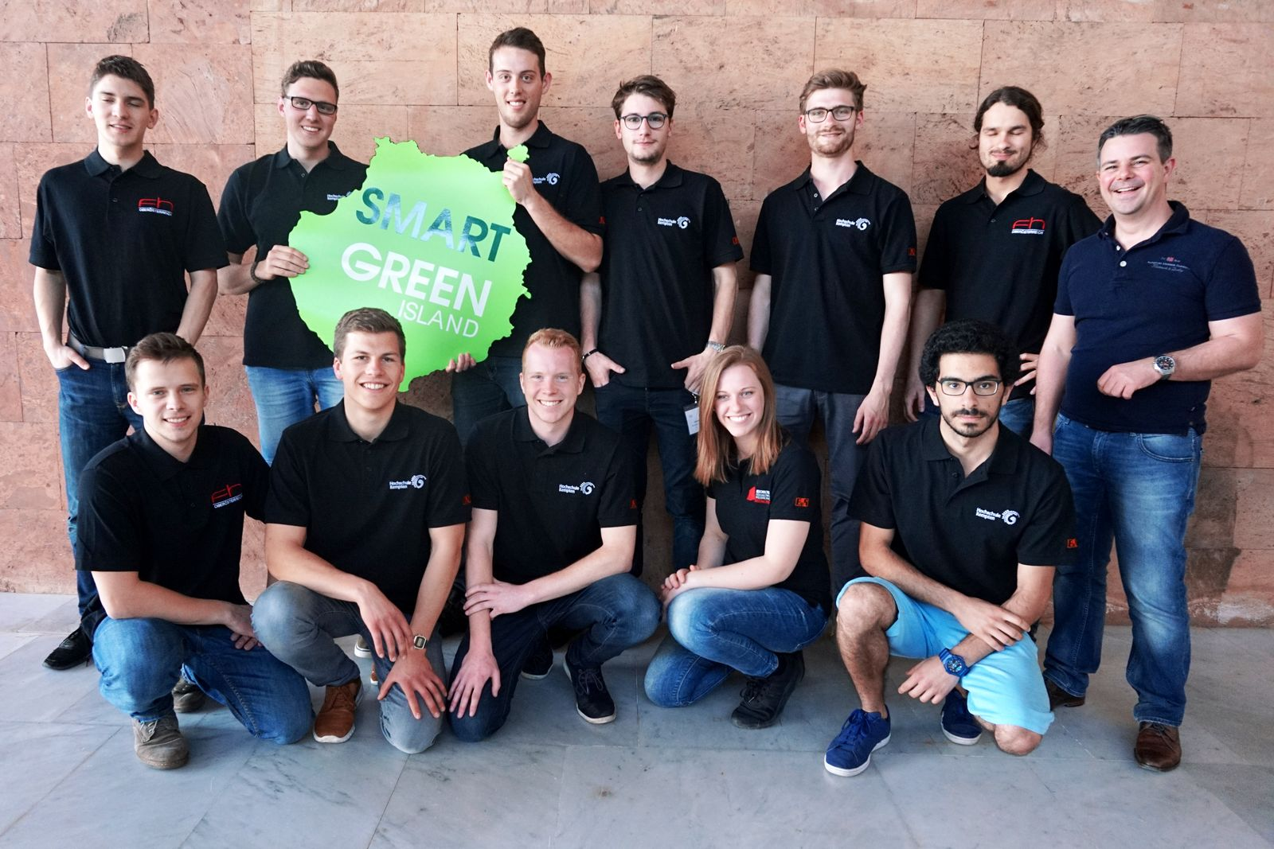
The team of university students from Kempten, Munich and Brno competed at the Smart Green Island Makeathon 2019 with B&R sponsorship and on-site supervision by Patrick Haberstroh, head of B&R's Education Network (back right).

About B&R
B&R, a division of ABB Group, is a global leader in industrial automation headquartered in Austria. B&R combines state-of-the-art technology with advanced engineering to provide customers in virtually every industry with complete solutions for machine and factory automation, motion control, HMI and integrated safety technology. With Industrial IoT communication standards including OPC UA, POWERLINK and openSAFETY as well as its Automation Studio software, B&R is constantly redefining the future of automation engineering. The innovative spirit that keeps B&R at the forefront of industrial automation is driven by a commitment to simplifying processes and exceeding customer expectations.
For more information, visit www.br-automation.com.

