B&R unveils it futuristic corporate headquarters in Pune
A modern office with unique architecture

B&R Industrial Automation has expanded its Pune office space to 16000 sq. ft. This new and modern office is now fully operational with unique architecture and efficient office automation. During the new infrastructure unveiling, Managing Director of B&R India, Jhankar Dutta addressed employees saying, “We are proud to expand our Pune office to accommodate the rapid growth in Indian market. With our new and hi tech working infrastructure, we continue to remain extremely competitive and are confident about sustained growth. We are perfectly placed and equipped to further support our customers in increasingly important automation market.” He further went on to thank customers, partners and employees for their trust and support to B&R India.
The corporate headquarters of B&R Industrial Automation in Pune also houses a demo room and a next generation customer experience centre, highlighting latest B&R hardware and technology. The futuristic design of B&R’s Pune infrastructure meets the needs of modern working environment outfitting innovative technologies and providing employees with working comfort. The fully automated infrastructure has connected all the functional elements and utilities to deliver a truly connected experience for employees and customers at the same time optimizing and reducing resource utilization. The infrastructure includes thoughtful use of daylight, thus, reducing ecological footprint. In addition, the automated lights and air-conditioning ensures automatic turn off with no human presence assuring further reduction of carbon footprint and a greener tomorrow.

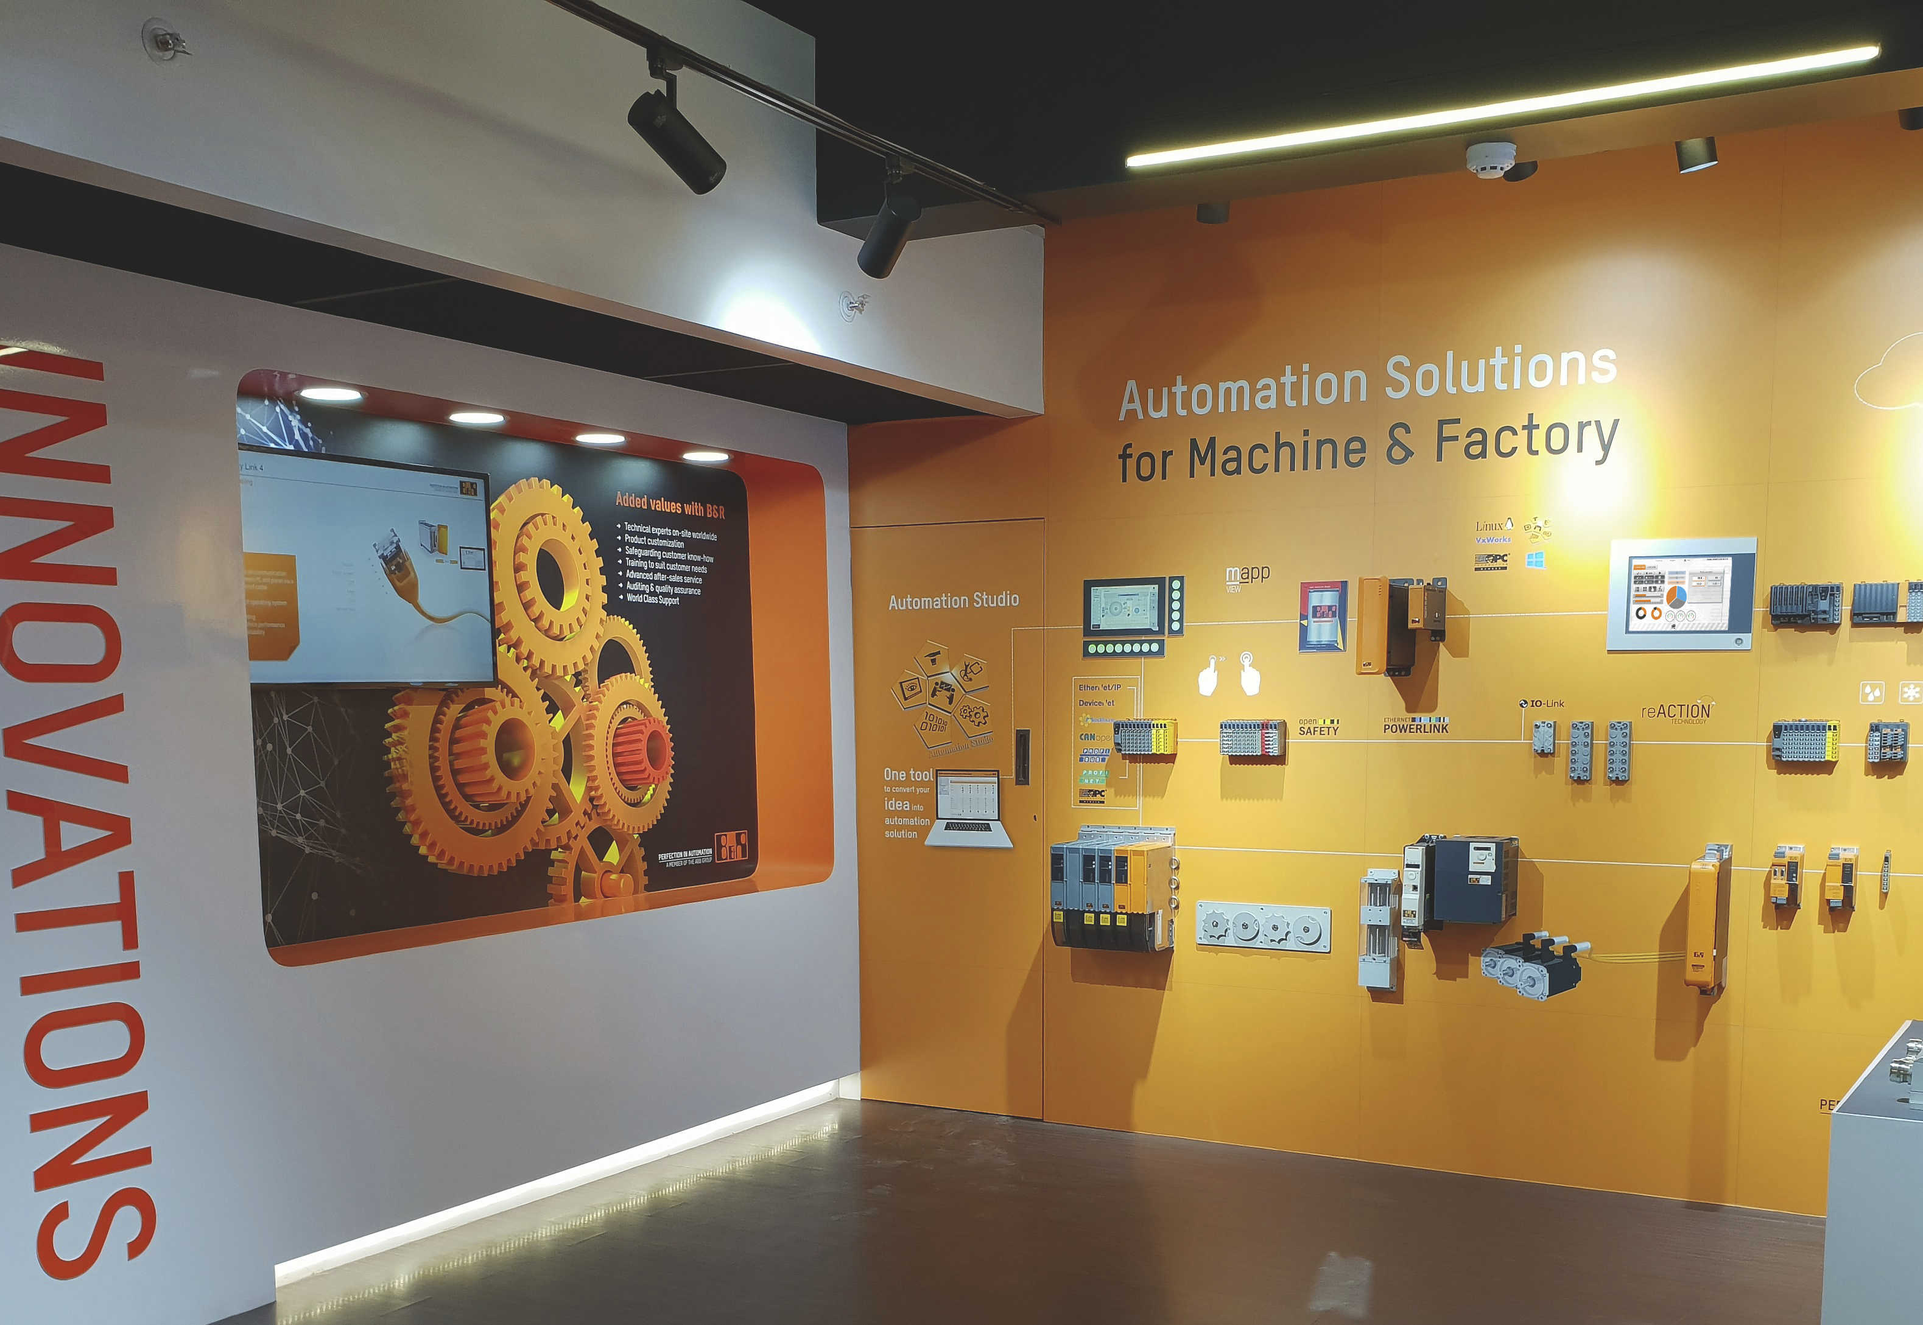
B&R Pune office houses a demo room and a next generation customer experience centre, highlighting latest hardware and technology.

About B&R
B&R, a division of ABB Group, is a global leader in industrial automation headquartered in Austria. B&R combines state-of-the-art technology with advanced engineering to provide customers in virtually every industry with complete solutions for machine and factory automation, motion control, HMI and integrated safety technology. With Industrial IoT communication standards including OPC UA, POWERLINK and openSAFETY as well as its Automation Studio software, B&R is constantly redefining the future of automation engineering. The innovative spirit that keeps B&R at the forefront of industrial automation is driven by a commitment to simplifying processes and exceeding customer expectations.
For more information, visit www.br-automation.com.

