B&R mourns the loss of company founder
Erwin Bernecker died on March 30, 2019, at the age of 67
B&R company founder Erwin Bernecker died suddenly and unexpectedly on March 30, 2019. The industrial electronics company B&R was founded in Eggelsberg in 1979 by Erwin Bernecker and Josef Rainer. Erwin Bernecker was an active member of the management board until the company was sold to the ABB Group. A native of the Austrian Innviertel region, he supported B&R's integration into the ABB Group's business processes as a consultant until the very end. Erwin Bernecker demonstrated great entrepreneurial skill, tremendous courage and incredible dedication over all these years.

Friends since their school days, B&R founders Erwin Bernecker and Josef Rainer gradually built up an international company based around their shared idea. As a result, B&R can now look back on 40 successful years. Erwin Bernecker's professional and human qualities were always highly appreciated by customers, business partners and staff. "Erwin Bernecker was an indispensable pillar of the company until the end. We pay deep respect to his life's work," says B&R Managing Director Hans Wimmer. Erwin Bernecker's spirit will forever be a guiding force for the company, and his memory will always be cherished. "Our deepest sympathy goes to the family, especially to his wife and children," says Wimmer.

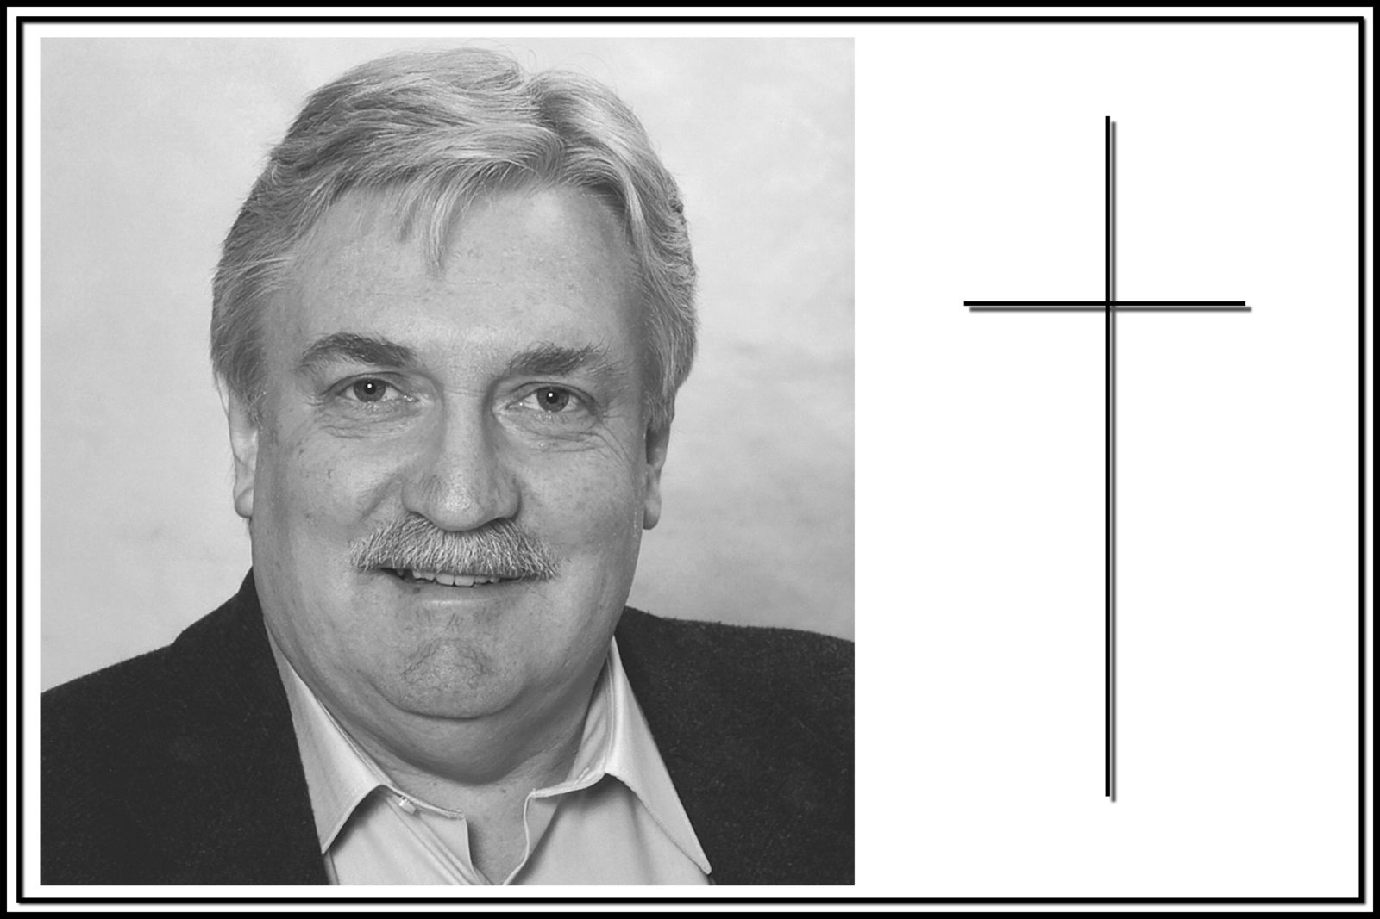
B&R company founder Erwin Bernecker died on March 30, 2019, at the age of 67.

About B&R
B&R, a division of ABB Group, is a global leader in industrial automation headquartered in Austria. B&R combines state-of-the-art technology with advanced engineering to provide customers in virtually every industry with complete solutions for machine and factory automation, motion control, HMI and integrated safety technology. With Industrial IoT communication standards including OPC UA, POWERLINK and openSAFETY as well as its Automation Studio software, B&R is constantly redefining the future of automation engineering. The innovative spirit that keeps B&R at the forefront of industrial automation is driven by a commitment to simplifying processes and exceeding customer expectations.
For more information, visit www.br-automation.com.

