Austria's largest self-consumption PV system
B&R expands photovoltaic system to 1.5 megawatts
Automation specialist B&R has expanded its photovoltaic system and increased its capacity from one megawatt to 1.5 megawatts. The roof of the company's headquarters in Eggelsberg is now home to Austria's largest solar power system for self-consumption. B&R uses sustainable solar power in its own manufacturing facilities.

B&R put the first part of the photovoltaic system into operation in May 2018. With the expansion, the plant now provides 1,500 MWh of climate-neutral solar energy per year. That's enough to power the homes of around 430 families for a year. The electricity the company generates is fed directly into its manufacturing facilities where it is used to operate numerous production lines. The photovoltaic system is installed on the rooftops of the B&R production halls and covers an area of around 12,000 m².
Contribution to sustainability
"We are proud to now have the largest self-consumption PV system in Austria and thus make our contribution to sustainability and environmental protection," says B&R Managing Director Hans Wimmer. The state government of Upper Austria supported the expansion of the plant. "Subsidies like this make it easier for companies to contribute to environmental protection. We are very grateful for the support," says Wimmer.
Making industry more sustainable
B&R's parent company ABB is involved in the Mission to Zero initiative for ending reliance on fossil fuel. ABB contributes to industrial sustainability through its products and services. More than half of ABB's revenue comes from technologies that combat the causes of climate change.

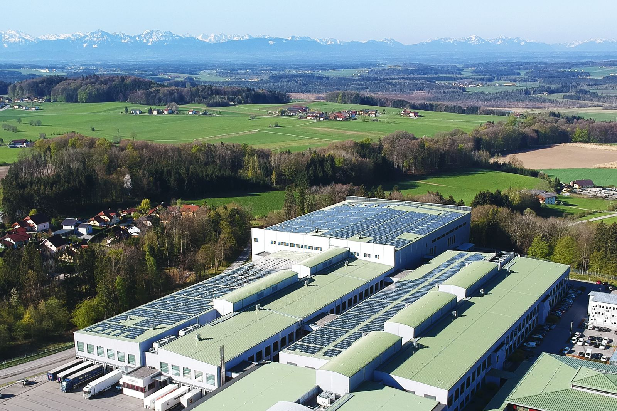
With a capacity of 1.5 megawatts, B&R's rooftop photovoltaic system is currently the largest self-consumption station in Austria.

About B&R
B&R, a division of ABB Group, is a global leader in industrial automation headquartered in Austria. B&R combines state-of-the-art technology with advanced engineering to provide customers in virtually every industry with complete solutions for machine and factory automation, motion control, HMI and integrated safety technology. With Industrial IoT communication standards including OPC UA, POWERLINK and openSAFETY as well as its Automation Studio software, B&R is constantly redefining the future of automation engineering. The innovative spirit that keeps B&R at the forefront of industrial automation is driven by a commitment to simplifying processes and exceeding customer expectations.
For more information, visit www.br-automation.com.

Source: Ökovolt Solartechnik GmbH

