Independently controled shuttles deliver the adaptive machine's unsurpassed flexibility
B&R features automation advances to maximize packaging performance, flexibility at PACK EXPO 2019, booth C-2058.
Innovations include intelligent track systems, cloud-based secure machine access, easy to use integrated machine vision, and HTML5 HMI solutions that work with popular PLCs.

B&R's ACOPOStrak intelligent track systems enable what has become known as The Adaptive Machine, representing the fourth generation of packaging machinery technology – allowing cost effective mass customization. A number of packaging machines based on ACOPOStrak have recently been introduced, ranging from fillers, cappers and labelers to cartoners, assembly systems, rainbow packers and indexing systems.

Asset Performance Monitor gives machine builders and users secure access to data from their installed machinery in the field, Asset Performance Monitor is B&R’s first cloud application, based on ABB Ability. The application automatically calculates KPIs such as OEE and machine health to identify opportunities to optimize operation and upgrade assets.
B&R’s new machine vision solution integrates directly into the machine controller and network rather than a separate vision system and features a powerful lighting capability. The result is simplified implementation that allows any automation engineer to develop a large portion of machine vision applications on their own, with sub-microsecond synchronization for increased machine performance and flexibility.
With Change Your View, B&R offers machine builders the ability to upgrade to the latest HTML5 based, high definition HMI technology without having to change their existing PLC code. Change Your View works with popular PLC brands and is operating system independent, so it can run on smart phones, tablets or any Web-enabled device.

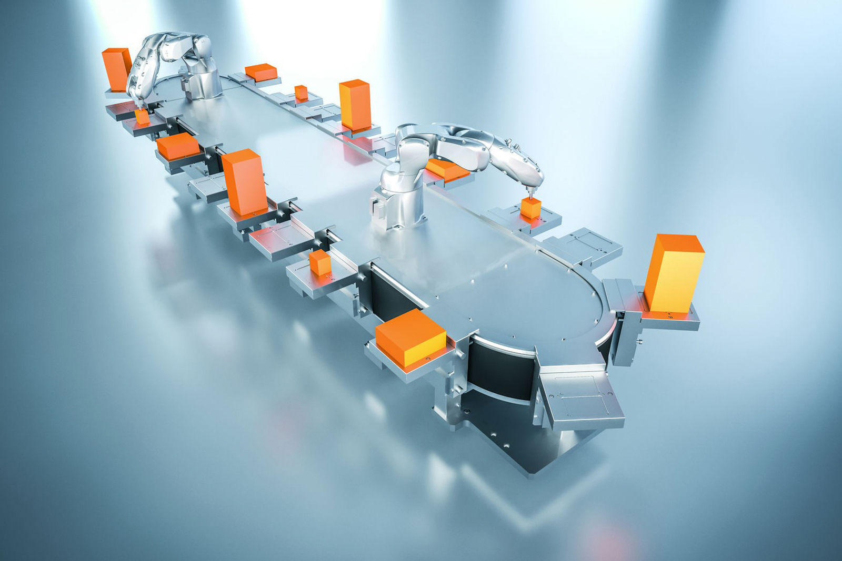
Independently controled shuttles deliver the adaptive machine's unsurpassed flexibility.

About B&R
B&R, a division of ABB Group, is a global leader in industrial automation headquartered in Austria. B&R combines state-of-the-art technology with advanced engineering to provide customers in virtually every industry with complete solutions for machine and factory automation, motion control, HMI and integrated safety technology. With Industrial IoT communication standards including OPC UA, POWERLINK and openSAFETY as well as its Automation Studio software, B&R is constantly redefining the future of automation engineering. The innovative spirit that keeps B&R at the forefront of industrial automation is driven by a commitment to simplifying processes and exceeding customer expectations.
For more information, visit www.br-automation.com.

