Safety for agricultural machinery
B&R presents X90 controller with integrated safety at Agritechnica 2019
B&R has added a safety solution to its portfolio for agricultural machinery. At Agritechnica 2019, the company will present its X90 controller with integrated safety technology. Another highlight of the B&R booth (Hall 15 / Booth H11) will be the compact and rugged Power Panel T50 mobile operator terminal.

A variant of the X90 controller is available with an integrated B&R SafeLOGIC safety controller. To create the corresponding safety application, the user simply connects ready-made software components using ladder diagram. This brings all the advantages of networked safety technology without any traditional programming and makes it substantially easier to achieve compliance with the European Machinery Directive.
Versatile HMI
The Power Panel T50 mobile operator terminal is a versatile addition to B&R's mobile automation portfolio. The panel offers highly reliable operation of agricultural vehicles with IP67 protection. The die-cast aluminum housing provides both mechanical stability and protection against all types of environmental influences. The Power Panel T50 mobile is available with display diagonals of 5", 7" or 10.1".
B&R X90 control system for agricultural machinery
The modular X90 control system is perfect for implementing flexible automation concepts built from standardized components. The heart of the X90 control system is a powerful ARM processor and multifunction I/O channels. Standard features include interfaces for CAN, Ethernet and the real-time POWERLINK bus system. All products in the X90 family are designed for use in harsh industrial environments. They can handle operating temperatures from -40 to +85°C and are resistant to environmental factors such as shock and vibration, salt, UV light and oil.

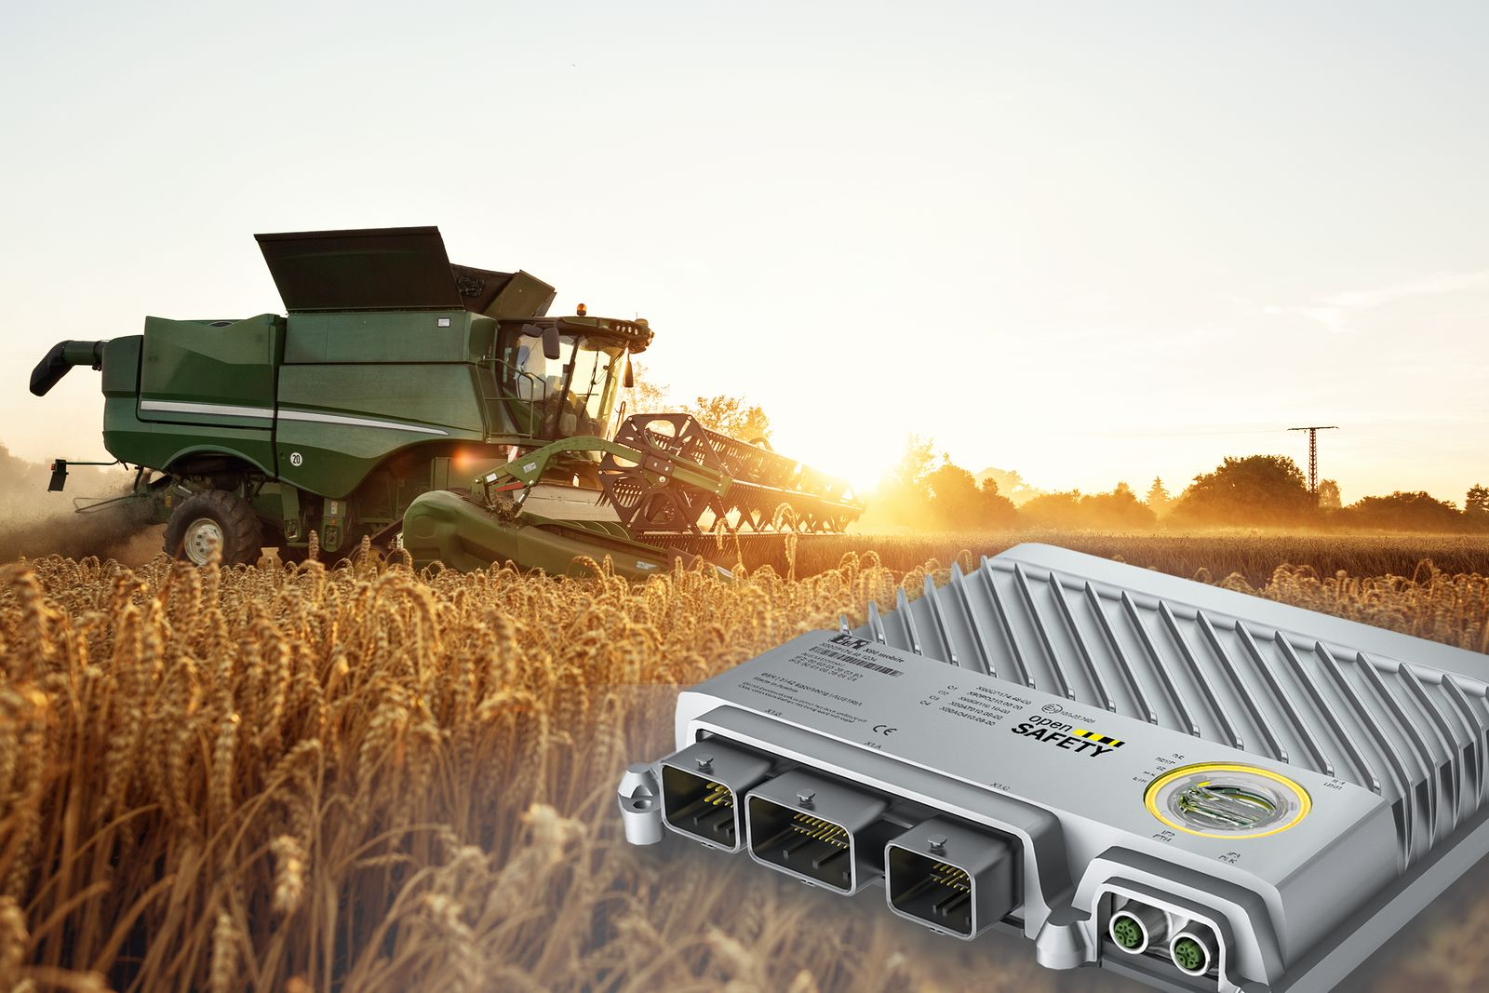
At Agritechnica 2019, B&R will present its X90 controller with integrated safety technology for agricultural machinery.

About B&R
B&R, a division of ABB Group, is a global leader in industrial automation headquartered in Austria. B&R combines state-of-the-art technology with advanced engineering to provide customers in virtually every industry with complete solutions for machine and factory automation, motion control, HMI and integrated safety technology. With Industrial IoT communication standards including OPC UA, POWERLINK and openSAFETY as well as its Automation Studio software, B&R is constantly redefining the future of automation engineering. The innovative spirit that keeps B&R at the forefront of industrial automation is driven by a commitment to simplifying processes and exceeding customer expectations.
For more information, visit www.br-automation.com.

