Contemporary HMI for popular PLCs

Now machine builders can offer wide screen aspect ratios, high def touch screens, connect with mobile devices, run HD videos and animations, without changing their current PLC code
With Change Your View, B&R Industrial Automation offers machine builders the ability to readily upgrade to the latest HTML5 based, high definition HMI technology without having to change their existing PLC code. Change Your View works with popular PLC brands and is operating system independent, so it can run on smart phones, tablets or any Web-enabled device.
User expectations for HMI graphics have never been higher because they can have a major impact on the effectiveness of machine operation, training, troubleshooting and changeovers. Change Your View delivers contemporary, easy to navigate, connected HMI software. Easy to develop from B&R’s mapp View drag-and-drop HMI software tool, featuring an extensive widget library, Change Your View can accommodate 3D models, HD videos, animations and PDF files.
The hardware includes wide aspect ratio, high definition, touch and multi-touch panels. Choices range from panel mount to swing arm, in ratings up to IP69K, in a variety of sizes, configurations and finishes. Options include ‘light ring’ pushbuttons, RFID readers and even customized brand identification.

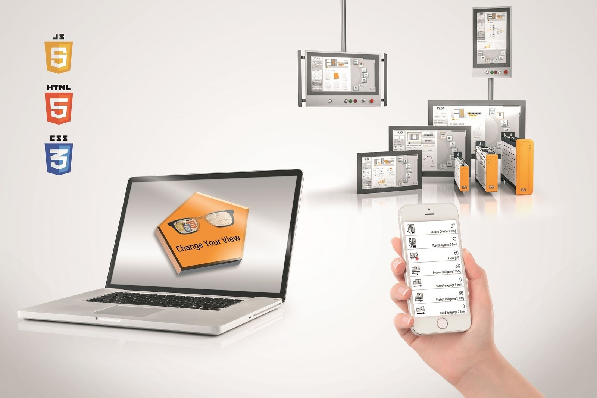
Change Your View delivers contemporary, easy to navigate, connected HMI software.

About B&R
B&R, a division of ABB Group, is a global leader in industrial automation headquartered in Austria. B&R combines state-of-the-art technology with advanced engineering to provide customers in virtually every industry with complete solutions for machine and factory automation, motion control, HMI and integrated safety technology. With Industrial IoT communication standards including OPC UA, POWERLINK and openSAFETY as well as its Automation Studio software, B&R is constantly redefining the future of automation engineering. The innovative spirit that keeps B&R at the forefront of industrial automation is driven by a commitment to simplifying processes and exceeding customer expectations.
For more information, visit www.br-automation.com.

