Connected efficiency
B&R at the K fair: Monitoring and analytics for improved machine performance
At the K 2019 trade fair (Hall 12 / Booth B16), B&R will be demonstrating how analysis of operating data can help detect and prevent impending equipment failures. Solutions such as continuous condition monitoring or the Asset Performance Monitor enable builders and operators of plastics machinery to carry out predictive maintenance in order to reduce downtime and lost revenue. Support of all EUROMAP information models guarantees simple implementation.
In addition to the company' s well-established complete solutions for machine automation, B&R will present a portfolio that creates added value for the plastics industry through connectivity, monitoring and data analysis. Support for all EUROMAP information models enables machines to communicate both with each other and with higher-level systems.
The collected data can be used to implement continuous condition monitoring, which monitors the wear and tear of individual components and provides information about when they should be replaced to avoid equipment failure. This minimizes the lost revenue and costly service calls associated with unplanned downtime.
Easily in touch with your machines
Asset Performance Monitor gives machine builders and operators a simple way to keep in touch with their installed base. The application collects data and makes it available for things like machine learning, big data analytics and business intelligence solutions. This makes it easy to make well-targeted improvements that have a real impact on machine performance.

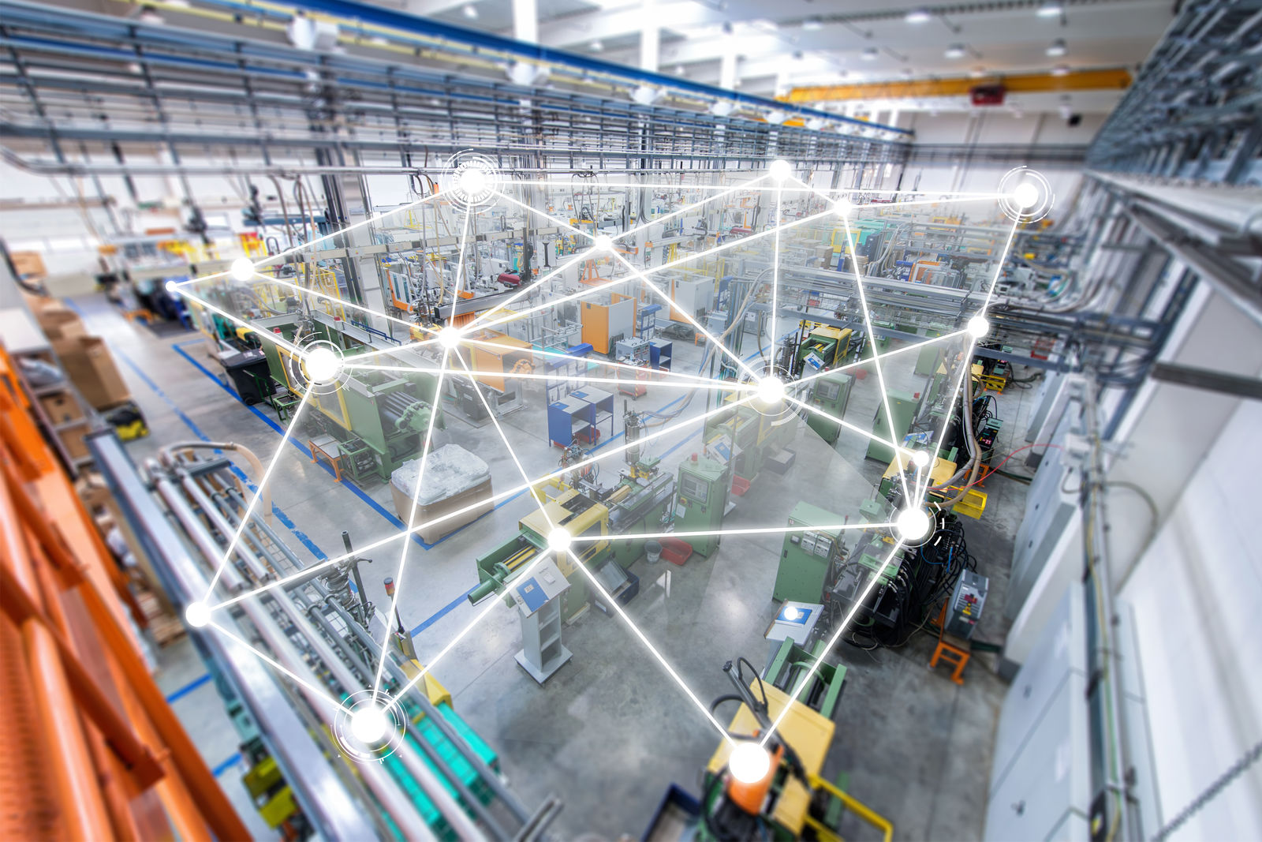
Visitors to the B&R booth will learn how connected machinery can help provide early detection of impending machine failures.

About B&R
B&R, a division of ABB Group, is a global leader in industrial automation headquartered in Austria. B&R combines state-of-the-art technology with advanced engineering to provide customers in virtually every industry with complete solutions for machine and factory automation, motion control, HMI and integrated safety technology. With Industrial IoT communication standards including OPC UA, POWERLINK and openSAFETY as well as its Automation Studio software, B&R is constantly redefining the future of automation engineering. The innovative spirit that keeps B&R at the forefront of industrial automation is driven by a commitment to simplifying processes and exceeding customer expectations.
For more information, visit www.br-automation.com.

